

Fay’s Physics Notes

Year 10

Chapter 1.1 – 1.2 : Measuring Length, Volume and Density

Standard Units

If the question does not state the specific unit the answer must be given in, use the standard version of that unit.

|  |  |  |
| --- | --- | --- |
| Type | Unit | Symbol |
| Length | Meter | m |
| Mass | Kilogram | kg |
| Time | Second | s |
| Electric current | Amperes | A |
| Temperature | (degrees) Kelvin | K |
| Amount of substance | Mole | mol |
| Luminous intensity | Candela | cd |
| Speed | Meters per second | m/s |

Accuracy and Precision

Accuracy and precision are two totally different things, though in everyday language we use them interchangeably.

Accuracy is how close a measurement is to the correct or accepted value. If you measure accurately,

Precision is how similar or close multiple measurements are to each other. This means if you measure precisely, your measurements will always be close to one another.

Reading measurements.

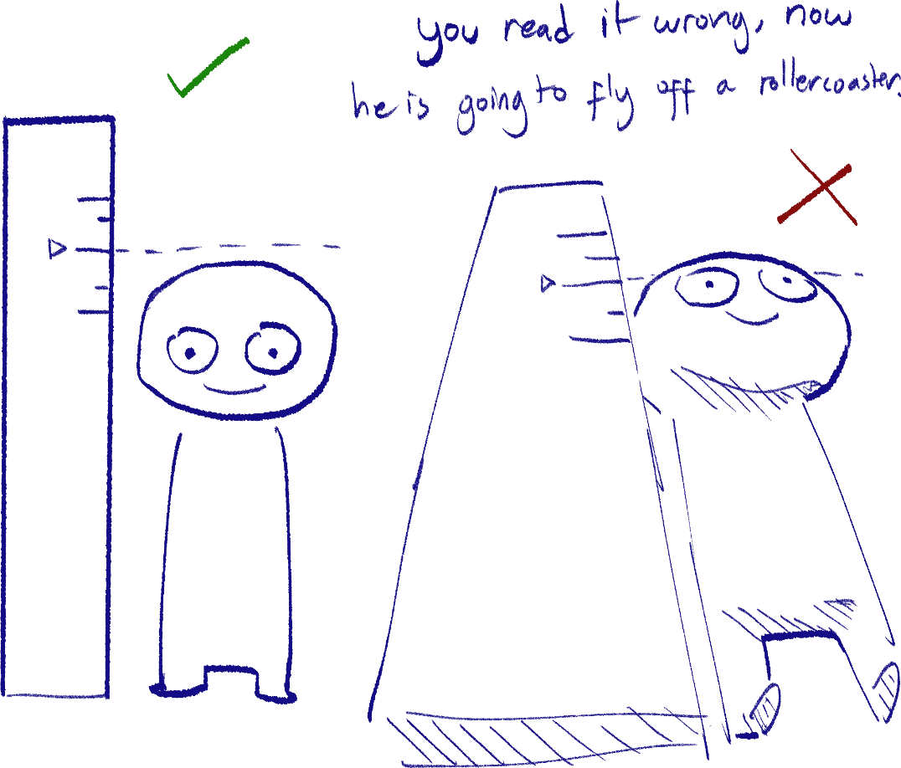 When reading a scale to measure, make sure your eyes are about perpendicular to the scale in order to prevent any wrong readings (these are also called *parallax errors*).

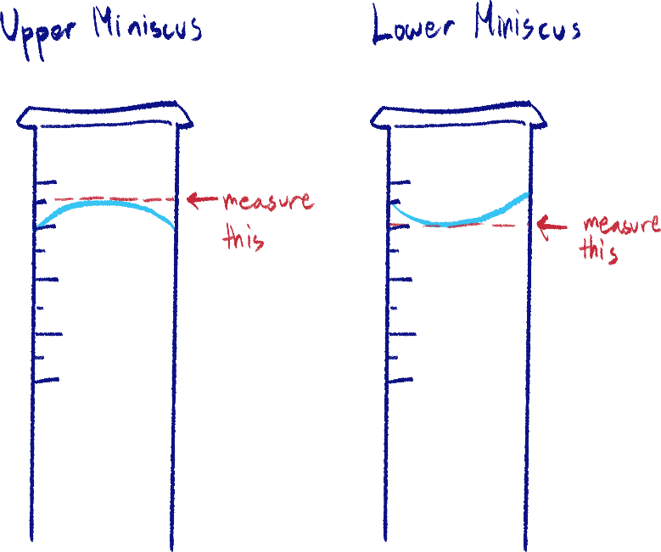Miniscus reading

There are two ways to read liquid measurements depending on the kind of curve it forms. Just look at the drawing.

Mass vs. weight

Mass and weight are also two totally different things. Mass is the amount of matter an object or substance has, while weight is how much force is exerted on the object by gravity.

For example, if you bring a body scale to the Moon, the readings will be very different and it is going to look like you haven’t failed your diet, when in reality, it is only the Moon’s gravity changing the scale’s measurements. This is weight.

But, if you could somehow count the number of atoms of your body, they would be the same on the Moon and on Earth. This is mass.

When working with measuring mass in physics and chemistry, we use a scale with units like grams and kilograms. Weight is measured by newtons.

Converting mass to weight

Now, this conversion isn’t the same as normal unit conversion (for example, cm to m) because as explained earlier, they are very separate things. However, because the weight experienced by a certain amount of mass is always the same on Earth, we can directly use the mass of an object to find its weight. This is done using the weight constant:

9.8N/kg

Depending on what past paper you’re looking at, they may ask you to use 10N/kg. The constant is always given in the instruction page, so just check it there.

The acceleration an object experiences in freefall is the same value, but we’ll get to that later.

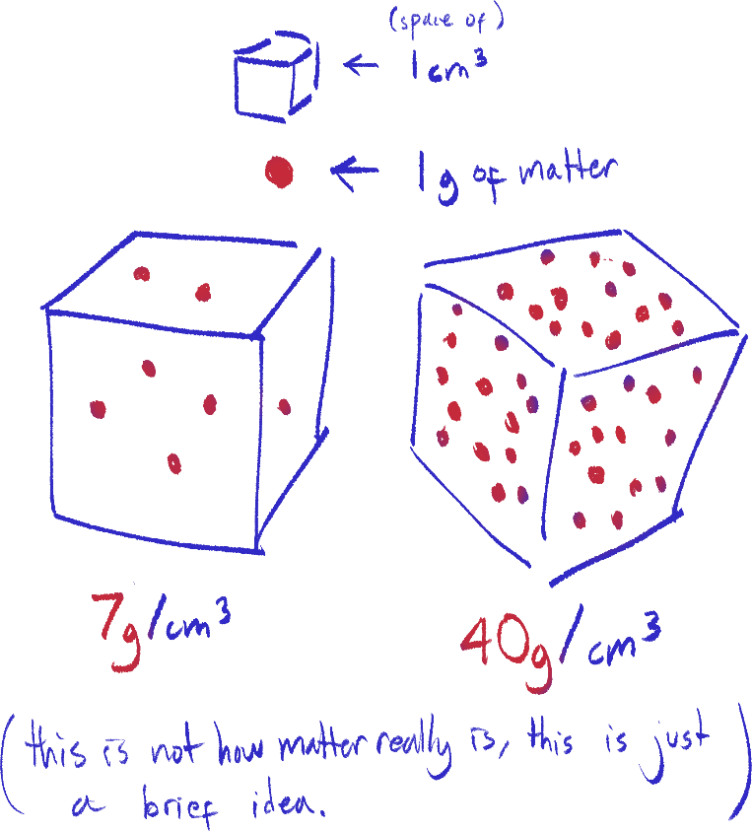Density

Density = Mass ÷ Volume

Density is usually stated in units such as g/cm3 or kg/m3, and is defined as how much mass there is in a unit of space.

So, if you want to measure the density[1] of a solid cube of concrete, you would calculate its volume by measurement and its mass by using a scale.

Just so you know: kg/m3 divided by 1000 = g/cm3[2]



Measuring the volume of irregularly shaped solids

You cannot mathematically calculate the volume of, say, a pebble, so these methods are used to measure the volume of such objects.

1. 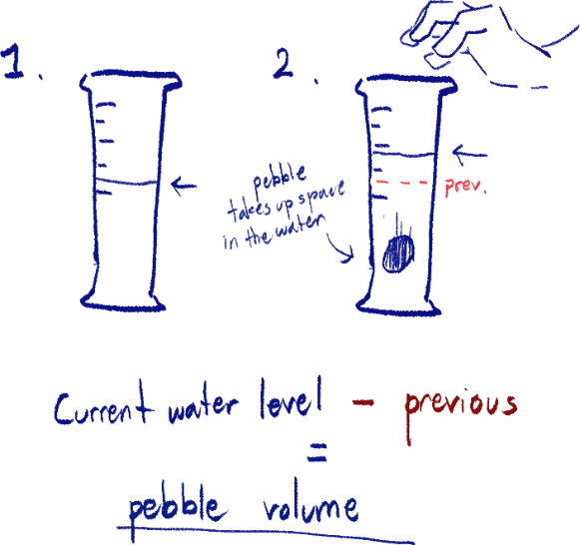Water displacement: measuring cylinder

A measuring cylinder is filled with water. The water level is noted first, then the object is dropped into the cylinder.

The object displaces water and causes the water level to rise, and that is also noted.

Subtracting the water level with the object and the level w/o the object will give you the amount of space the object took up, which is its volume.

1. Water displacement: displacement can

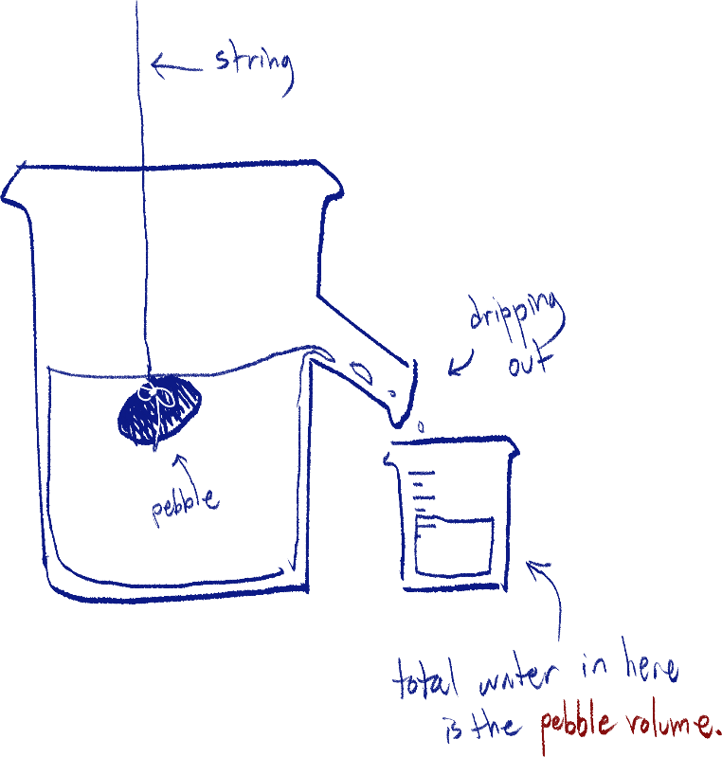This method uses a similar concept as the former, but in this case the water is set up where its level is very near to the opening, and the object must be slowly lowered to prevent splashing. The water displaced out of the can is the volume.

Chapter 1.3 – 2.1: Time and Speed

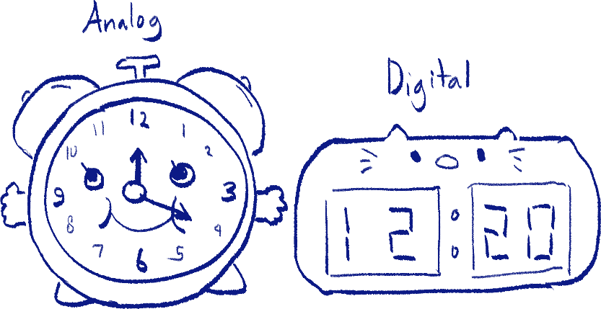Analog vs. digital clocks (you can probably skip this)

Analog clocks display time as continuous (you can estimate, but you cannot count exactly where the hands are)

Digital clocks use countable integers to display time. That’s it. The rest you need to know are physical features.

Light gates

A light gate is able to detect when an object passes through the ‘gate’ with and infrared transmitter and receiver.

There are two methods[3] to use light gates:

1. Two light gates

A light gate each is placed at the start and end of a track. The moving object starts the timer by going through the first gate and stops it by going through the second gate.

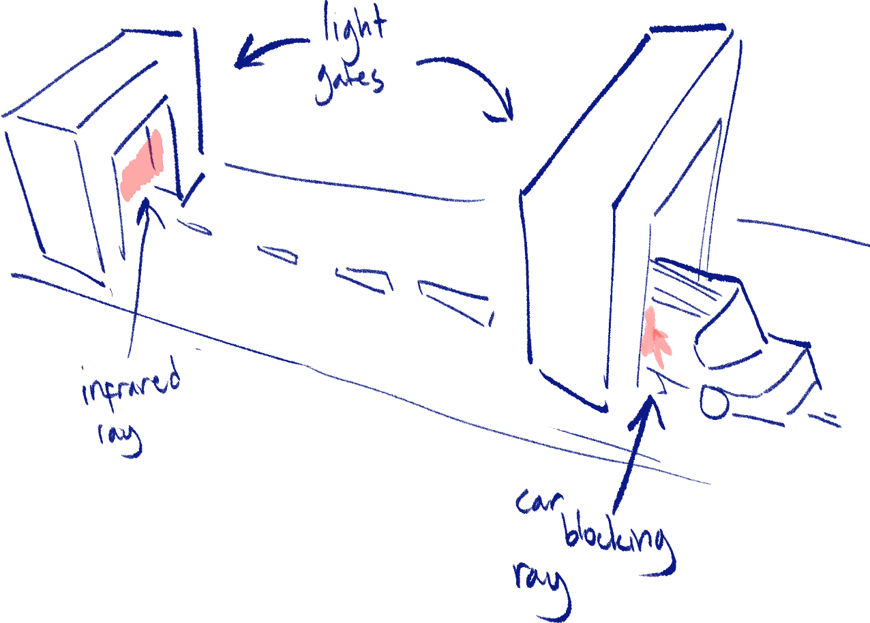The speed can be calculated by distance between gates divided by time taken.

1. Interrupt card

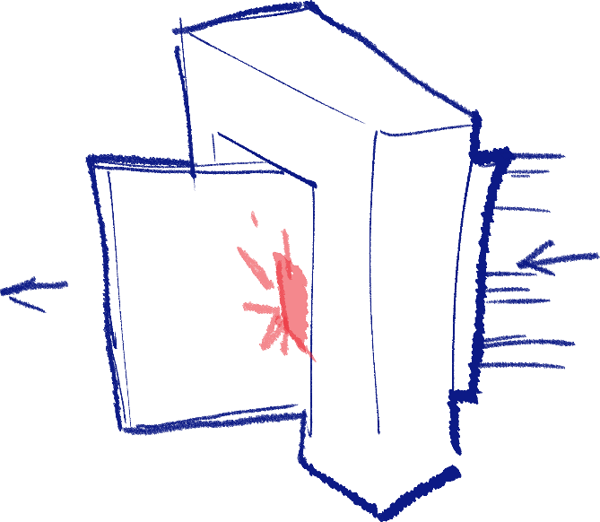An interrupt card is stuck onto the moving object, and the object goes through one light gate. The light gate will time when the card first blocks its ray connection and when the connection returns (A.K.A. when the card leaves the light gate).

The speed is calculated by the length of the interrupt card[4] divided by how long it took for it to enter and leave the gate[5].

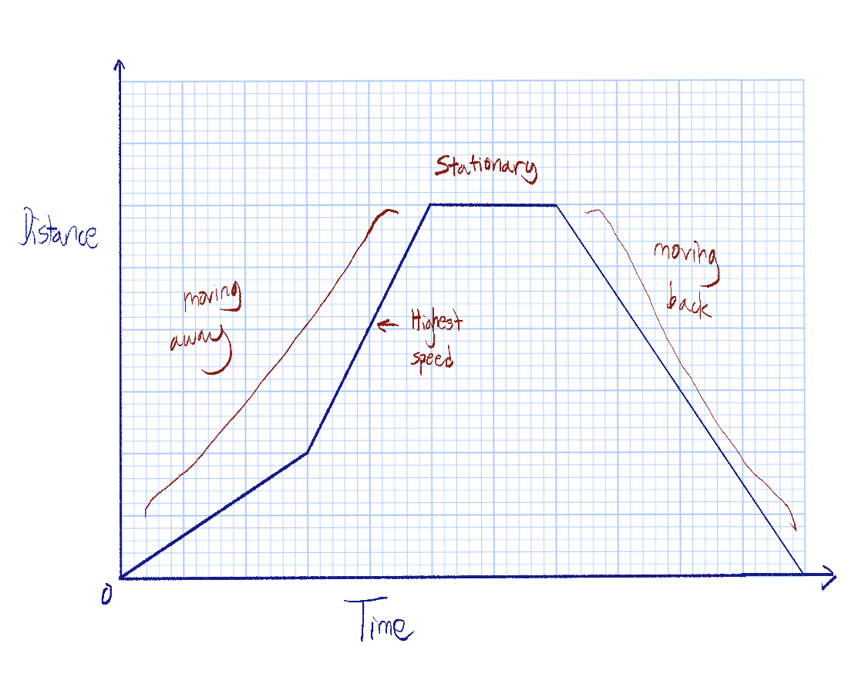Distance/time graphs dude

Distance/time graphs show the distance an object is from a specific point at a specific time.

The average speed of an object throughout the graph can be discerned from a distance/time graph by using the total time and total distance taken from the graph in the formula for speed.

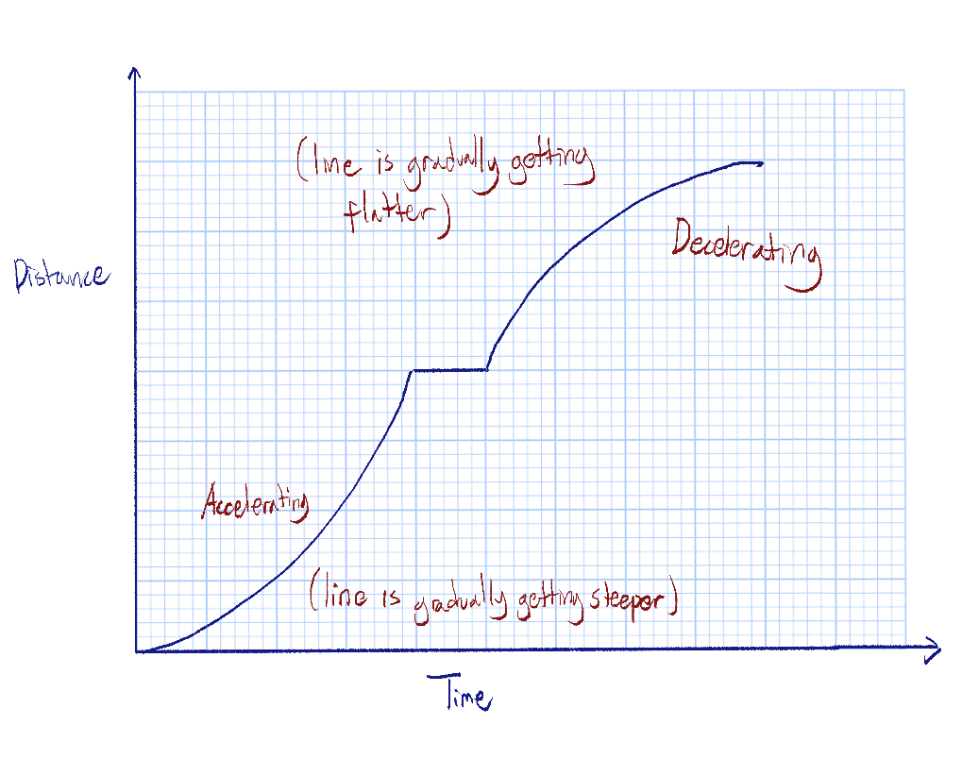The speed within a specific time period can also be calculated this way.

The graph here shows how curves show acceleration or deceleration in a distance/time graph.

Speed/time graphs

Do not confuse them with distance/time graphs.

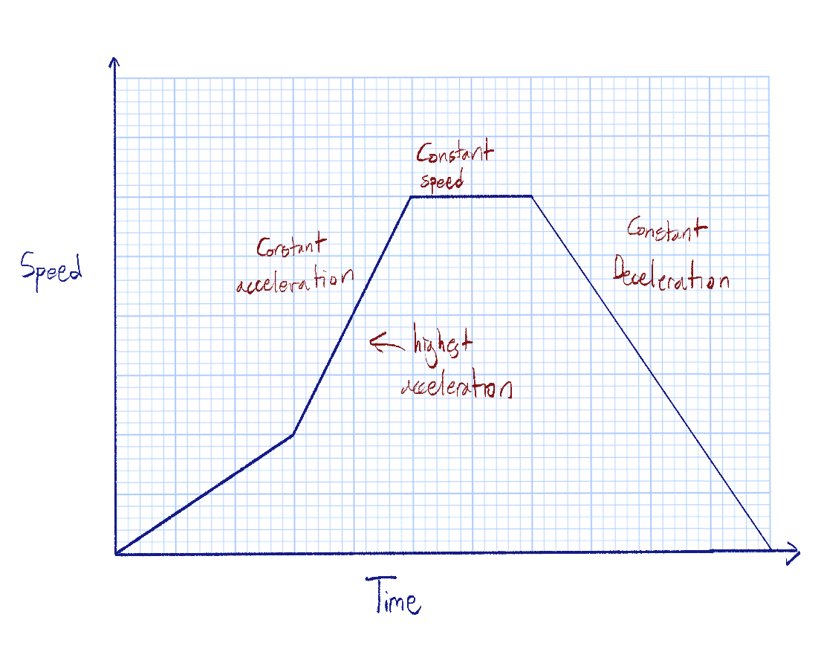

The sample graph here labels what each part represents. The steeper the slope, the higher the speed has increased within a certain amount of time, so the acceleration is higher.

Keep note that unlike the distance/time graph, an object is stationary only when y = 0, or speed = 0. A flat line otherwise means the speed is constant, or not changing.

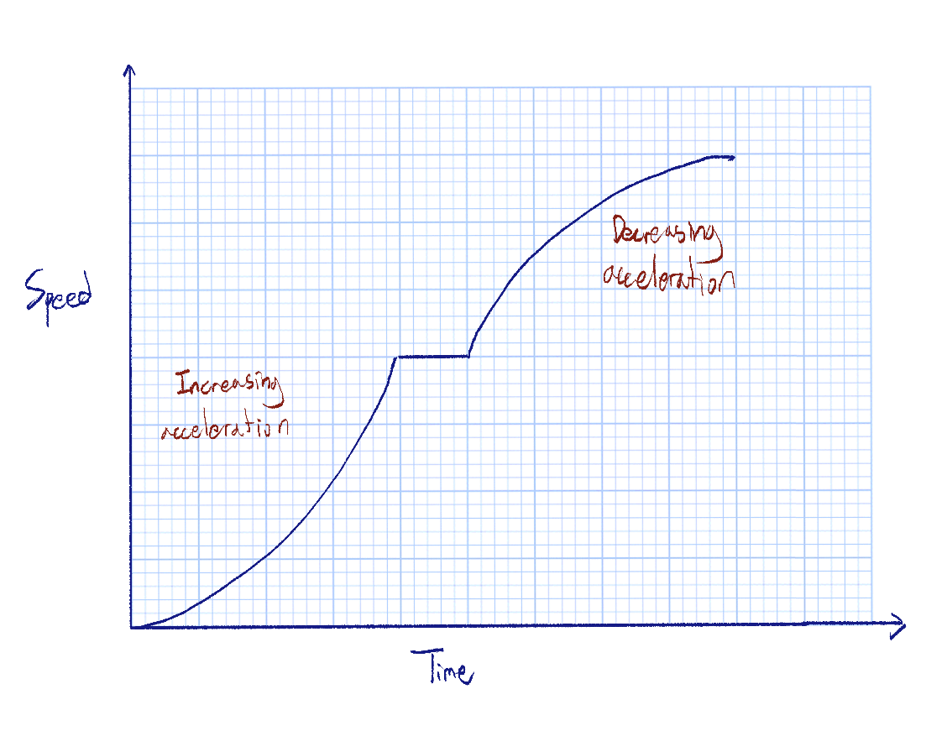

The graph here shows how curves represent increasing acceleration and decreasing acceleration. But, can just say ‘non-constant’ acceleration.

Yes, it is hard to wrap your head around ‘decreasing the increase of speed’, but this just means that the speed is changing at a slower rate in the case of decreasing acceleration, and vice versa for increasing.

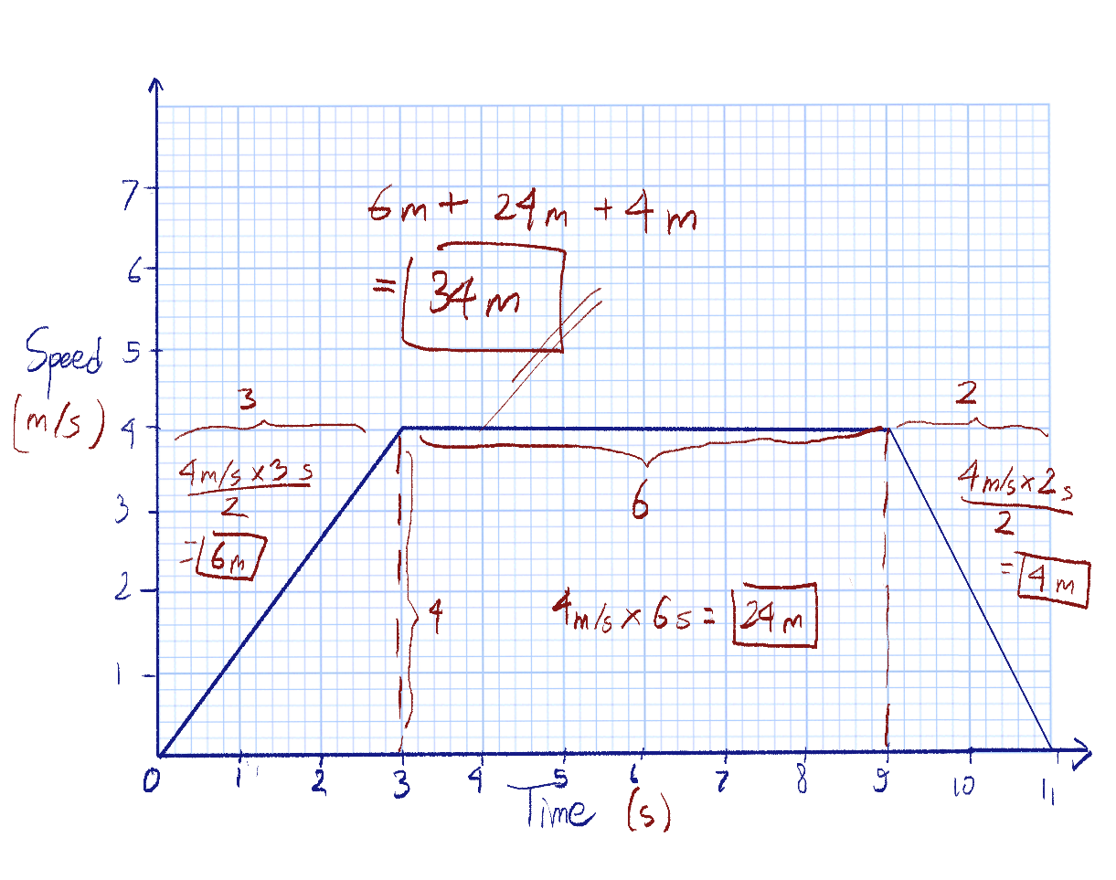

The distance travelled by the object can be discerned from this type of graph by calculating the area under the graph line, using time as the width and speed as the height measurements.

The equations of motion

a = (v-u)/t

s = ut + at2/2

s = t(u+v)/2

v2 – u2 = 2as

Where:

a = acceleration

s = displacement

u = initial velocity

v = final velocity

These four equations relate all four variables with each other, each with only 3 variables in an equation. You already know the first and third, so I recommend you just memorize the last, because that can find velocity, displacement or acceleration without using time.

Forces and the Laws of Motion

Newton’s 1st law of motion

An object’s motion will not change (velocity will remain constant) unless acted upon by a force.

This applies to both stationary and moving objects – without any force acting upon either of them, the stationary object will not move and the moving object’s velocity will be constant.

Newton’s 2nd law of motion

The force of an object is the product of its mass and acceleration.

Thus, it can be simplified into this formula:

F = m * A

This formula can be rearranged to find any one component of the formula when the other two are known.

Newton’s 3rd law of motion

When two objects interact, they exert forces that are equal in magnitude and opposite in direction to each other.

For example, a bouncy ball hitting the ground will bounce in the opposite of its initial direction, and will experience the same[6] magnitude of force that it exerted on the ground when it the ball hit it.

Another example is a rocket ship – it releases gas from its thrusters to accelerate. The gas obviously has much less mass than the ship, but because the ship is ‘pushing’ the particles out and away from it at high velocity, the particles will exert a force equal in magnitude (and high magnitude at that, due to the high velocity) pushing the ship up.

Force

It has already been aforementioned the definition of force in Newton’s 2nd law of motion, but here is more elaboration.

Units must be paid attention to.

Newtons (N) is the unit for force.

Kilograms (kg) is the unit for mass.

m/s2 is the unit for acceleration.

These units must be followed for accurate calculation. If given different units (such as g instead of kg) you must convert them beforehand.

For example, if a ball was originally moving 10 kg*m/s and had a change in momentum causing it to move 10kg*m/s the opposite direction, it would be written as -10kg*m/s.

Converting mass to weight.

The current IGCSE syllabus assumes that the value weight per kg and the acceleration of free fall is 9.8 (N/kg for weight, and m/s2 for freefall). Some earlier past papers will assume it as 10, however.

So, an object of 10kg will have the weight of 10kg(9.8N/kg) = 98N, experiencing 98N of gravitational force.

Centripetal force

Centripetal force, not to be confused with centrifugal force, is a constant pulling force that causes an object to spin around a center. I recommend watching [this video](https://youtu.be/5vtH1uBaoBY), it makes this a lot easier to understand.

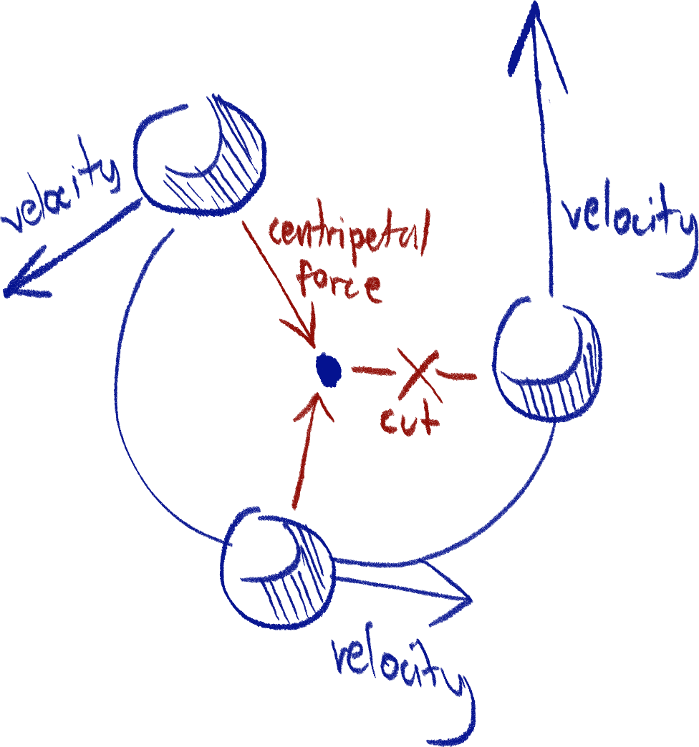The object, despite moving at a constant speed, has a constantly changing velocity, as its direction is constantly changing as it spins. The diagram below illustrates this.

You can see that velocity is always a straight line because of its direction. The line of velocity when an object is spinning is always a tangent of the circle the object is traveling in.

When the object stops receiving centripetal force, the object is not bound anymore and thus will travel straight in the line of its velocity.

Free fall

Free fall is the term for when an object is falling in the air[7]. In freefall, the object is experiencing only gravitational force. It is more theoretical than anything, but helps us understand how objects fall and the force of gravity.

The object is said to experience freefall acceleration from gravity, it being 9.8 m/s2 (the same value as gravitational force). Any object of any mass will always accelerate at this speed in free fall. In real life, it can be different due to air resistance.

Terminal velocity

Because of factors such as air resistance, there is a certain point where an object cannot accelerate anymore, reaching a steady velocity, called terminal velocity. This can happen during free fall or any scenario where an object is moving at high speeds.

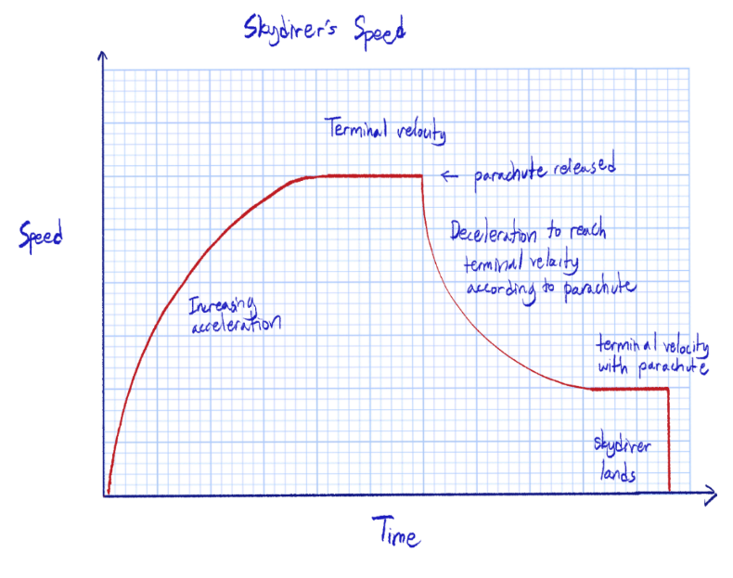 Air resistance increases as velocity increases, so at some point, the upwards force of air resistance is equal to the downwards force of gravity, resulting in no resultant force. No resultant force means no acceleration, resulting in constant velocity – this is terminal velocity.

Note that this explanation falls in line with Newton’s 3rd law of opposing forces.

Air resistance elaboration if you want to

You can see in the speed/time graph of the skydiver that the acceleration is not constant – it is a curve. When the skydiver jumps off the plane, you can see that the acceleration starts off high and levels off gradually.

This is because as air resistance increases with velocity, and air resistance reduces acceleration. You can imagine the air particles pushing back on the falling object.

So, even before reaching terminal velocity, air resistance takes effect by slowing the rate at which the speed increases (A.K.A. acceleration.)

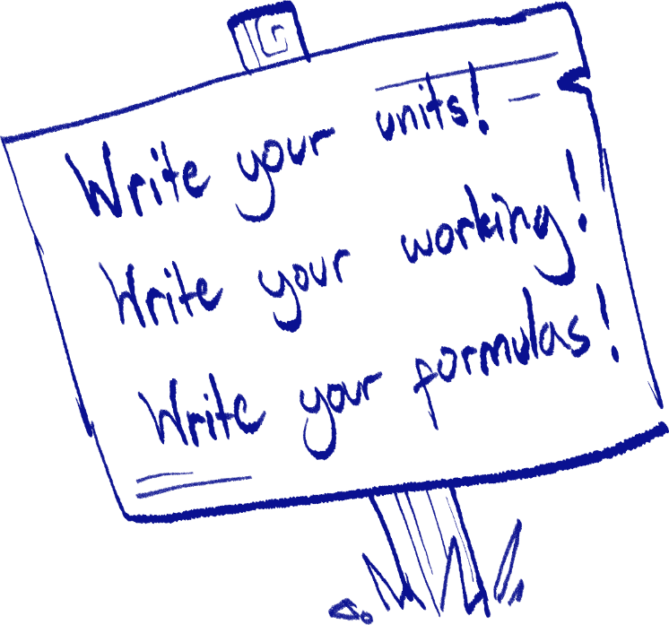

Momentum

Momentum is how much motion there is in a moving object. In comparison,force is the external strength exerted on an object. The formula is similar to force, but keep in mind that it uses velocity rather than acceleration.

p[8] = m * V

The standard unit for momentum is kg * m/s.

Momentum is proportional to mass, so between a small and big object at the same velocity, the larger object will have a higher momentum. Think of getting rammed by a toy car versus a truck.

Because of the formula for momentum, force can also be rewritten as:

F = $Δ$ p (impulse)/ t[9]

An important rule is that in a closed environment, momentum before and after collision are equal. Similar to the law of conservation of energy and matter.

Even though two objects will move differently after collision, they will sustain the same momentum, like one losing momentum while the other object gains that lost momentum.

A concept often put into use in questions are when a moving object collides with a stationary one, and both objects are brought to move. Unlike minecarts in Minecraft, a moving minecart when hitting a stationary one will cause both of them to move, but at lower speeds than originally.

But momentum is always conserved, so how does that work? The reason behind this is because momentum is proportional to mass, and the mass of the two objects are higher than the first object, so the velocity will decrease to keep the momentum the same.

Impulse[10]

There are two ways to go about impulse.

Impulse is apparently defined as the amount of force applied over time, which is why its unit is N*s (newton times seconds). [11] Thus, one formula for it is F*t.

According to the *Impulse-Momentum theorem,* the change in an object’s momentum (initial momentum and final momentum, otherwise known as delta momentum) is equal to the amount of impulse exerted on that object. So impulse’s unit can also be kg*m/s. You can see that this can be converted to Ns.

A common example of impulse is hitting an incoming baseball with a bat. When the bat applies force for a brief amount of time (effectively impulse), the ball’s momentum changes.

Direction of momentum and other vectors

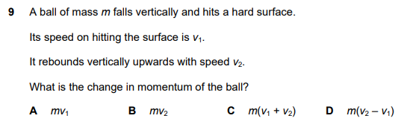 Momentum, like force and velocity, is a vector. This means it has a magnitude and direction. When you’re looking at a scenario where there are vectors like momentum being used in opposite directions, you should assign one to be positive, and the other negative. Although not used much in questions with diagrams that directly show you these directions, it is used in word problems.

Here, they tell us the *speed*, which is the scalar value of velocity, so it has no direction. However, they are asking for the change in *momentum*, which is a vector. So, although one (me) may think D is the answer as it is the normal way to find change/difference, the correct answer is C, because:

Since m is constant, we will cancel it out and only use the v values. Assume v1 is 10m/s, and v2 is 6m/s. If we were asking the change in *speed*, it is 10m/s – 6m/s, 4m/s. However, because v2 will be traveling in the opposite direction, think of it as -v2.

The change of 10m/s to -6m/s is not 4m/s, but 16m/s. That is the reason v1 and v2 are summed up, rather than subtracted.

You could also visualize this by putting them on a number line, with each end of it pointing to opposite directions.

Vectors and scalars

Vectors are values with both magnitude and direction, while scalars only include magnitude. Here’s a list of the different units.

Vectors:

* Displacement
* Velocity
* Force
* Momentum
* Acceleration
* Drag
* Lift
* Thrust
* Weight[12]

Scalars:

* Mass
* Length
* Width
* Height
* Volume
* Speed
* Density
* Temperature
* Pressure
* Entropy
* Work
* Power

Calculating resultant vectors (for right angles)

There are two ways; on paper and mathematically.

We will work with the example 8 N East and 10 N North.

First, you must draw the two vectors to scale, end to end, making sure to draw them as arrows, like this:[13]

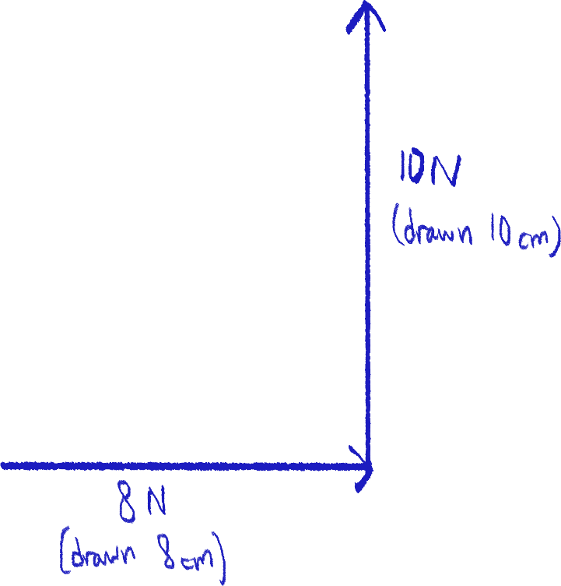It is very important to make sure the directions of the arrows are correct. Incorrect examples below:

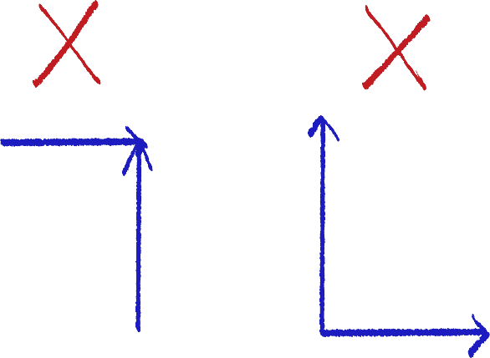

Next, using the vectors as a base and height, draw a hypotenuse from the remaining ends of the lines.

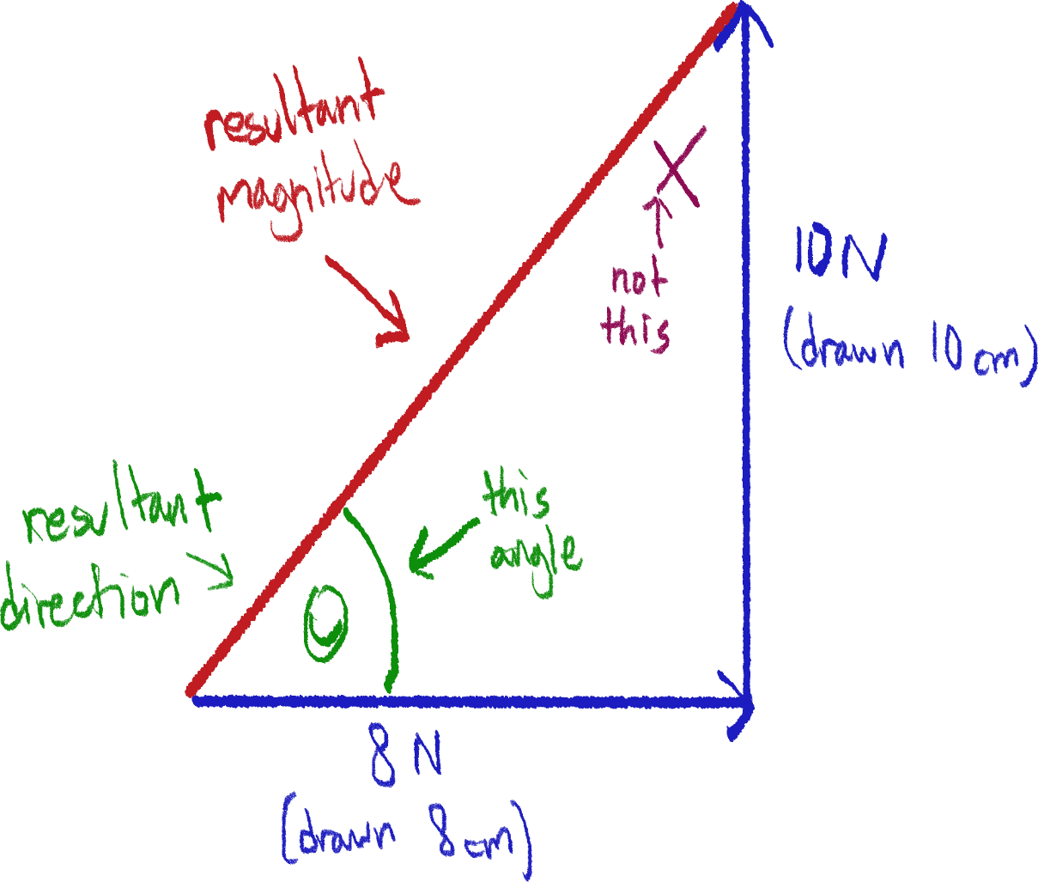

The hypotenuse length is the magnitude of the resultant vector, and the angle at the tail end of the arrows (notice that the highlighted angle is opposite the direction the arrows are pointing at) is the direction of the resultant vector, which can be measured using a protractor.

The mathematical solution, which is much more accurate, involves finding the hypotenuse using Pythagoras’ theorem which is:

(base)2 + (height)2 = (hypotenuse)2

This equation can be solved to find the length of the hypotenuse.

As for the angle, we can use tan-1(opposite/adjacent) to find the angle. Make sure your calculator is in degree mode.

In this case, tan-1(10/8) = 51.34˚.

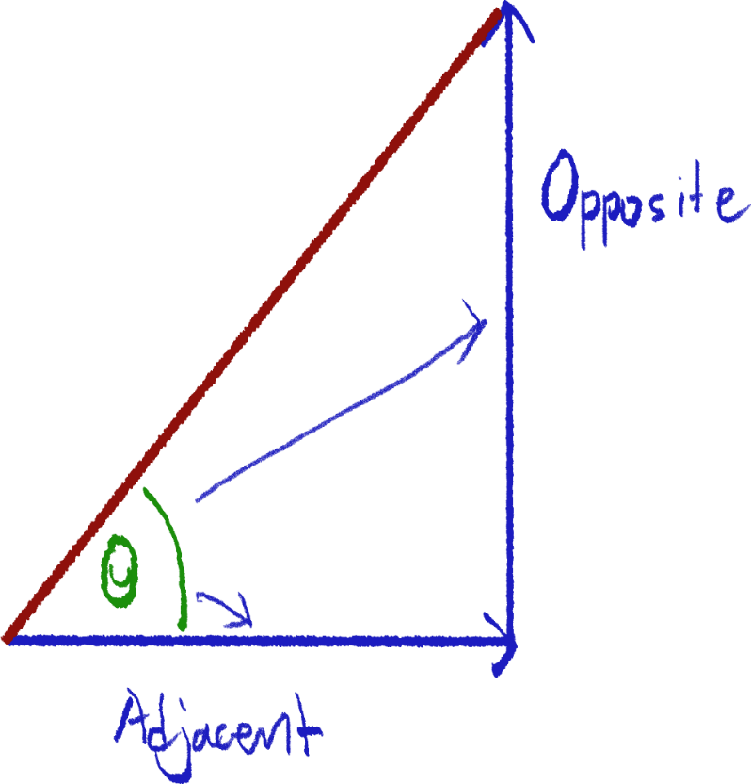

Moment

Moment is the turning force around a pivot. Here is an example:

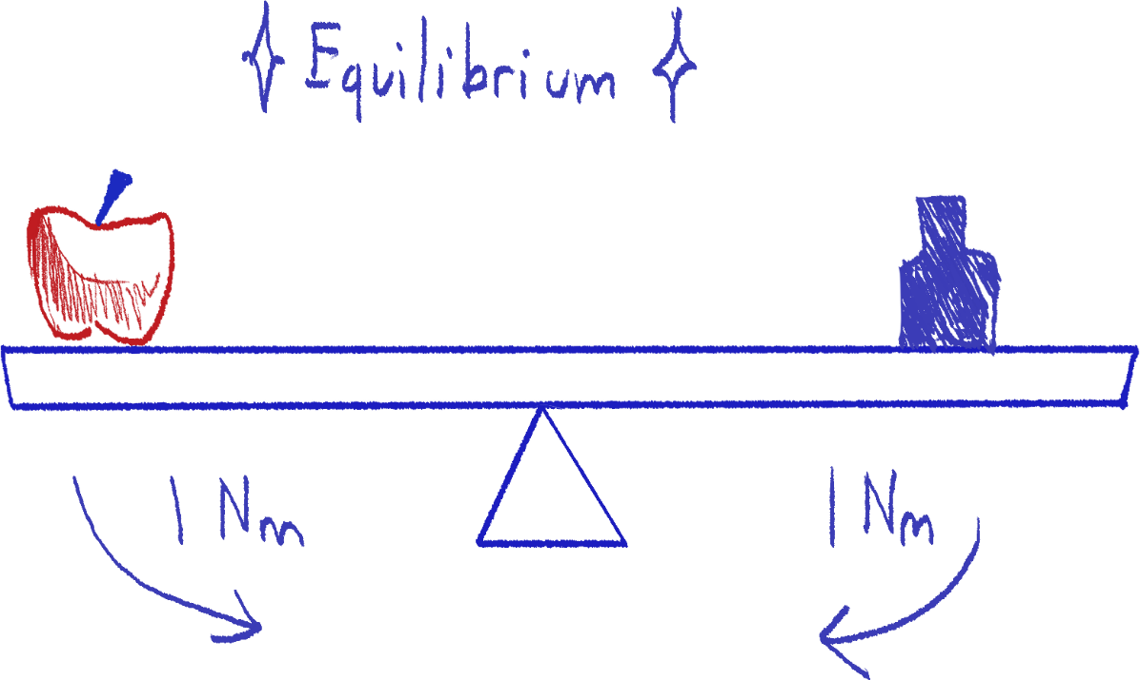

The clockwise and anticlockwise moment shown here are equal to each other, so the object is said to be in equilibrium. Equilibrium has multiple criteria which we will discuss later.

The triangle tip is the pivot here. A pivot is a single point of which the object rotates.

The moment of a force is defined as force multiplied by distance from the pivot perpendicular to the direction of the force. Formula being:

M = F * d

(d being distance from pivot)

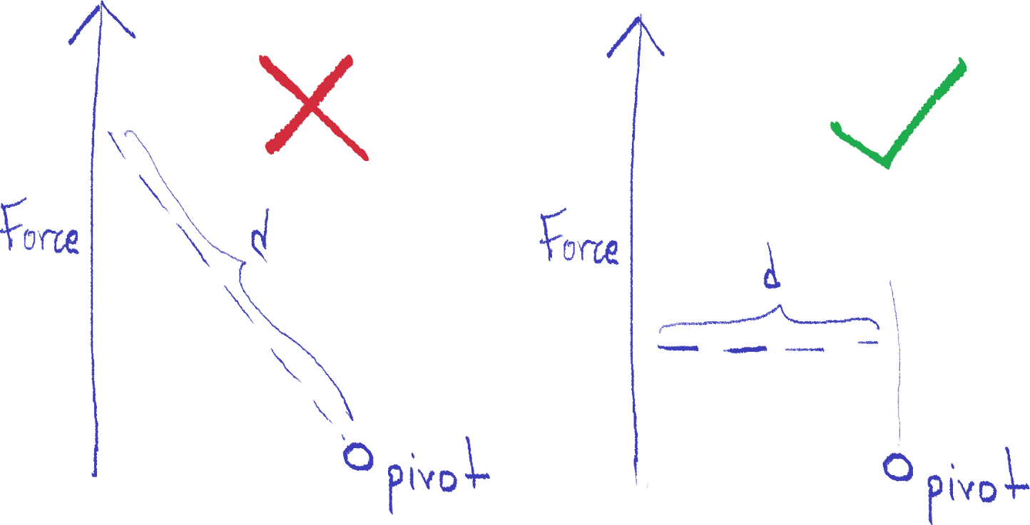

Distance should be perpendicular to the direction of the force, like this

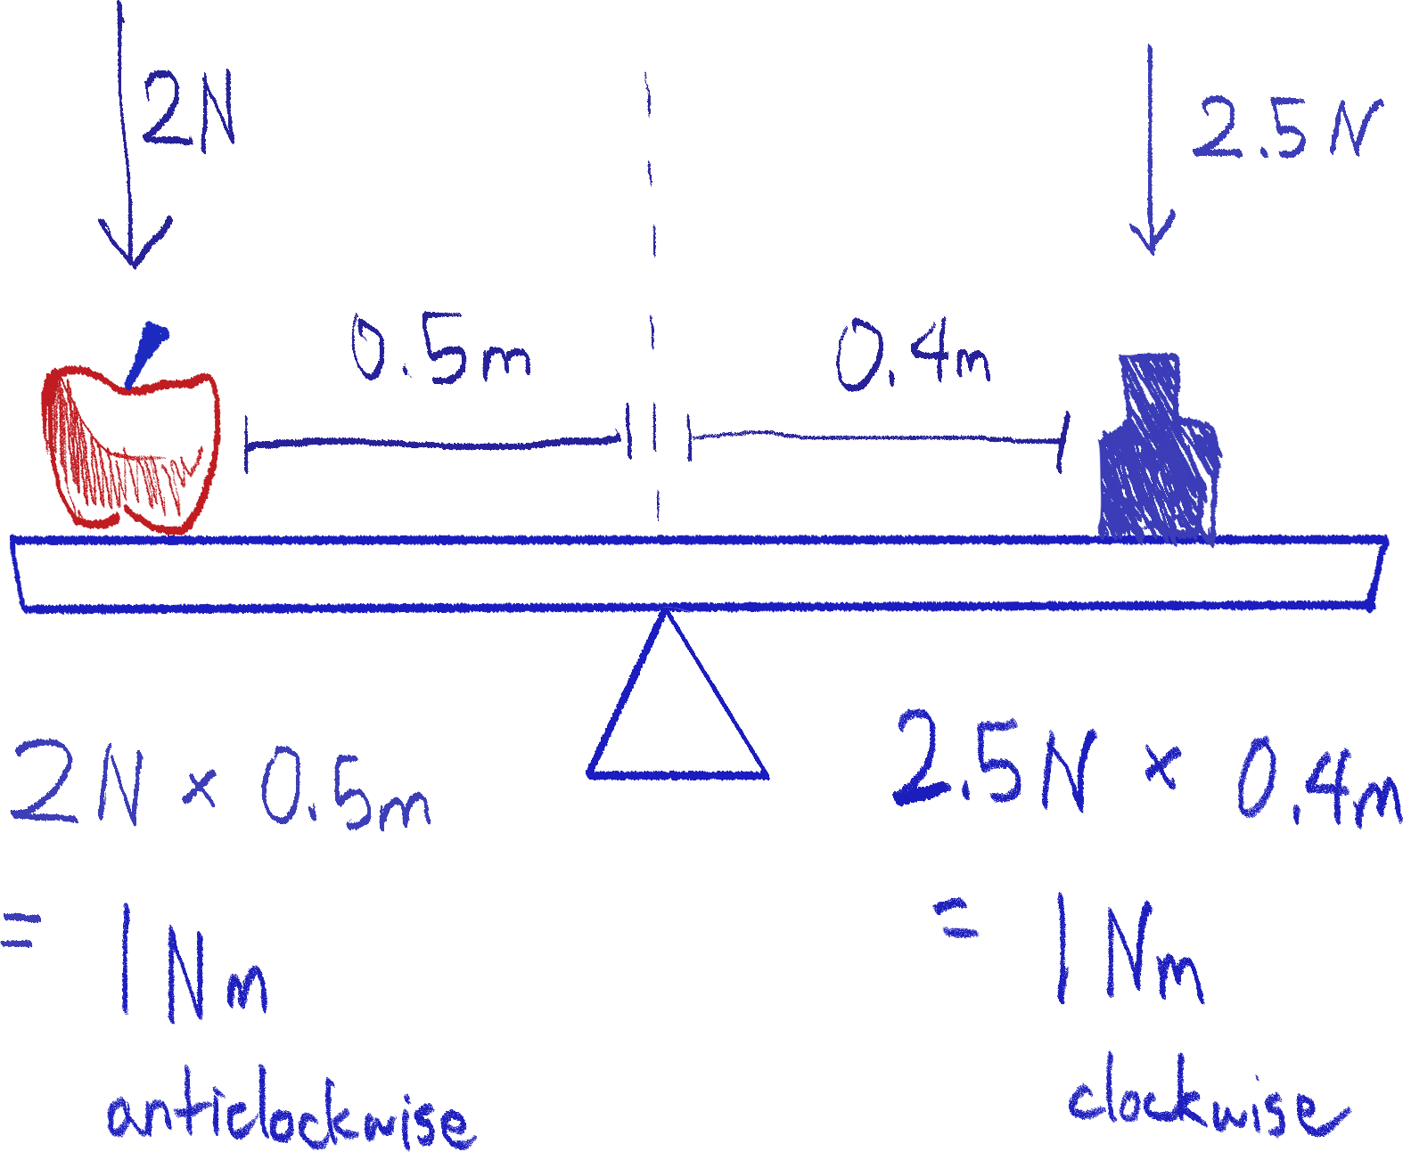

Example of calculating moment; anticlockwise and clockwise moments are equal, so the object is in equilibrium.

Equilibrium

For an object to be in equilibrium, the object’s state of motion must be constant. If the object is moving, it should not speed up, slow down or stop. If the object is stationary, it should not start moving. The object should not start or stop turning.

The criteria for an object to be in equilibrium are:

* There should be no resultant force being exerted on the object
* The clockwise and anticlockwise moment on the object is equal – no resultant moment

Center of gravity

An object’s center of gravity is the point at which the weight of the object is considered to act, like the point where all the weight of the object accumulates.

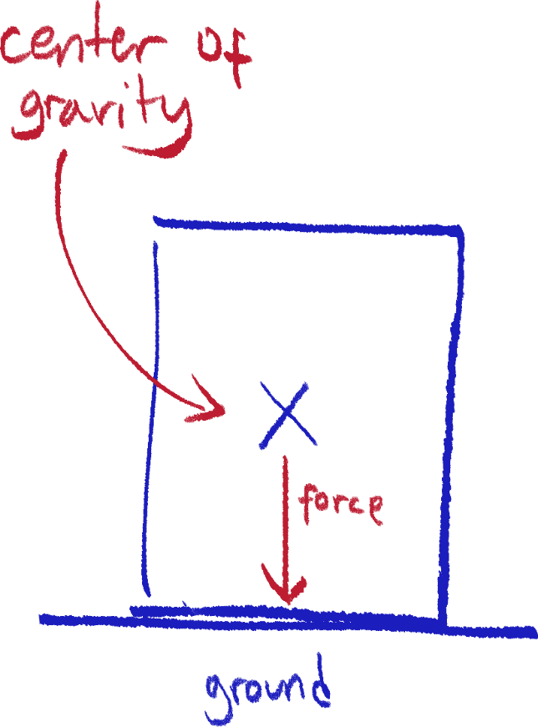 Because weight acts according to gravity, one can imagine a line of force stemming from the center of gravity to the ground.

It is a rule that if the center of gravity lies above the base of an object, then it is stable. However, if the center of gravity is beyond the base, it will topple over.

The center of mass is a different term, referring to a point at the center of distribution of mass in an object.

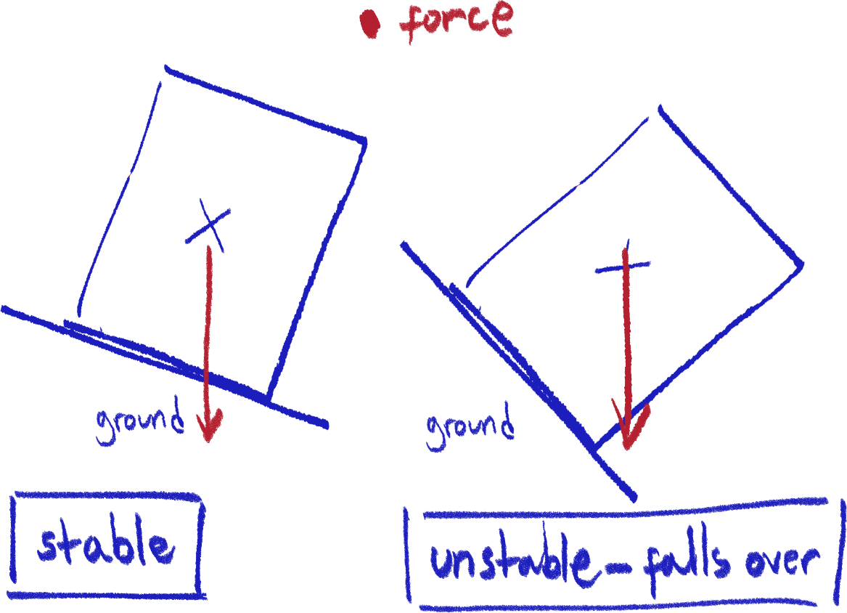

Finding the center of gravity

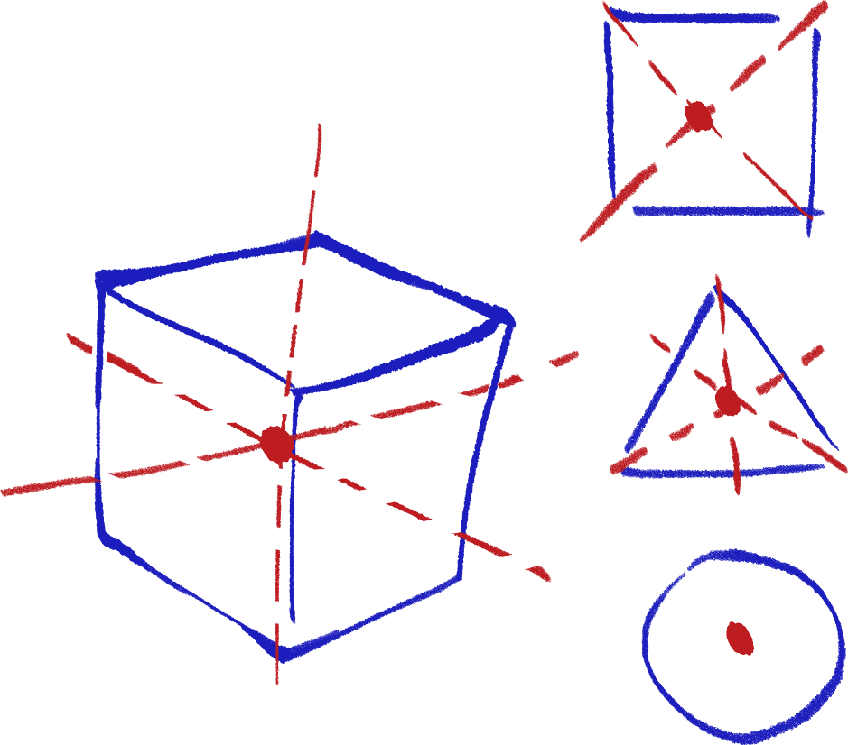

For regularly shaped objects with an even distribution of mass, one can find the center of mass by finding the intersection between 2 or more lines/planes of symmetry.

However, it is difficult to find the center of gravity with an irregularly shaped object.

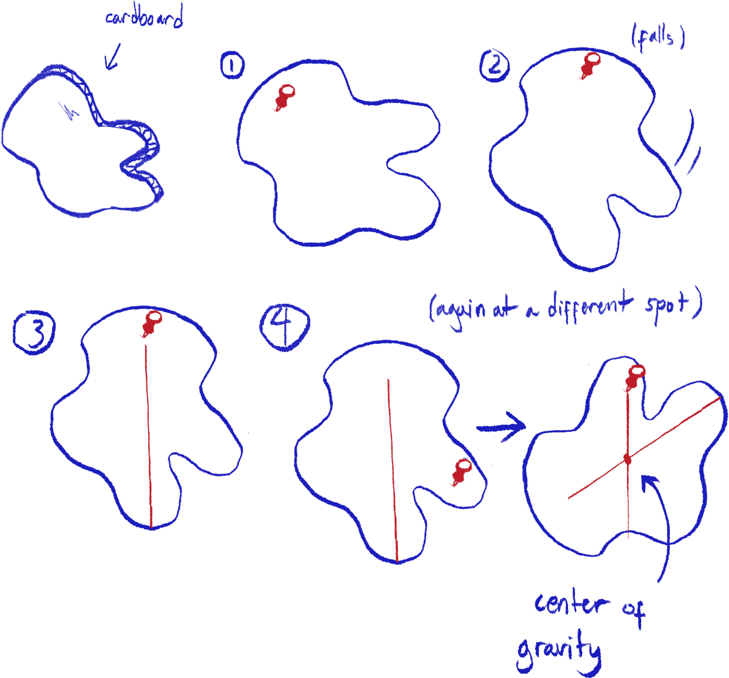 A plane lamina is an object considered as very flat and thin; two of its dimensions being much bigger in proportion to the third. Examples of lamina objects are a paper sheet, or cardboard.

The center of gravity of an object like this[14] can be determined by pinning the object on its flat side vertically, letting it hang naturally, then tracing a line from the pinpoint towards the ground, then doing the same thing, pinning the object on a different point.

The intersection between the two lines is the center of gravity of the object.

Two pivot problems

In order to solve problems like this, the main idea is to use one pivot as a reference to another pivot.

The problem is:

*Timmy, 20kg, is on a 40m bridge of 100kg. The bridge is held up by two ropes on the ends of the bridge. If Timmy is 5m across the bridge from the left, what are the forces exerted on the bridge by the left rope and right tope? (Assume everything is in equilibrium)*

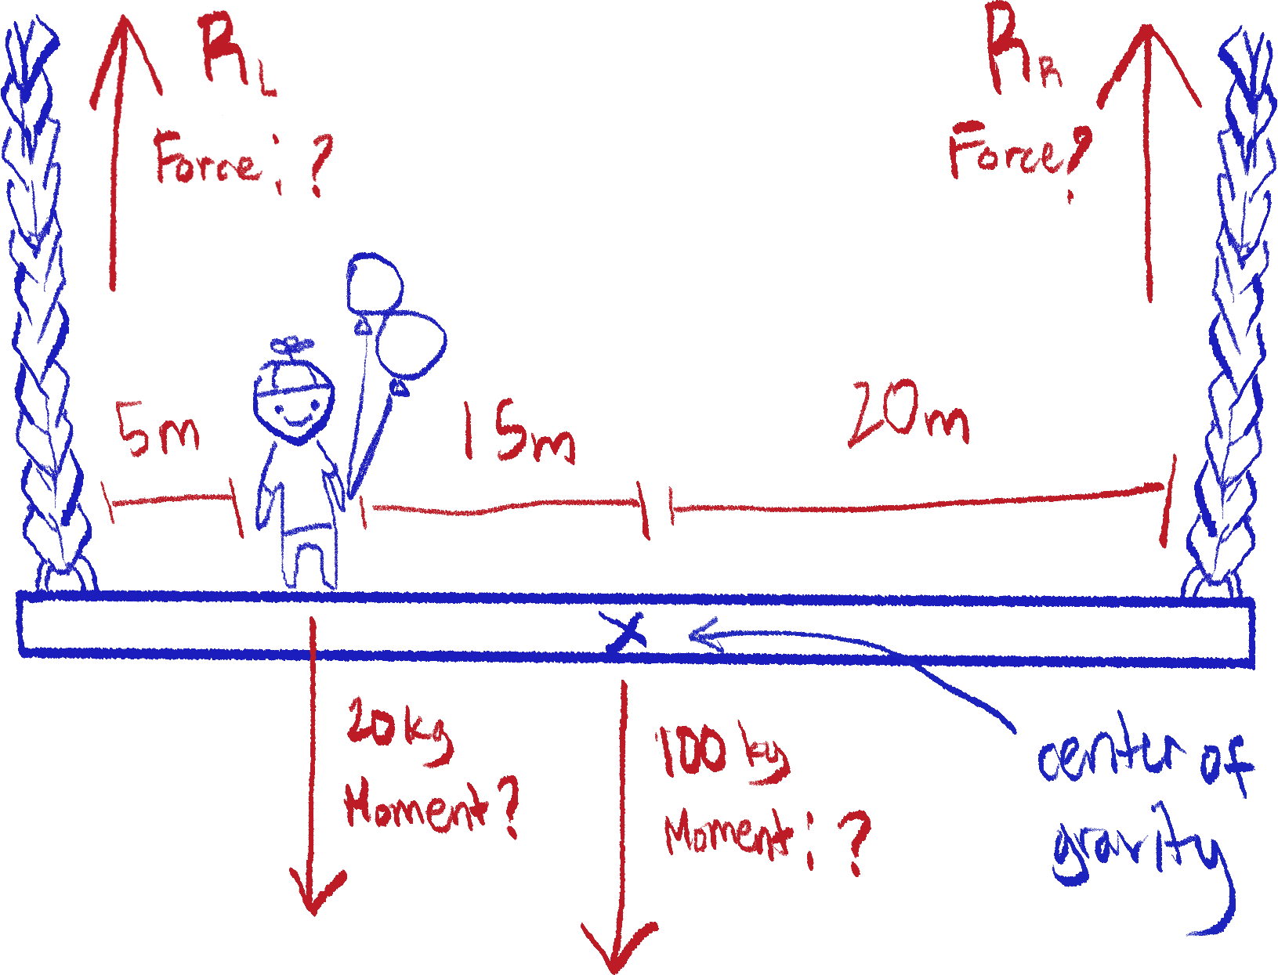If a diagram is not given, it is easier to draw the problem as a simple diagram to reference: Where the ropes attach to the bridge we can consider as pivots.

We can start by defining the moments around the left rope, the left pivot. Because the upwards force by the rope has no distance from the pivot, its moment can be considered zero for now.

The moments created by Timmy and the bridge’s center of gravity is clockwise, while the moment created by the force of the right rope is anticlockwise.

Because clockwise moments = anticlockwise moments for an object in equilibrium, we can define the moments around the left pivot as:

((20kg * 9.8N)[15] * 5m)[16] + ((100kg * 9.8N) * 20m)[17] = (RR * 40m)[18]

Look at footnotes for labels of each part of this equation.

Solve the calculations,

980Nm + 19600Nm = RR * 40m

20580Nm = RR * 40m

Then rearrange and solve to find force RR (force of right rope)

20580Nm ÷ 40m = RR

514.5N = RR

This gives us one of the answers. You can find the force of the left rope via the same method, this time using the right pivot as the point of reference.

However, we will use an easier way. Because the object is in equilibrium, all forces when summed will have no resultant force. We can see that there are two directions the forces go here; downwards (Timmy, bridge) and upwards (ropes).

So, we can say that the sum of downward forces is equal to the sum of upward forces. We can write this equation:

(20kg * 9.8N)[19] + (100kg * 9.8N)[20] = 514.5N[21] + RL

Labels for each part of the equation in the footnotes.

Here, the downward forces are on the left side and the upward forces are on the right side of the equation. Now, we can solve for the left rope’s force:

196N + 980N = 514.5N + RL

1176N = 514.5N + RL

1176N – 514.5N = RL

661.5N = RL

Thus, the answer to this problem is

Left rope force = 514.5N

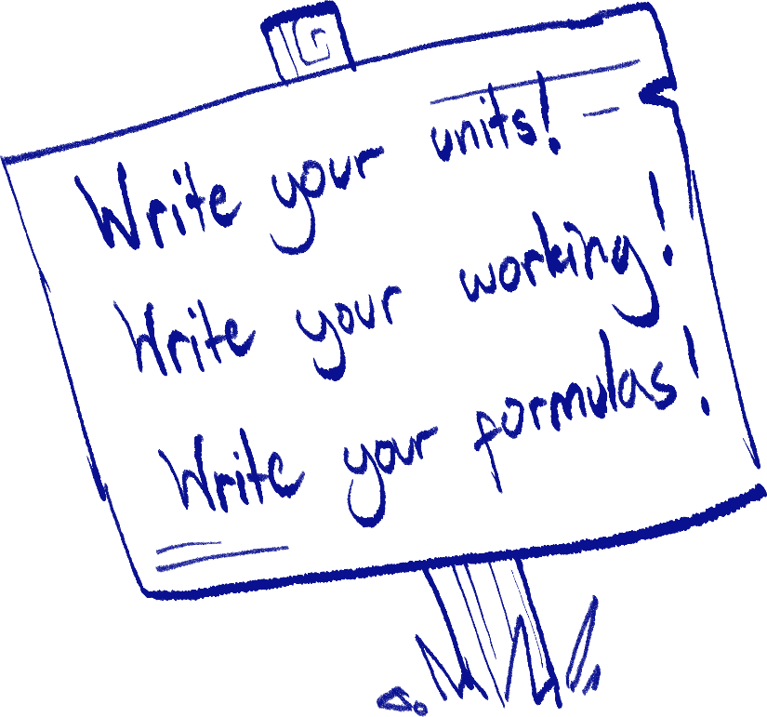Right rope force = 661.5N

Contact force

Just some clarification because it can be hard to explain some things without contact force.

Contact force has actually already been defined, in the form of Newton’s second law of motion. However, it’s definitely easier just calling it contact force rather than the second law.

So, if an object is in the ground, exerting its weight on the ground (or otherwise any other object) it will also experience contact force back.

Springs

Hooke’s law/law of proportionality

Hooke’s law states that the force being exerted on a spring is equal to its spring constant multiplied by the length of its extension[22]. Symbol formula being:

F = kx

k = spring constant

x = extension (compared to original length)

I will explain what each term means next section.

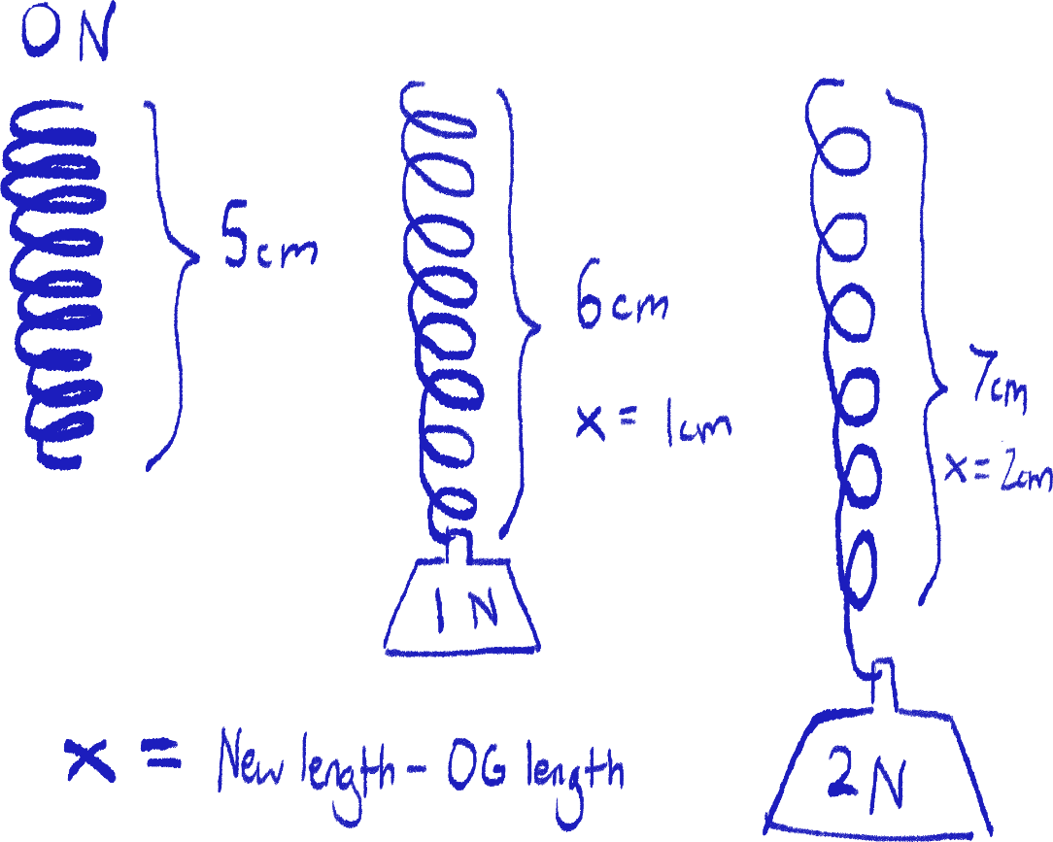Spring extension

Look at the diagram above.

The spring’s length without any weight added onto it (0N) is its initial/original length. This length is used as a point of reference to find the extension of the spring.

You can see that when 1N of weight is added onto the end of the spring, it becomes longer. The difference between this length and the initial length is the extension, defined with the symbol x.

Spring constant

Using the same diagram, we can find the spring constant of this spring. Rearranging Hooke’s law, k = F/x. Dividing 1N by 1cm, we get 1N/cm. This is the spring constant.

If you want a proper definition of what the spring constant is, using the N/cm unit, it is essentially how many Newtons are needed to extend the spring per cm. So, if the spring constant is 1N/cm, then 1 N is needed to extend the spring by 1cm.

Elastic and plastic deformation

Hooke’s law only applies to elastic deformation, which is spring deformation to the extent that it can still revert to its initial length without damage.

However, when a spring reaches its limit of proportionality at a certain weight according to its elasticity[23], it will stop following Hooke’s law and extend by plastic deformation. Usually, plastic deformation will need less force to extend more than elastic deformation, but the spring will not be able to return to its original length.

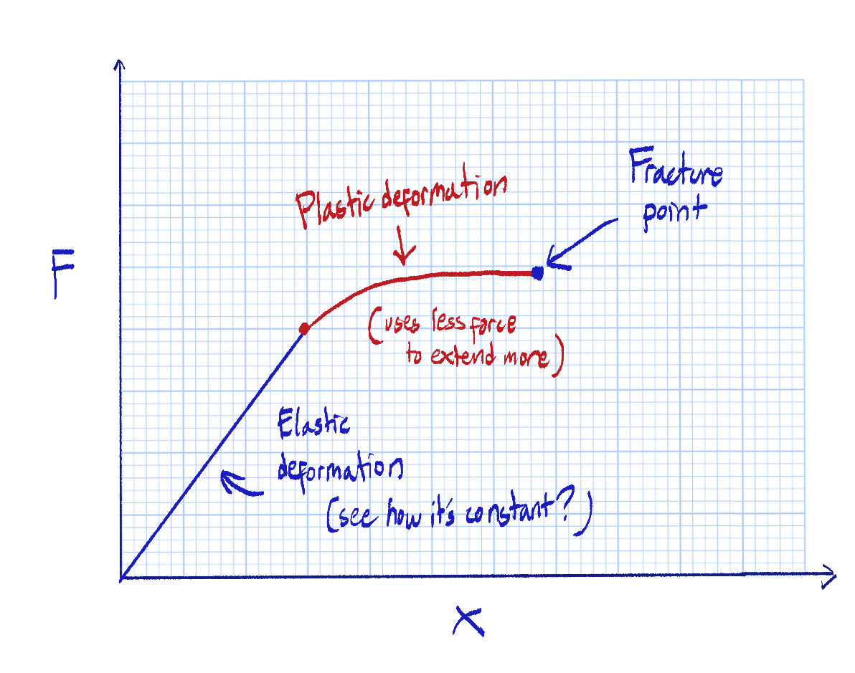

At a certain point, the spring will not be able to withstand the weight it is carrying and snap. This is called the fracture point.

Graphs

This isn’t the most important section in the world, but it is something I noticed that could be a problem (that means I got it wrong myself :-|).

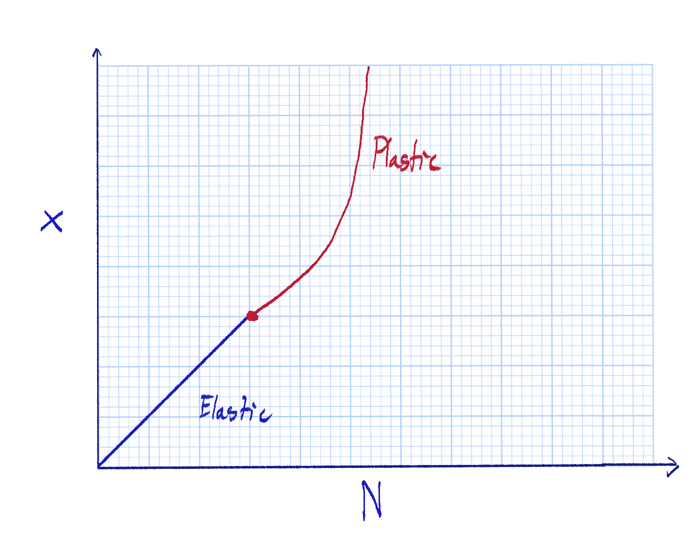 Always remember to pay attention to the values on the x and y axes of the graph you’re looking at.

You can see here that the way the graph is drawn is far different from the last one. This time, the force is on the x axis and the extension is on the y axis. So, the plastic region will be steeper rather than flatter, contrary to the force against extension graph.

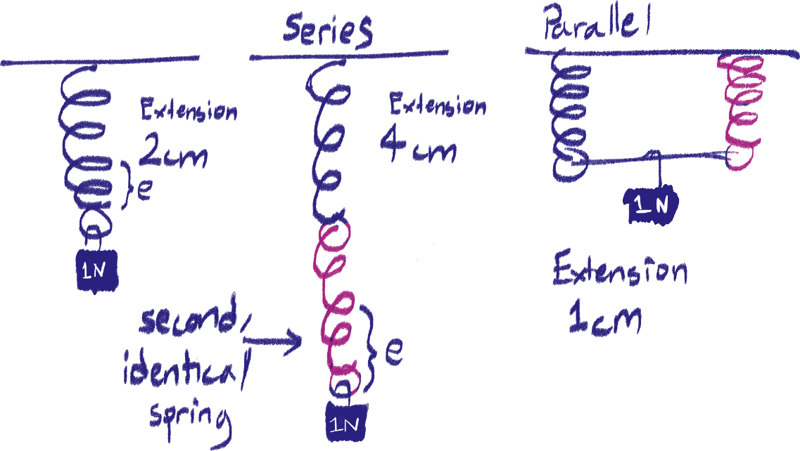Springs in series and in parallel

Look at the diagram to see what is meant by connecting springs in parallel and in series.

When two identical strings are connected in series, the overall spring constant will decrease by half its original value – that means the extension with the same load increases.

It’s the opposite for parallel – think of it as if the two springs are distributing the weight between them. The overall spring constant will double and thus the extension with the same load will decrease.

That’s really all you need to know, but here is a better explanation for springs in series:

In series, all the springs connected together (this applies for more than two strings together) are all experiencing the same load – in the case of the diagram, both springs are experiencing 1 N individually, and thus both extend 2cm as they would like in the first diagram. This results in the total extension of 4cm.

Pressure

Pressure, in words, can be defined as the amount of force being applied by an object over a unit of area.

Calculating pressure

There are two formulae for pressure depending on whether you’re calculating the pressure of a solid or fluid.

For solids:

P = F÷ A

P: pressure

F: force

A: area

For liquids:

P = ρgh

ρ: density

g: force of gravitational field (on Earth, 9.8N)

h: height/depth

The unit for pressure is N/m2 (as well as it’s iterations, like kN/km2 etc.) or Pascals (Pa). 1 Pa is equal to 1N/m2, so if you don’t feel like converting the units, you can keep it without using Pascals.

As for the pressure of gases, it can be measured in millimeters mercury as well as Pascals, but none of these formulas can really be applied to gases.

Explanation for liquid pressure

If you’ve noticed, according to the formula for liquid pressure, the more depth there is, the higher the pressure. This is because the weight of the particles above of the point you’re calculating is also accounted for. The diagram below shows the difference in pressure at different depths.

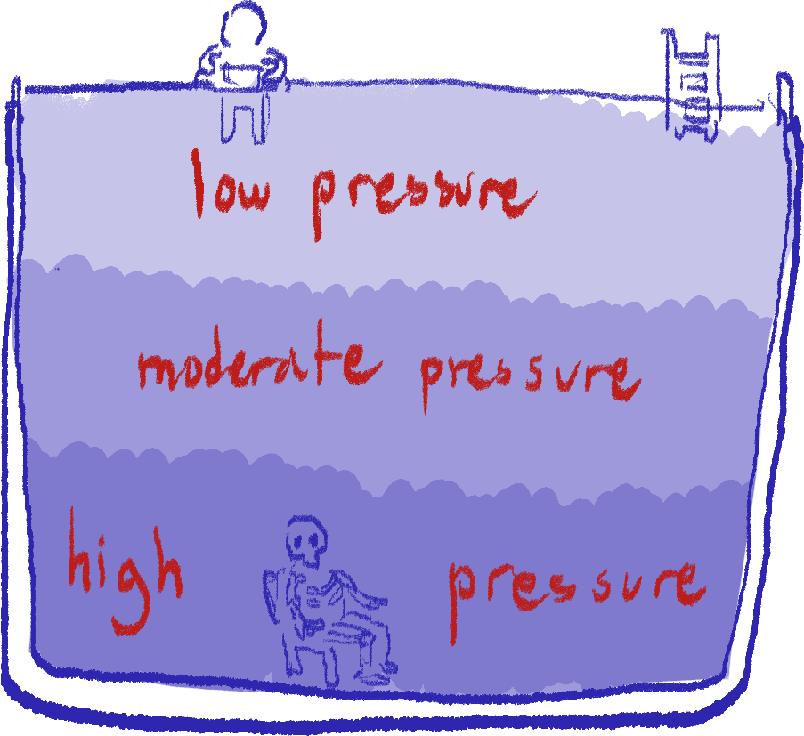

Upthrust

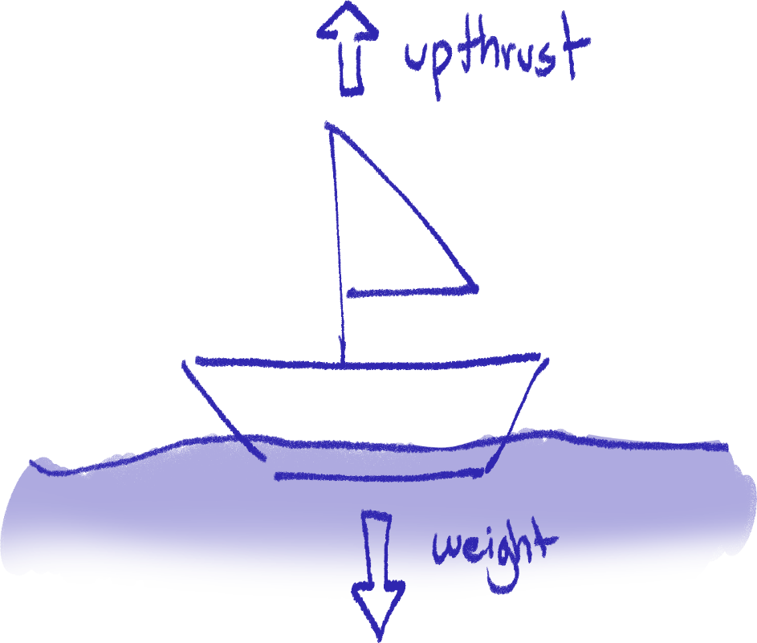

It’s like contact force but for liquids. Newton’s third law. That’s it.

Barometer

A barometer is an instrument used to measure atmospheric pressure, A.K.A. air pressure. The example we’ll use here is a very simplified version of a barometer.

If we were to prepare a barometer, we would need to fill a test tube with mercury, flip it and immediately place it upside-down in a mercury-filled container/tub.

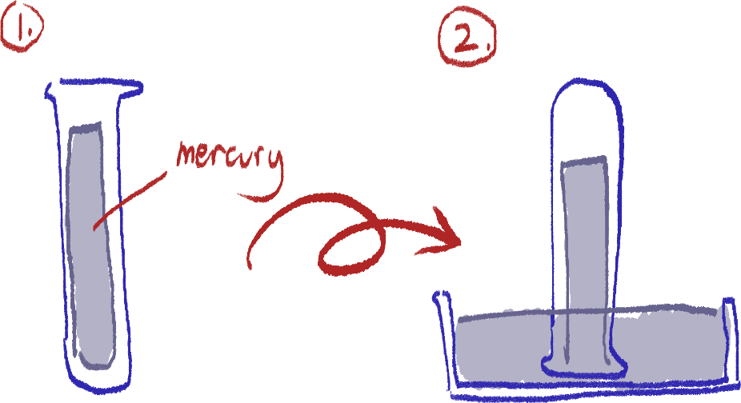

Once you do this, you’ll notice that the mercury level in the tube will always rise up/lower down to 76cm. This is due to the air particles exerting pressure on the mercury outside the tube, pushing mercury up, or letting some mercury flow out the tube, according to the air pressure.

Manometer

Gas pressure

Effect of temperature

At a constant volume, when temperature increases, gas pressure exerted on its container increases. As the gas particles gain more kinetic energy, they collide with container walls more frequently and stronger, exerting more force over the area of the walls, which means more pressure.

Effect of volume

At a constant temperature, when the volume of a gas’ container decreases, the pressure exerted on the container increases. This is because particles will get closer to each other with less space between them, colliding with the walls more frequently. So, they exert more force over the area of the walls as the collide, increasing pressure.

In a formula

These relationships can be defined in this formula:

T/ V ∝ P

Where:

T = temperature

V = volume

P = pressure

Note that this shows that T/V is directly proportional to pressure, not pressure itself. However, we can use a constant:

T/ V = k

So our formula is rewritten as:

kT/ V = P

Boyle’s Law

Boyle’s Law states that as long as temperature and mass of a gas is constant, this formula applies for any gas that changes in pressure:

P1V1  = P2V2

Where:

P1 = first pressure

V1 = first volume

P2 = second pressure

V2 = second volume

Length Measuring Tools I Forgot to Include

Micrometer

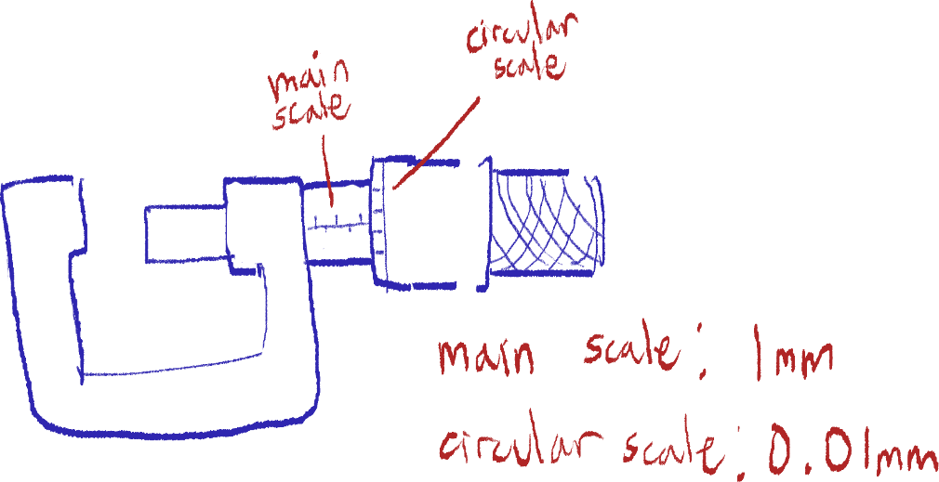 This instrument is used to measure very short lengths, such as the thickness of paper or the cross-section of a wire.

Here you can see a labeled diagram of a micrometer and the scales of each part. The object measured is placed in between the rod and the end of the U-shaped part. Keep in mind that this instrument measures in mm (millimeters) and not actual micrometers.

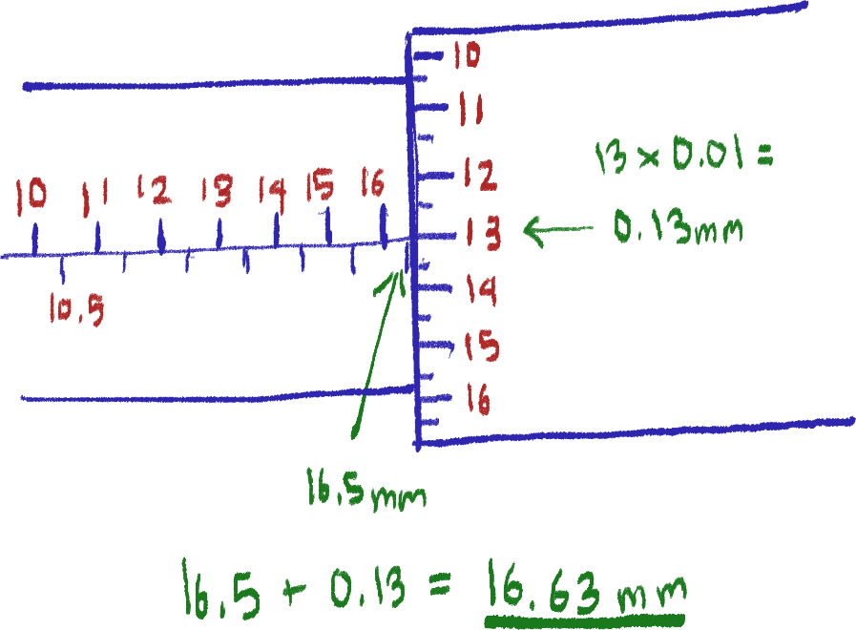 The next diagram here shows how one measures from the scales. The main scale is divided by 1mm with subdivisions of 0.5mm. The circular scale has divisions of 0.01 mm with subdivisions of 0.005mm.

The main scale is read on the edge of the circular scale, and the circular scale is read where the main scale’s line meets.

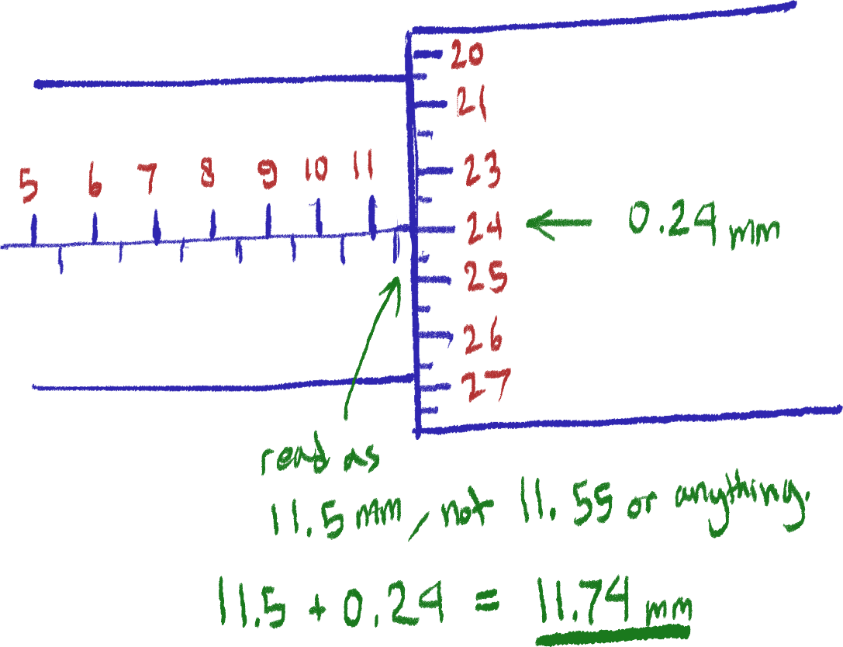 There may be instances where the main scale reading is between divisions or is very close to the next division but it does not reach that division’s line. In any case, only take the reading as the last visible division[24]. This is shown in the following diagram.

The reason for this is that the circular scale’s reading makes up for that extra length.

Vernier calliper

Ahhhhh

Energy

Energy

Energy can be stored and can be transferred. For example, a battery’s chemical energy store can be converted to electrical energy in a torch, which is then converted into light and thermal energy. Energy is measured in J (Joules).

One main idea is the law of conservation of energy – it states that energy cannot be destroyed or created, only transferred.

There are different types of energy, these are only a few:

1. Kinetic energy

The energy of moving objects.

1. Gravitational potential energy

Energy gained by an object above ground height. The higher the object, the more gravitational energy. When falling, the object’s gravitational potential energy is converted to kinetic energy.

1. Elastic potential energy

The energy stored by a stretched spring or elastic band.

1. Thermal energy
2. Light energy
3. Radiant energy
4. Internal energy

All energy stored in a body.

1. Chemical energy

Energy stored in the chemical bonds of an object.

1. Electrical energy

Energy of the movement of electrons.

1. Nuclear energy

Energy from the nucleus of an atom.

1. Sound energy

Energy from sound waves caused by particles moving in the air.

1. Mechanical energy

The sum of kinetic and potential gravitational energy in an object.

Formula for kinetic energy:

KE = ½ mv2

Formula for gravitational potential energy:

GPE = mgh

Where:

KE: Kinetic energy (J)

GPE: Gravitational potential energy (J)

m: mass (kg)

v: velocity (m/s)

g: gravity (usually 9.8)

h: height above ground (m)

Energy stores, changes and transfers

An energy store is essentially any object holding that energy. For example, a running guy is a kinetic energy store.

When referring to an energy change, it is talking about the decrease or increase in energy.

Energy transfers are ways energy moves from one object to another. It includes forces (mechanical), electrical currents, heating, and through waves.

Power

Power is essentially the amount of energy being transferred per unit of time. The standard unit for this is W (watts, J/s).

P = E/t

Where:

P: power (W)

E: energy (J)

t: time (s)

Work done

Work done is the amount of energy being transferred to an object by a force which results in it moving. This only applies to mechanical energy, as aforementioned in force energy transfers.

Work is only done if the object moves and if the movement is in the same direction of the force.

The formula is:

W = Fd

Where:

W: work done (J)

F: force (N)

d: distance moved (m)

Energy resources

Terms

* Renewability

Renewable energy sources can be replenished as quickly as it is being used. Non-renewable energy takes longer to replenish than the rate at which it is used up, meaning it can run out.

* Availability

A resource is more available when it there is a large supply of it that is easily obtained.

* Reliability

If a resource can consistently generate energy, it is more reliable.

Heating the water

A lot of energy sources generate electricity by first producing heat that can then be used to boil water in a boiler, turning it into steam. This steam turns turbines that run generators producing electricity.

Fossil fuels and biofuels

Fossil fuels are non-renewable as they are made up of the remnants of dead animals that take many, many years to form. However, they are very inexpensive and easily available.

On the other hand, biofuel is a renewable fuel as it is made from plants like palm trees that can be grown.

Both of these fuels store chemical energy which can later be turned into electrical energy by being burned. Both are reliable sources, but they produce greenhouse gases (contributing to global warming) and pollute the air as they must be burned.

Tidal barrages

Generating electricity from tidal power involves building a dam connected to the ocean that allows water from the ocean during the high tide – when water level is highest – into it, then closes its gates. When the sea moves into low tide, there is a large difference in GPE between the low water in the sea and the high water in the dam.

During the lowest points of the low tide, a turbine in the dam is opened, letting the water in the dam flow through it back into the sea. The turning of the turbine thus turns the GPE of the water into electrical energy. This type of dam is called a tidal barrage.

The turbine may also be opened during the high tide, so it is turned when water from the sea flows into the emptier dam.

This source is renewable and available, but is quite expensive (since it needs large dams to be built) and is not completely reliable as the tides may vary. They don’t produce any emissions, which is good for the environment.

Hydroelectric dams

Hydroelectric dams are essentially the same as tidal barrages, but they are built in the middle of a river. It accumulates water flowing from upstream. This builds a difference of GPE between the water behind the dam and water outside the dam. It releases the water through a turbine like tidal barrages to generate electricity from GPE.

Like tidal barrages, these are renewable, but are expensive and not reliable. They do not produce any emissions.

Wave power

Wave power generation involves putting buoys in the ocean, and using the wave’s oscillatory motion to generate electricity as the buoys move from these waves. So, this turns kinetic energy into electrical energy.

These are also renewable but not reliable, and do not produce any emissions.

Geothermal power

Geothermal energy uses the heat from the Earth’s core to heat water and generate electricity. This source is renewable as there isn’t any material being used up and is quite reliable. However, building a station can be expensive. There is little environmental impact as no emissions are produced, although rock must be dug through to get closer to the core.

Nuclear power

Nuclear power involves putting uranium under nuclear fission to produce large amounts of heat that is used to boil water and generate electricity. This is non-renewable as the fuel, uranium, is not replenishable. However, only very small amounts of it are needed to produce large amounts of energy. This process is reliable, and does not produce any harmful emissions. However, building a station can be expensive, and radiation leaks can be dangerous.

Solar cells

Solar cells turn the light energy from the Sun into electrical energy. This is renewable, but can be costly and is unreliable, as this depends on how much Sun there is. It is environmentally sustainable as it doesn’t produce any emissions.

Solar panels

Solar panels (not to be confused with solar cells) direct light and infrared onto a water tank by reflection. So, this water is heated to generate electricity. Renewable, no emissions, but is unreliable and expensive.

The Sun

Nearly all of our energy sources can be traced back to radiation from the Sun as the ultimate energy source. Chemical energy in our food and fuel starts from plants photosynthesizing, wind comes from convection currents from the uneven heating of the Earths surface, and wind causes waves, and so on.

There are only three energy sources we should know of that don’t ultimately come from the Sun:

* Tidal power, as this comes from the gravitational pull of the Moon
* Nuclear power, as this comes from nuclear fission
* and geothermal power, as this comes from the Earth’s core

Efficiency

The formula for percentage efficiency is:

(Useful energy/total energy) x 100

Total energy is the amount of energy supplied to the appliance or generator, while useful energy is the energy output that is useful. For example, the total energy of a lamp is the electrical energy supplied to it, while its useful energy is the light energy it produces. Other forms of energy may be output by this lamp, such as thermal energy, but this is not considered useful energy.

So, efficiency tells us the amount of input energy that has successfully been converted into useful energy.

Thermal Physics

There are three ways to transfer thermal energy:

Conduction

Conduction happens when a substance is heated, and the particles of the substance being directly heated will thus gain kinetic energy and vibrate more. These particles will transfer kinetic energy to the particles around them as they bump into each other, subsequently transferring thermal energy through the substance, continuing until the entire substance is heated.

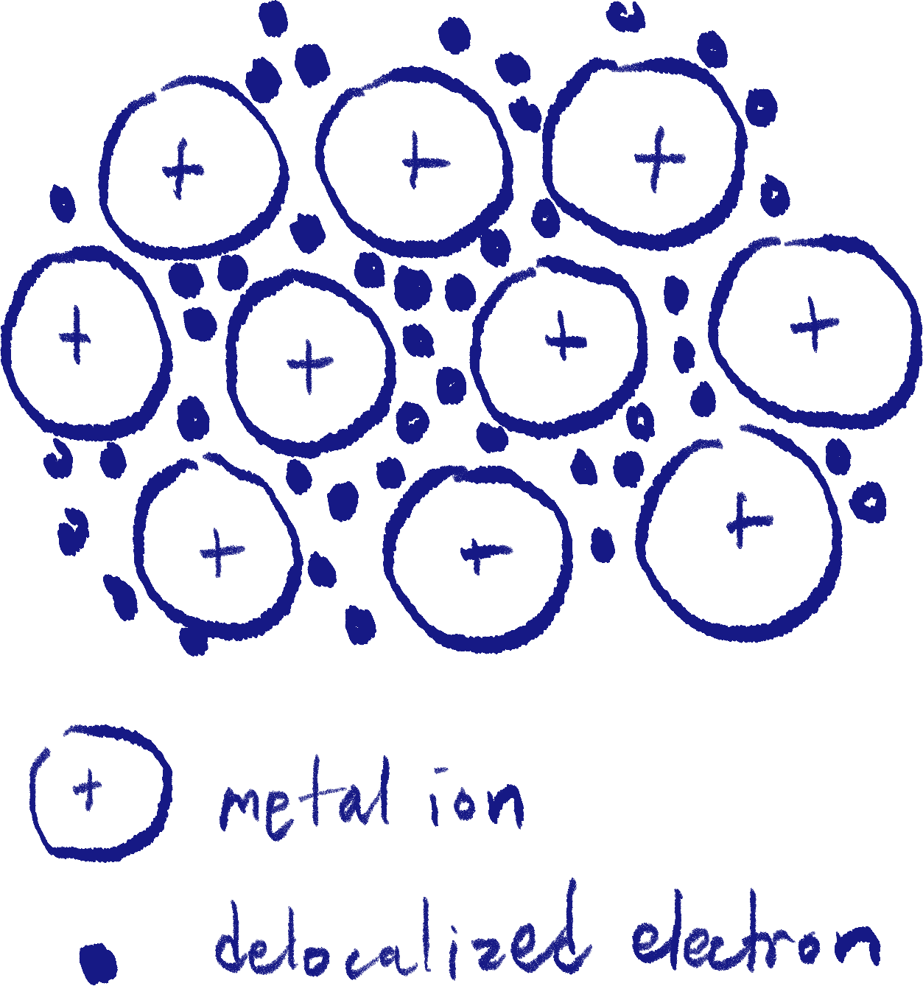

Conduction occurs best in metals as their free electrons can move throughout the entire substance freely, thus bumping into each other faster and transferring thermal energy faster. Any substance that is good at conducting is called a conductor. Materials like wood and rubber are not good at conducting heat, and are thus called insulators.

Although conduction can technically happen in all states of matter, liquids and gases are not primarily said to conduct heat as their particles are much farther apart from each other relative to solids that are densely packed. The most you can call fluids are poor conductors.

Convection

The transfer of thermal energy by the movement of fluid particles (gas or liquid). This works as the more thermal energy a fluid has, the more it will expand and become less dense. So, the hotter parts of a fluid, expanding, will float to the top of the substance while colder parts sink, condensing.

Radiation

Specifically infrared radiation. Radiation is a type of electromagnetic wave which means it does not need any physical medium or particles to travel – it can work in a vacuum. An example is heat from the Sun.

Reflectors and absorbers of radiation

We’ll probably cover this in more detail in the chapter about electromagnetism, but work with this for now.

Surfaces that are bright colored, brightest being white, and glossy/reflective are most efficient at reflecting and emitting[25] radiation.

Surfaces that are dark, darkest being black, and dull/matte are the opposite. They are very good absorbers and poor emitters of radiation, like an insulator for radiation.

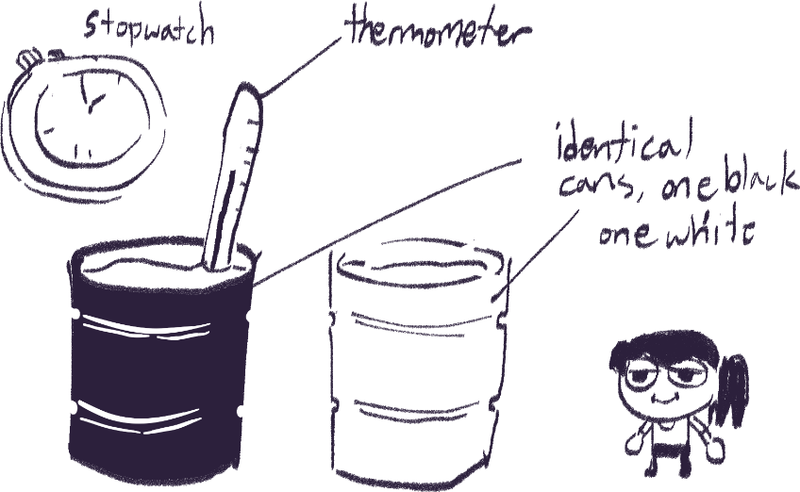Testing surfaces

A common experiment you’ll see will be an experiment where two identical cans are filled with hot water, with only their surfaces – one being black and the other white – being different. A thermometer can be used to measure changes in temperature after the cans have been left out for a while.

Depending on the situation, you may be asked to describe how to conduct this experiment to see which surface is a better emitter, or a better absorber.

And always remember to keep everything controlled; the amount of water in each can, the initial water temperature, the time taken for any reading, and the conditions the cans are left out in.

Thermal capacity and specific thermal capacity

The thermal capacity of an object is how much energy that must be transferred to it to increase its temperature by 1o Celsius.

For example, for two blocks of the same material but different sizes, the bigger block will have a greater thermal capacity – it needs more energy to increase its average temperature than the smaller block.

The formula for the thermal capacity of an object is:

Q = $\frac{E}{ΔT}$

Where

Q : Thermal capacity (J/oC)

E : Energy transferred to object (J)

ΔT : Change in temperature (oC)

Specific thermal capacity

Specific thermal capacity is the thermal capacity of 1kg of a certain material, or how many joules that must be transferred to a material to increase 1kg of it by 1o Celsius.

The formula is:

c = $\frac{E}{ΔTm}$

Where

c : Specific thermal capacity (J/kgoC)

m : Mass (kg)

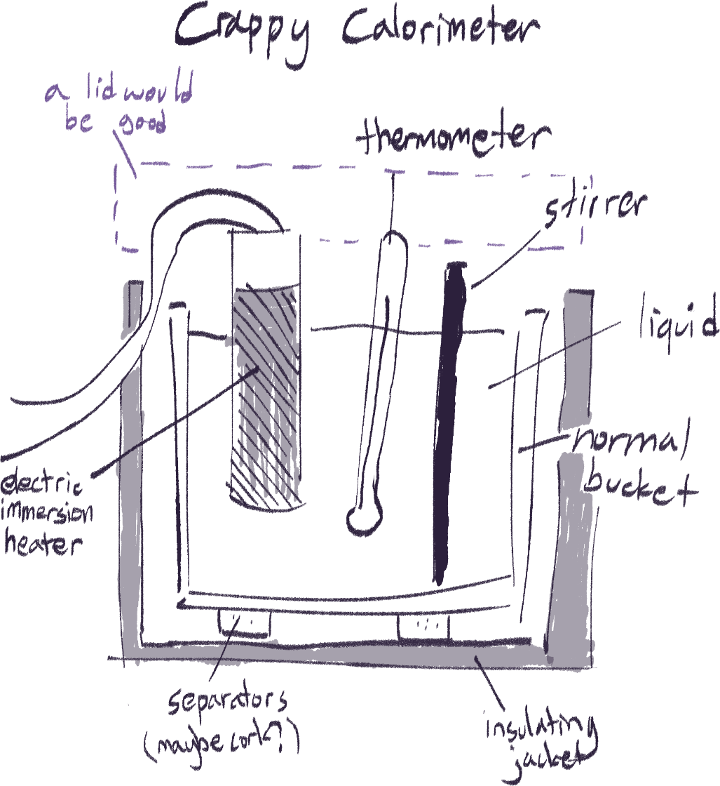Measuring thermal capacity[26]

This is a setup for measuring the thermal capacity (or specific thermal capacity of a liquid. The heater’s power should be known in order to deduce the energy transferred from the heater to the liquid. The stirrer is just to make sure the liquid’s heat is spread uniformly.

The mass of the liquid should be measured beforehand, and the time taken to heat up the liquid should also be recorded to calculate the energy from the heater using its power. Initial and final temperature must also be recorded. With the energy, mass, and change in temperature, the specific heat capacity of the liquid can be calculated.

A similar setup is also possible for solids; just drill holes into it for the heater and thermometer.

Converting between Celsius and Kelvin

You need to know this, because they might just ask you straight up “convert 130o C to Kelvin”.

Use this:

273o K = 0o C

Kelvin and Celsius actually work on the same scale, unlike Fahrenheit. They always have a 273 degree difference between each other, Kelvin being higher than Celsius. So, 130o C = 130o + 273o K = 403o K.

The way I remember which one is higher is from a fun science fact: 0o Kelvin is the lowest possible temperature, while 0o Celsius is achievable in our freezer.

Properties of Waves

Longitudinal and transverse waves

There are two types of waves in terms of the way they travel; longitudinal and transverse.

Longitudinal

 Longitudinal waves are waves that have its particles move parallel to the direction the wave is travelling in. For example, sound waves are longitudinal.

Transverse

Transverse waves have its particles move perpendicular to the direction the wave is travelling in. For example, all electromagnetic waves (light, infrared, ultraviolet…) are transverse.

If you’ve noticed, these are similar to the descriptions of P-waves and S-waves of earthquakes from geography.

Main terms and features of waves

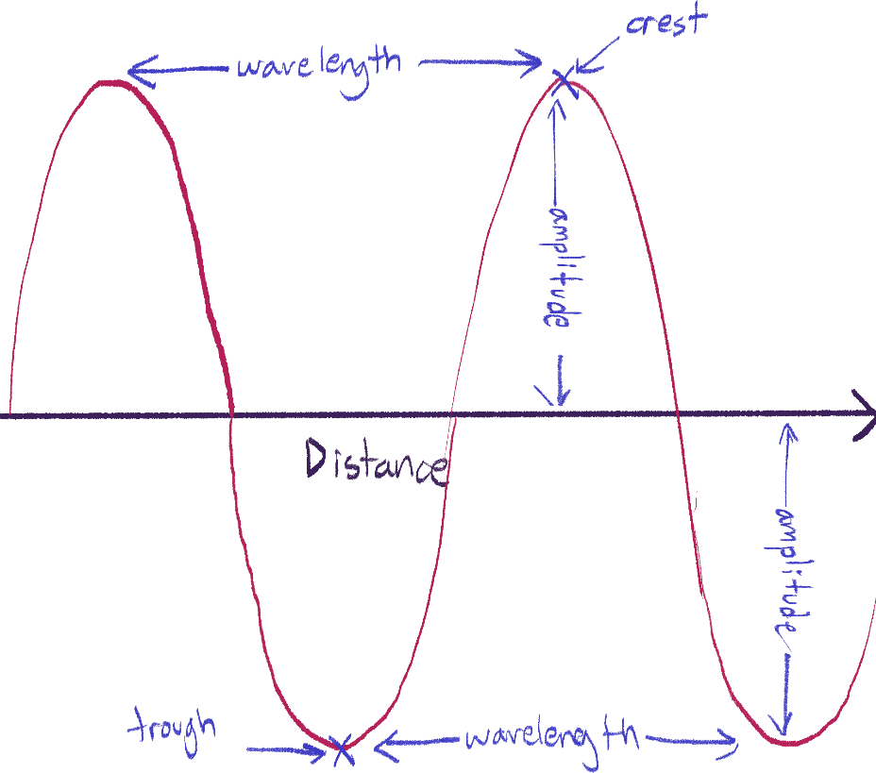Distance

The crest and trough is the furthest point the particles of the wave are from its original position in a single wave. The crest is always the opposite direction or the trough, in any wave.

The amplitude is how far the particles are displaced from its original position in the wave, and thus is the distance from 0 to a crest or a trough.

The wavelength is in the name. It is how long a single wave is. This can be measured between two crests or two troughs.

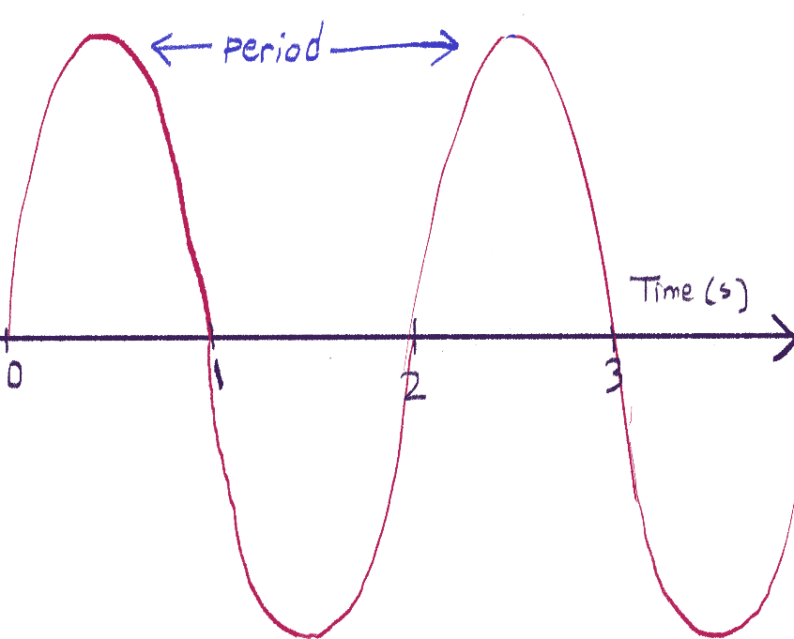Time

The amount of time taken for one wave to complete is called a period. For this waveform, it is seen that one wave takes 2 seconds to complete, so its period is 2s.

The frequency of a wave is how many waves it has in one second, unit being Hertz (Hz). For this waveform, it is seen that one of its waves completes in 2 seconds, so its frequency is:

1 wave / 2s = 0.5Hz

Frequency can also be calculated using the formula 1/period.

Notice that the two graphs are different – one is displacement against distance and the other is displacement against time. When reading questions with wave graphs like this, pay attention to that part.

Calculating the speed of a wave

The formula is:

s = f**λ**

Where

s : speed (m/s)

f : frequency (Hz)

λ : wavelength (m)

Ripple tank

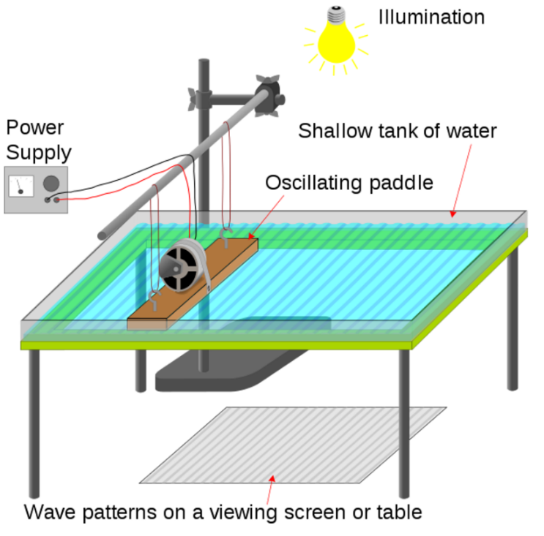 A ripple tank is a thing used to test and show the properties of waves. The board is mechanically moved up and down at a constant rate to create ripples in the water. The ripples create shadows under the transparent tank that can be observed and analyzed.

Don't feel like drawing it right now

The diagrams

The following wave diagrams are going to be representing lines as wavefronts of water ripples (the crests).

The gap between wavefronts is the wavelength of the waves, because, you know, crest-to-crest is how you measure wavelength.

Diffraction

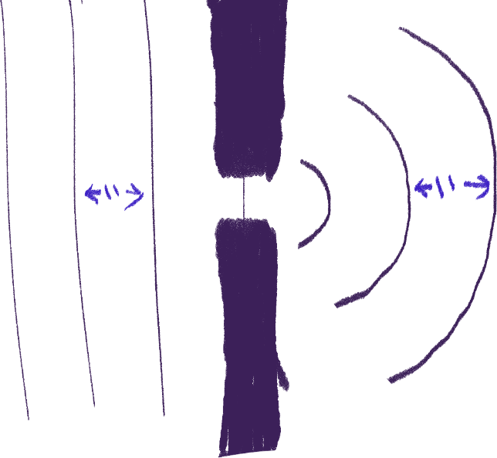 Diffraction is defined as the spreading of waves around obstacles. We’ll really only be covering diffraction through gaps, though.

This example has the gap smaller than the wavelength of the waves going through it. When this happens, the waves curve like this. This also happens if the gap is equal to the wavelength, but the smaller the gap, the more extreme the diffraction is.

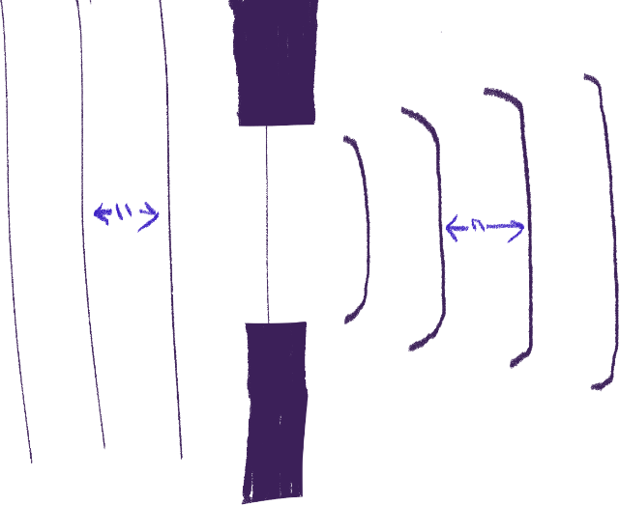 The next example has the gap larger than the wavelength of the waves, so they only diffract a little bit and mostly stay straight, with their ends slightly curved. If the gap is really big, it’s possible to have hardly any diffraction.

A very important part of drawing these diagrams is that the wavelength before and after diffracting in all scenarios is always going to stay the same, because the speed of a wave does not change in diffraction.

So, when drawing diffracting waves, you will need to use a ruler to make sure the gap between the new wavefronts is equal to what it was before diffracting.

Refraction

How it works

Refraction is defined as the change in direction of a wave when it passes from one medium to another due to a change in speed.

The speed of waves depend on the density of the medium it is travelling in. In higher densities, waves travel slower, and they travel faster in lower densities. Think of it like the waves need to push though more particles in higher densities.

The direction waves travel is altered when the speed changes, which is what refraction is.

If you remember, the formula for the speed of waves is s = f λ. The frequency does not change when changing mediums, so if speed decreases, then the wavelength will also have to decrease.

Drawing a diagram

When waves go to a denser medium and refract, its angle to the normal of the barrier it passes through decreases. What does that mean?

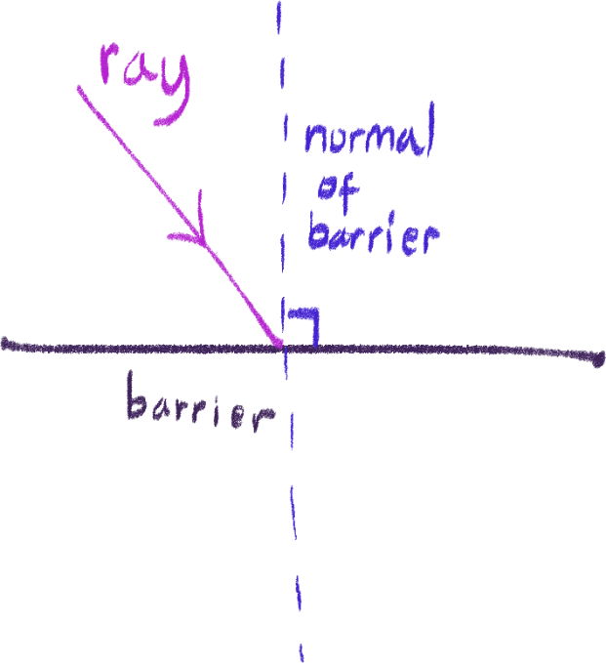 First of all, this is what the normal is. The normal is just an imaginary line that is perpendicular to the barrier that also touches the line you are looking to compare.

This is necessary because we need to measure the angle using a protractor between the normal and the ray to properly refract it.

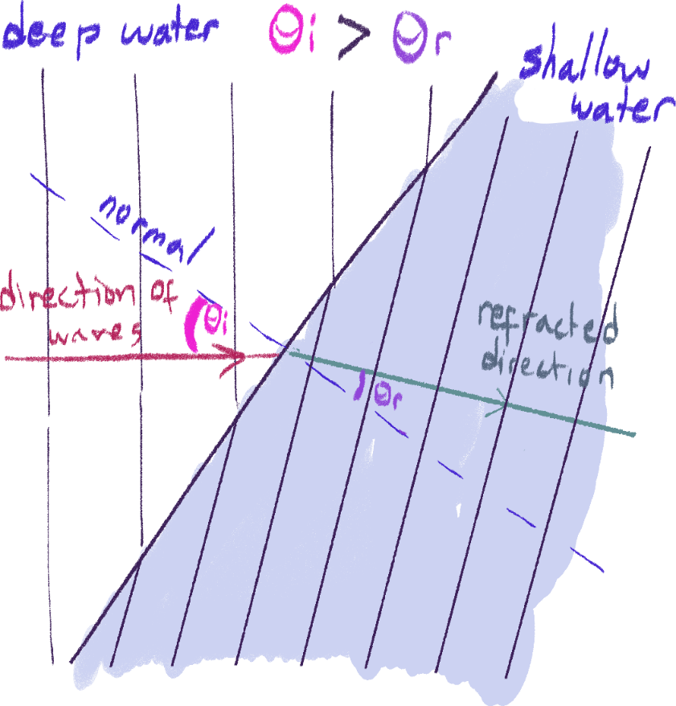 As you can see here, the angle of the wavefronts have changed. In this example, moving from the right, the waves move from a less dense medium to a denser medium. In this case, the waves’ direction will be at an angle closer to the normal than before, which is why you can see the angle becomes smaller.

When working with diagrams like these, make sure to use the line of movement of the waves rather than the lines of the wavefronts themselves to draw the refraction happening, and then draw the wavefronts perpendicular to the line afterwards.

And as stated earlier – the wavelength has decreased after refraction since it is going into a denser medium. Make sure that this is followed when drawing diagrams as well.

You may also be asked to do the opposite and draw the refraction of waves going into a less dense medium; where you must refract the waves further from the normal, with a greater wavelength, since the speed increases.

Deep and shallow water

This is to clarify some things, since in the diagram earlier, it was shown that the two mediums were deep water and shallow water. You just need to remember that water waves travel faster in deeper water than shallow water, and assume as if shallow water is denser.

If you’re curious about this, look at [this](https://gcsephysicsninja.com/lessons/waves/water-waves-shallow-deep/). Crazy right.

Reflection

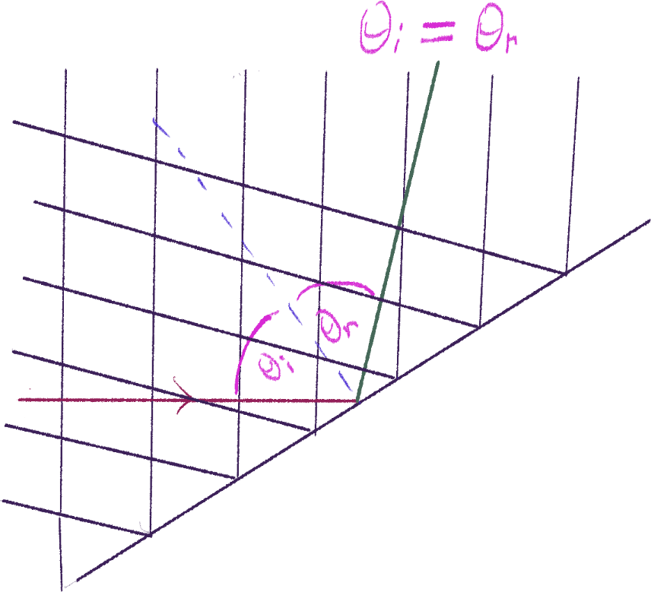 The key phrase for reflection is: incident angle = reflected angle. When waves hit a barrier, they will generate new waves traveling in an angle opposite but equal to the angle of incidence. Again, we will be using the normal of the reflecting barrier to measure this angle. It should look something like this with ripple waves:

Sorry

It’s easier than refraction and the method is similar, all you need to do is to use the same angle on the other side of the normal.

Sound

Now that we understand waves, how they work and their terms, it will be easier to work on sound and light.

Properties

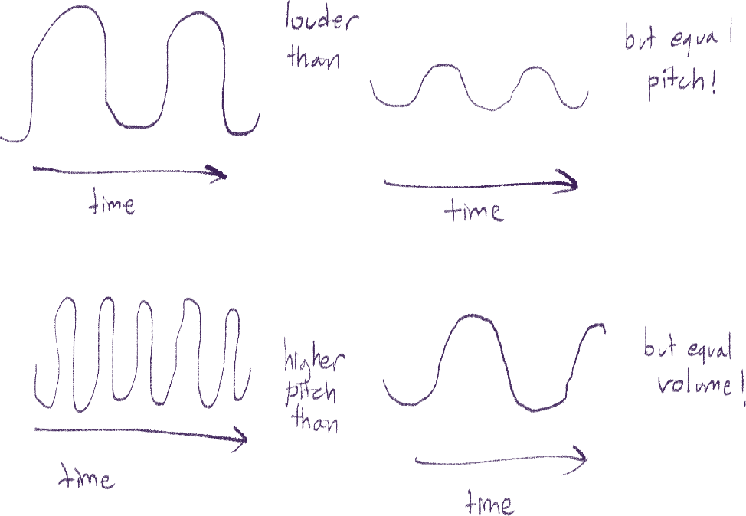 Sound is a longitudinal wave that uses particles as its medium, having particles vibrate back and forth in parallel to the direction it is travelling in. Because of that, it cannot travel in a vacuum.

The larger the amplitude of a sound wave, the louder it is, and the higher the frequency of the sound, the higher its pitch is, and vice versa.

The speed of sound

|  |  |
| --- | --- |
| Medium | Average speed of sound in it |
| Gas | 350m/s |
| Liquid | 1500m/s |
| Solid | 5000m/s |

Remember these values, sometimes they’ll ask you for it.

As you can see, sound travels slowest in gases and fastest in solids. The reason for this is not density – as stated earlier, waves travel slower in higher densities. Instead, this is due to the higher rigidity of solids and lower rigidity of gases. You can watch [this video](https://youtu.be/yF4cvbAYjwI) for an explanation.

A common demonstration of this used in IGCSE questions is this:

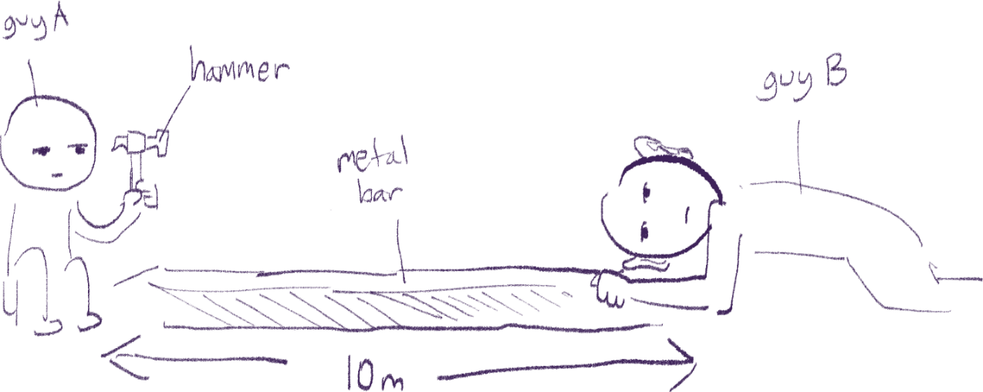

Guy A will use hit the metal bar, and the sound will be heard by guy B twice; first from the metal bar, and second from the air. The sound should be heard from the bar first since sound travels faster in solids than air.

Since the speed of sound also depends on the density of its medium, things like the temperature of the air sound is travelling through also affect the speed – since hotter air is less dense, sound will travel through it faster than cold air.

Echoes

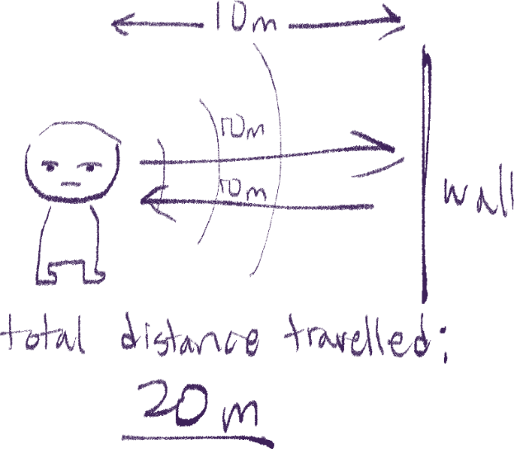 You hear echoes in a large auditorium rather than in a small class because although sound does reflect off the classroom’s walls, you hear all of it at about the same time. The larger distance between the sound source and the walls of an auditorium allow us to hear an echo – you hear it once directly from the sound source, and again as a reflection from the wall.

This delay is often used in questions to ask for the speed of the sound – be careful, because you must remember that within the time taken for the sound to return to its starting point, it has gone the distance to the wall twice; to the wall, and back to you.

Human hearing

The frequency range for human hearing is 20Hz to 20kHz; humans cannot hear frequencies any higher or lower than that. You will have to remember this range since IGCSE also asks questions about it.

Ultrasound and its uses

Sounds with frequencies above 20kHz (and thus cannot be heard by the human ear) are called ultrasound. There have been many uses for it:

* Sonar – ships send ultrasound waves under them to measure the depth of the water under them.
* Material testing – to check for and find cracks and flaws in materials
* Ultrasound imaging in medicine – to see and analyze things within the body like the heart or a fetus.

Light

Properties of light

Light is a type of electromagnetic wave, and thus it is transverse. These waves are usually drawn and perceived as rays, to work with them easier. All electromagnetic waves do not need matter to travel through, either.

Since light is a type of wave, its properties follow the general properties of waves discussed earlier. Well, except for speed in different mediums. Yep, that’s right – light travels fastest in a vacuum, and travels slower in denser mediums. Sorry, it just works like that. Apparently it’s because light doesn’t need any particles to travel, and having particles they need to interact with just makes things slower.

Reflecting light

This is actually just like reflection in ‘Properties of Waves’, but without drawing the wavefronts. Because rays represent the entire line of waves, all you need to do is draw the line and an arrow for its direction.

The key phrase for reflection is:

Angle of incidence = angle of reflection

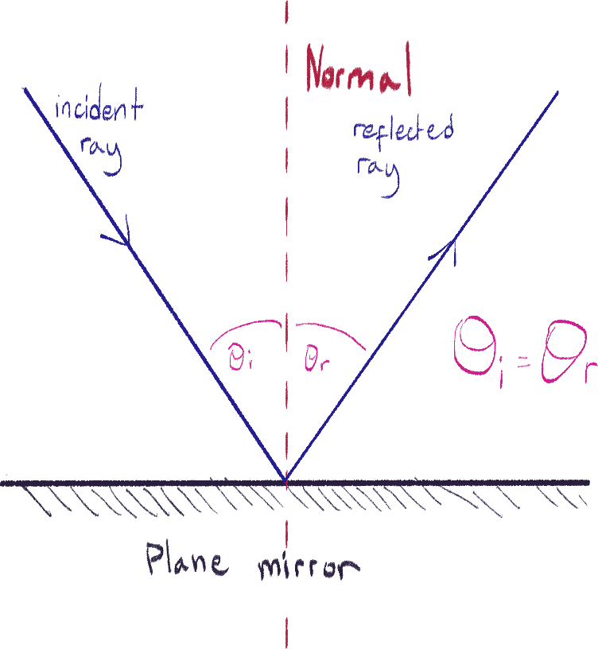 Light rays reflect off plane mirrors. Look at the diagram to see how they look.

Forming images

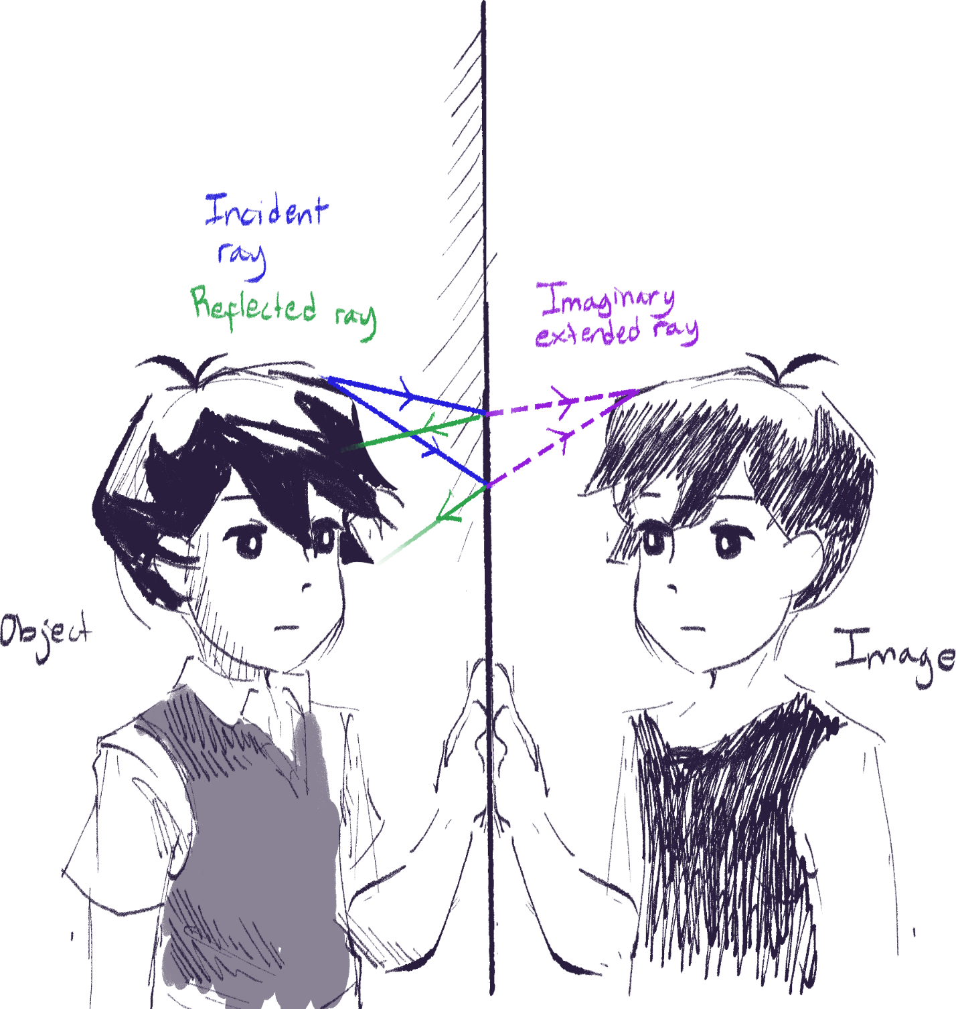 I think this is just an important thing to clarify. Object are real physical things, and images are things that we see or are projected. There are virtual and real images, but that is discussed later. Just know that objects reflect/emit light rays that form an image that we see of them. Images are formed when two light rays intersect, shown here.

Refracting light

Now, drawing the diagram is simple, just like before, except you don’t have to draw the wavefronts, just the rays.

However, there are some more things you need to know about refracting light.

Refractive index

The refractive index of a medium is defined as:

Speed of light in a vacuum/speed of light in the medium

So, the refractive index of a vacuum is 1, air being slightly higher but close to that, and something like diamond having an index of 2.4. In most questions, you can assume that the refractive index of air is equal to the index of a vacuum.

The critical angle[27]

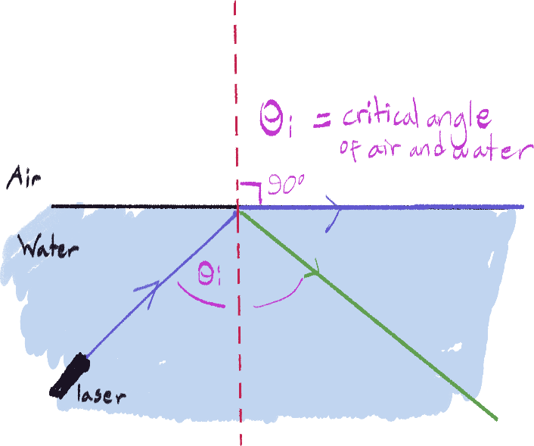 The critical angle is a degree value particular to two mediums at once. W

hen light rays travel to the boundary between these two mediums from the denser medium at the critical angle, the light refracts 90 degrees – basically, it goes onto the line of the boundary. Like this:

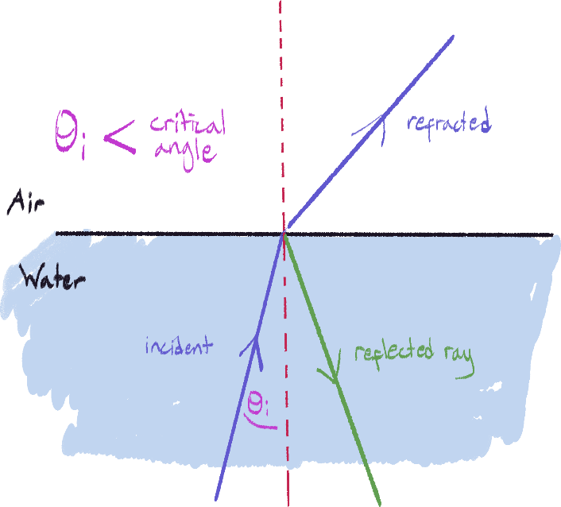What is that green ray, you may be wondering. Well, for light, when refracting, the ray also reflects at the same time. There are two other cases you should remember:

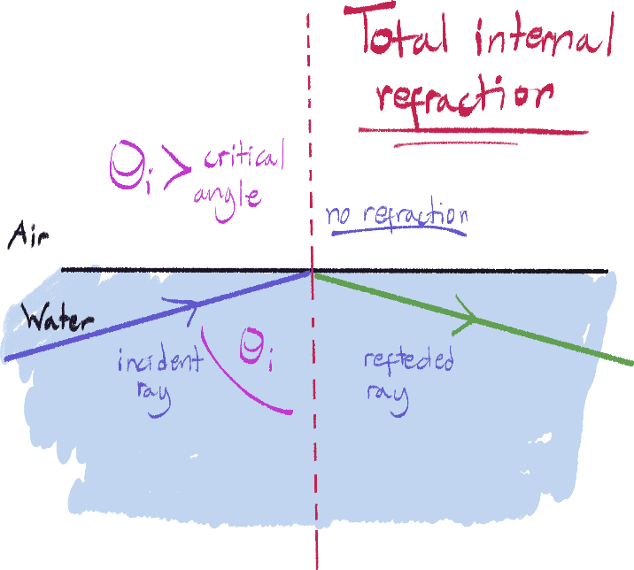The name for this one below matters: total internal refraction, when it completely reflects and no refraction happens.

I have to reiterate that these only work when the light is going from the denser medium into the less dense medium. The critical angle’s value completely depends on the combination of the two mediums involved; the value for water-air is different than glass-water.

Extra

Another thing is that as the ray gets closer and closer to the critical angle, less of the light gets refracted and more of it gets reflected.

The formula for the critical angle is:

c = sine-1 (nr/ni)

Where c is the critical angle

Snell’s law

Snell’s law states that the sine of the angle of incidence times the refractive index of the first medium is equal to the sine of the angle of refraction times the index of the second medium. Yup. The formula is:

n1 * sin(θ1) = n2 * sin(θ2)

Where:

n1 : the refractive index of first medium

n2 : the refractive index of second medium

θ1 : angle from normal of light in first medium

θ2 : angle from normal of light in second medium

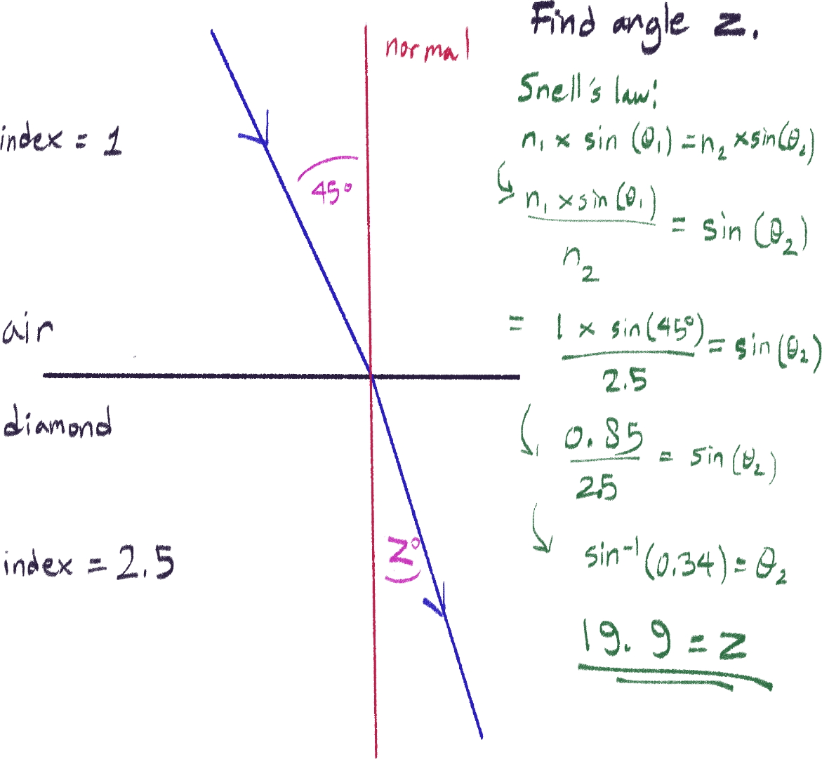Here is an example of how to use it:

Another formula for refractive index

n1 = n2/sin(c)

You can achieve this by deriving the formula for critical angle. The medium for n1 and c should be the same in this case.

Converging/convex lenses

Intro

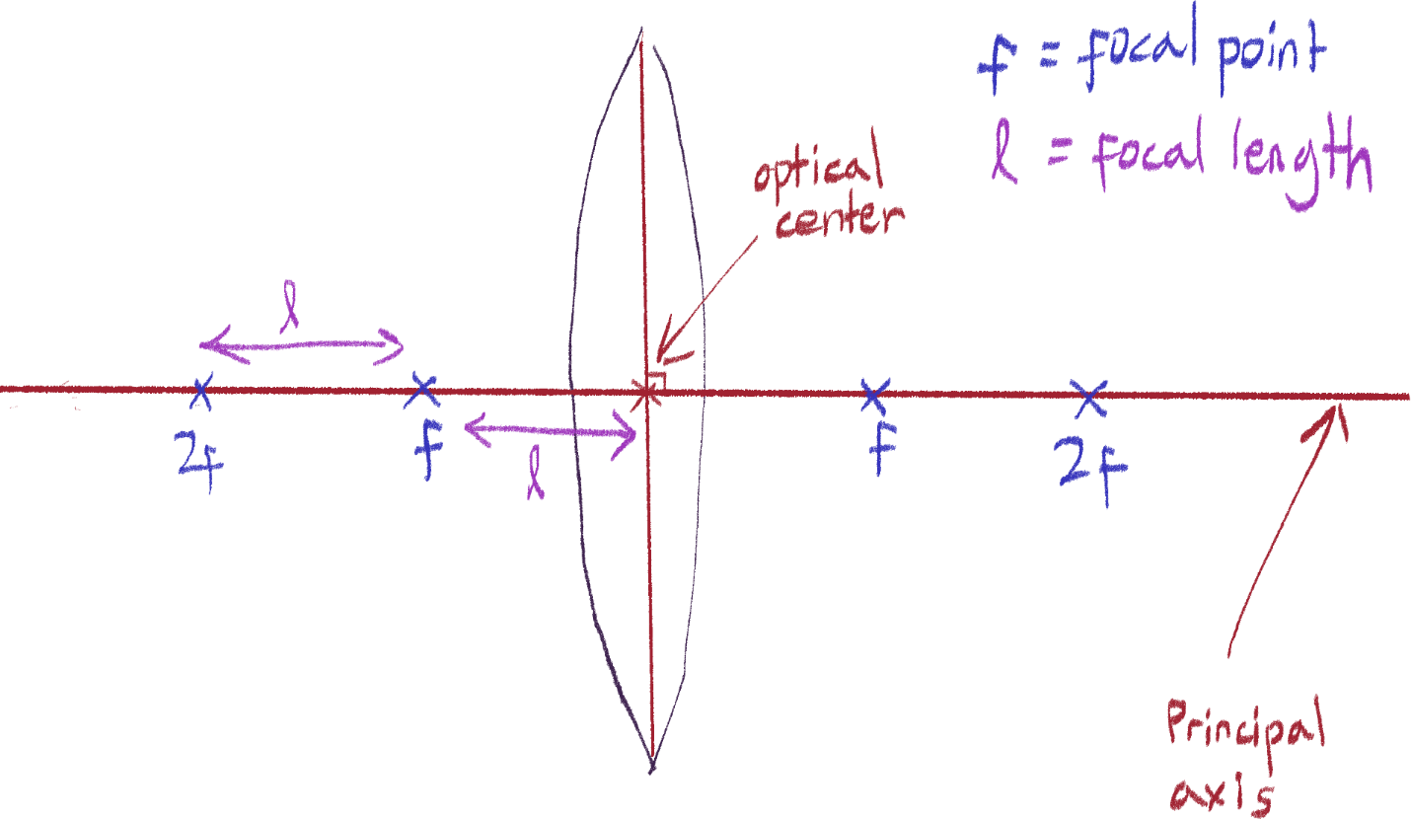 Convex/converging lenses look like this, and as the name implies, it refracts any multiple light rays going into it to converge.

For any kind of lens, these terms will be used:

* The optical center is the point at the center of the lens.
* The principal axis is the horizontal axis of the lens that passes through the center.
* There is also a vertical axis but we don’t have any fancy name for it.
* A focal point/principal focus of a lens is a point on the principal axis that’s a certain distance away from the lens with one on both sides, depending on its material and thickness.
* The focal length the length away the each of the foci are from the optical center.
* The 2f points are a focal length away from their focal points on the same side – or double the focal length away from the optical center. They will be used later.

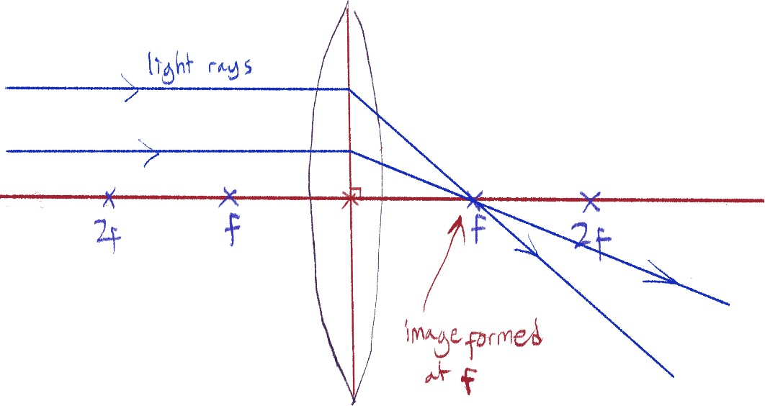Finding the focal points

A rule you should know with convex lenses is that any ray parallel to the principal axis will cross the focus point. The example above illustrates that. From here, you can measure the focal length and find all the other points.

Second and third rule

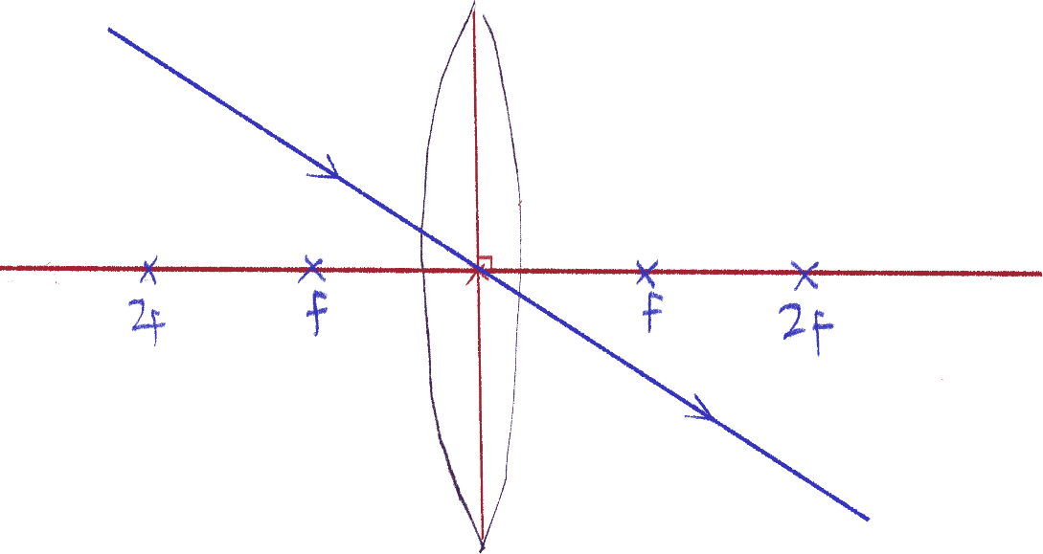 The second rule is that any ray that crosses the optical center will continue without any deviation, like this.

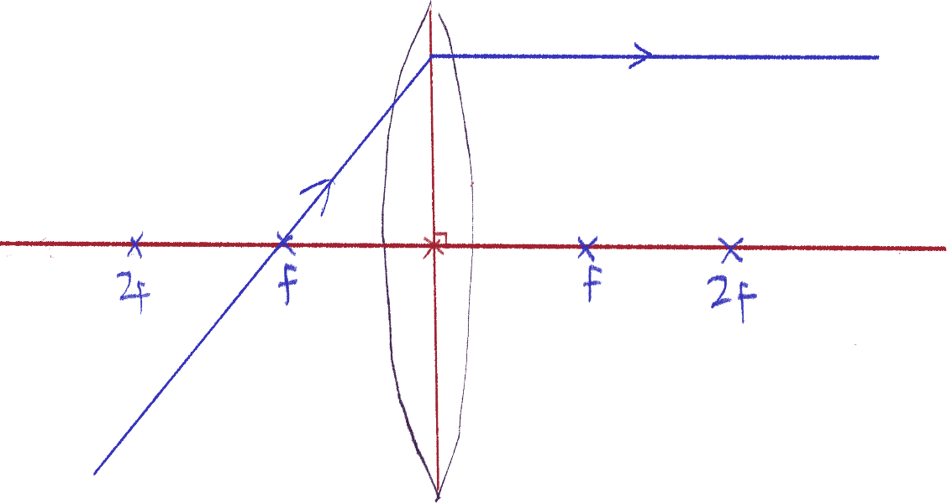 The third is very similar to the first; if a ray crosses the focal point before entering the convex lens, it will refract parallel to the principal axis. It’s the reverse of the first rule.

This displays the property of the reversibility of light.

Real vs virtual images

Real images are images formed by real rays of light that exit the lens and can project an image on a screen. For example, if I shine a light through glass, it will refract it and the light can be seen hitting the wall behind the glass.

Virtual images are formed by rays of light that don’t actually converge, and only seem to as two real rays seem to converge. An example of this is in the mirror diagram – the dotted rays are the imaginary extended rays only seen in the mirror. Virtual images cannot be projected, and only seen through the medium, like magnified images seen in the lens of a magnifying glass.

Cases

Using these rules, we can see how the light rays of an object form an image at different positions away from the lens.

We will be using an arrow sitting on the principal axis to represent the object, since it will show us which way up it is and its size easier.

The properties of a resulting image we’ll be focusing on are:

* Size – is it magnified, diminished (smaller) or the same?
* Orientation – is it the same/erect or flipped/inverted vertically?
* Position – where is it in terms of the focal points?
* Image type – is it real or virtual?

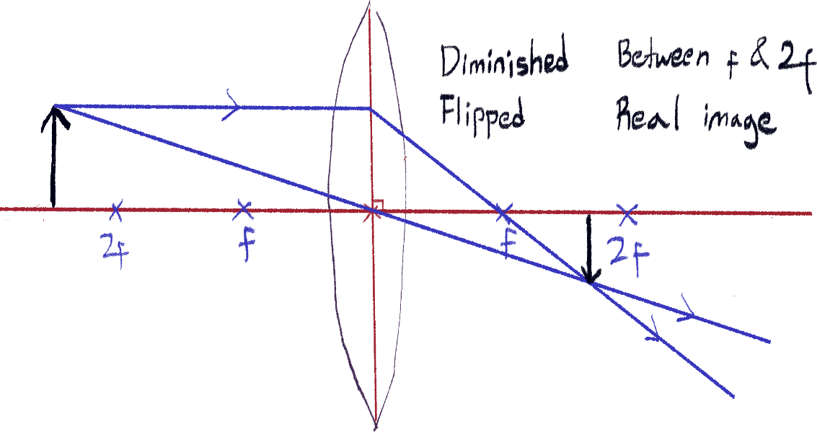Case 1: Object beyond 2f

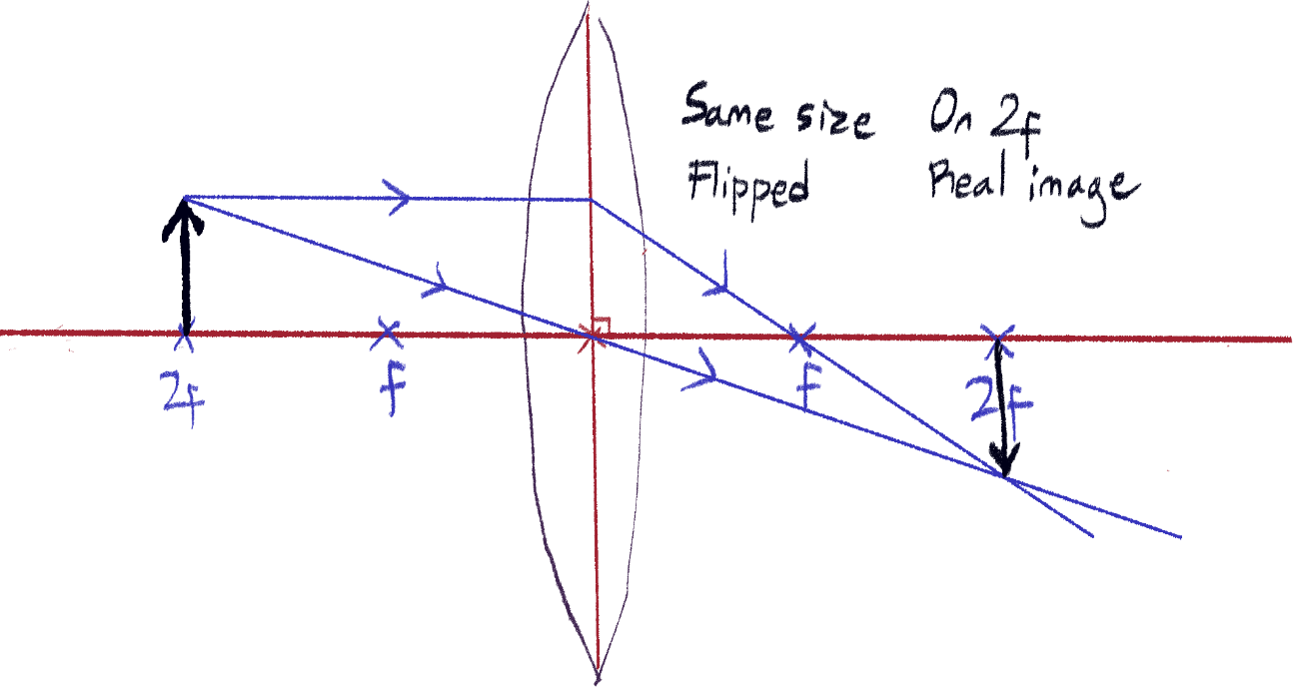Case 2: Object on 2f

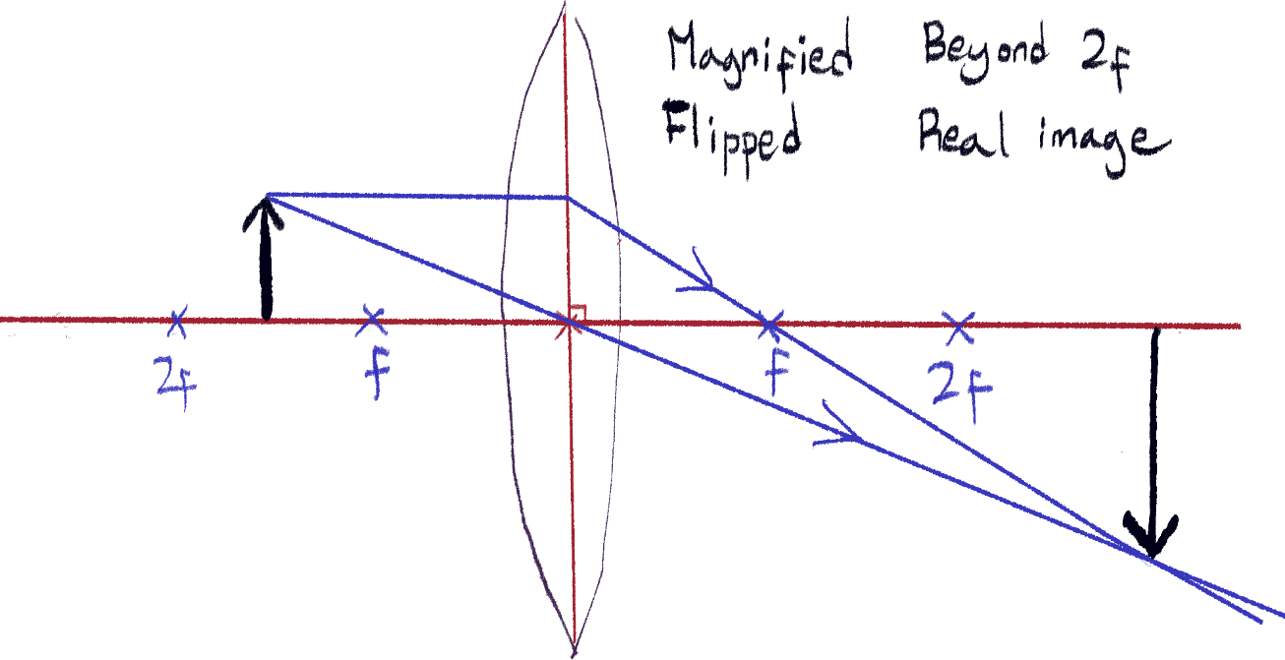Case 3: Object between 2f and f

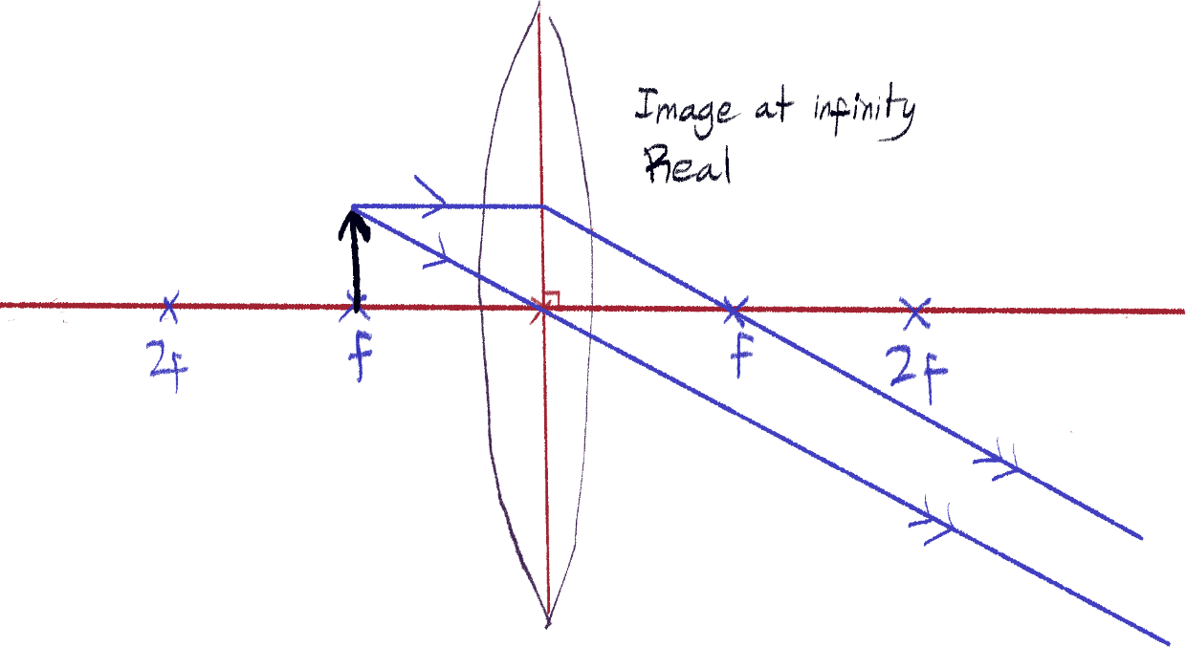Case 4: Object on f

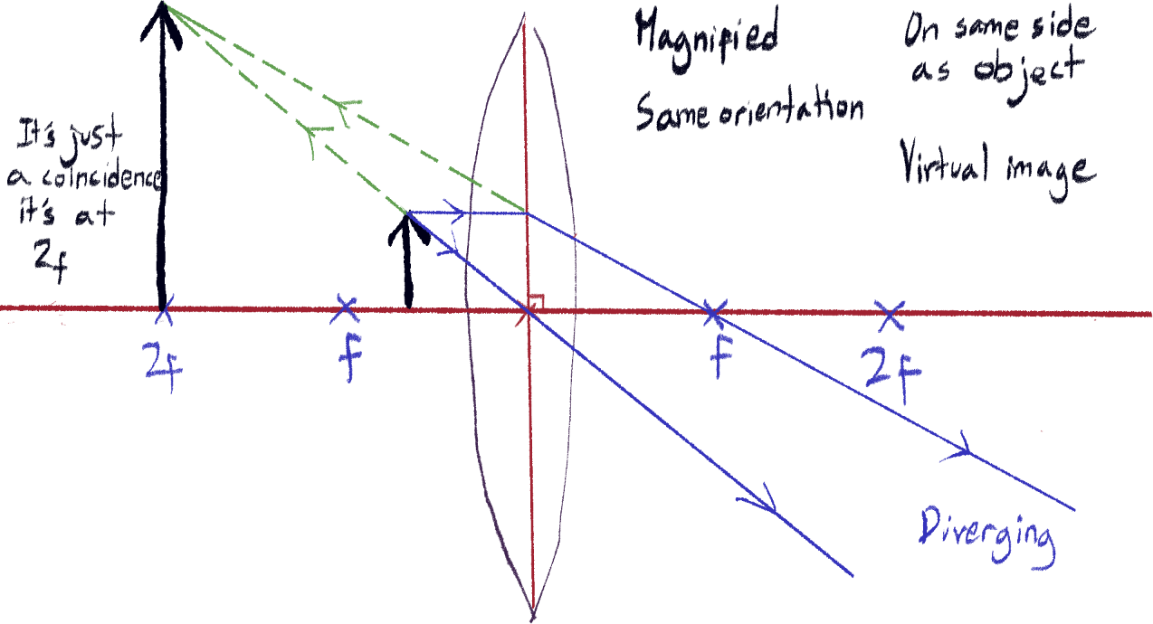Case 5: Object between f and optical center

This last case likes to be talked about since it works as a magnifying glass.

Concave lenses

Rules

Yeah sorry, I drew it like this. The rules are pretty simple though, like the ones for convex lenses.

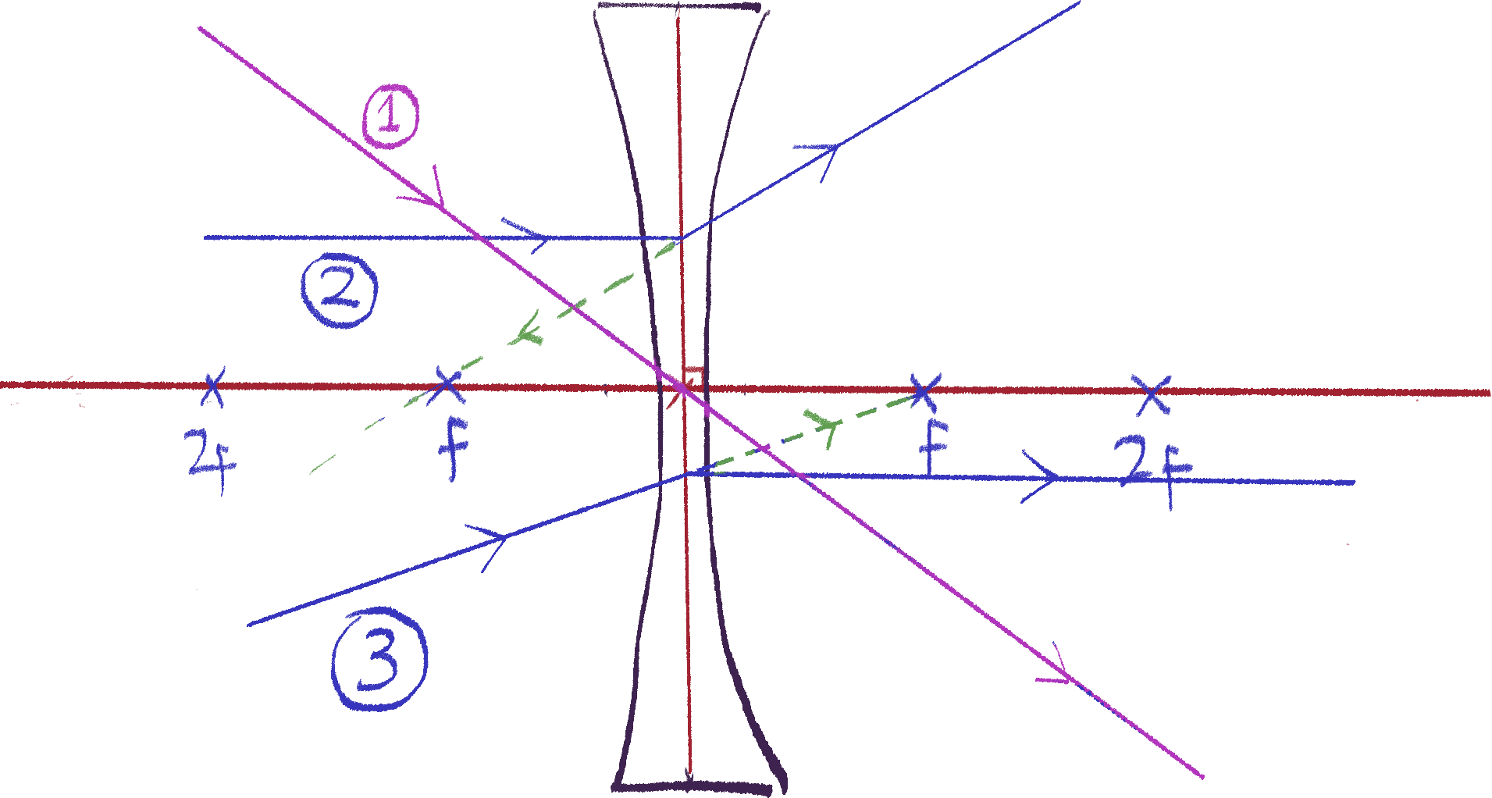

1. Like in convex lenses, rays that shoot through the optical center do not refract.
2. Rays parallel to the principal axis will refract in such a way that extending the ray backward will make the extension pass through the opposite focal point. See the green dotted line in the drawing.
3. Reverse of rule 2. Rays that would shoot through the focal point of the other side are refracted to become parallel to the principal axis.

Cases

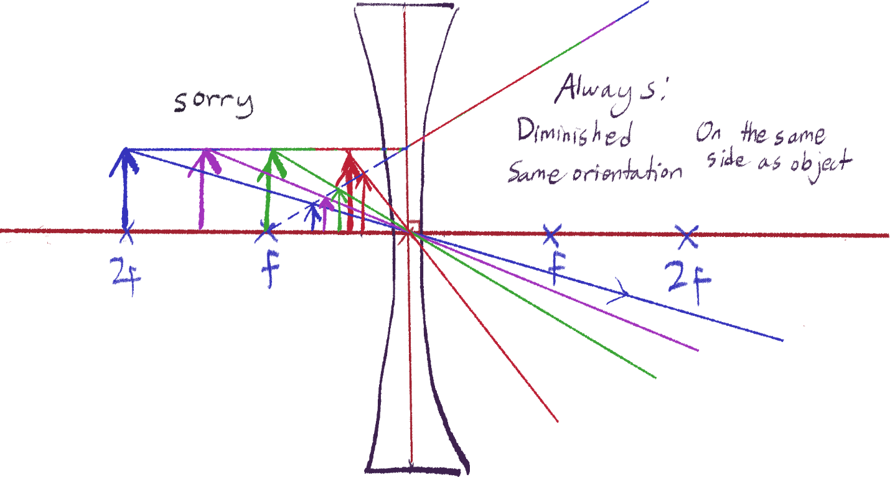Luckily, all cases are the same. Because rays will always refract to be divergent on the other side, a real image can never be formed, and virtual images will always be formed.

In any case, the virtual image will always have the same original orientation, exist on the same side as the object, and have a diminished size.

Dispersion of light

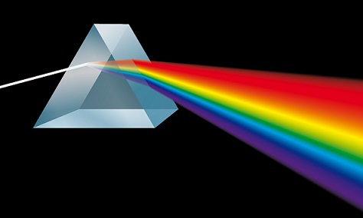Dispersion of light is the phenomenon where white light can be separated into a spectrum of colored light when shone through a triangular prism.

This is because different wavelengths of light refract to different degrees. Red refracts the least, while violet the most. The reason for this is because red is least slowed down by the glass while violet is the most slowed down by glass. Thus, violet refracts the most.

It’s important to remember this fact as well as the order of all the colors in between (not that hard) because they ask about it sometimes.

The seven traditional colors to know are:

Red – Orange – Yellow – Green – Blue – Indigo - Violet

The Electromagnetic Spectrum

Definition of electromagnetic waves

It is a transverse wave, that does not need any physical medium to travel – in other words, it can travel through a vacuum. All electromagnetic waves travel at a constant speed of 3 x 108m/s. They have other interesting properties, but in terms of how they act as waves, they have all the same properties as waves aforementioned the previous chapter.

Types of electromagnetic waves

|  |  |  |  |  |  |  |  |
| --- | --- | --- | --- | --- | --- | --- | --- |
| Name | Radio | Microwave | Infrared | Visible Light | Ultraviolet | X-Rays | Gamma Rays |
| Wavelength starts from | 104m -> | 10-1m -> | 10-3m -> | 10-6 -> | 10-7 -> | 10-9m -> | 10-11m -> 10-14 |
| Frequency starts from | 3 x 104 -> | 3 x 109 -> | 3 x 1011 -> | 3 x 1014 -> | 3 x 1015 -> | 3 x 1017 -> | 3 x 1019  ->> 3 x 1022 |

You will need to know these values and their order, but I recommend you only memorize either the wavelengths or the frequencies, since all electromagnetic waves have the same speed of 3 x 108, you can use the formula speed = frequency x wavelength to find the other value.

Notice that wavelength and frequency are inversely proportional in this table, because of the constant speed.

Roman Men Invented Very Unusual X-Ray Guns

I wrote ‘starts from’ since all the types have a range. For example, an electromagnetic wave with the wavelength of 10-4 is infrared. The arrows I put are to show that from that value onward until the next type, it will be that wave.

How electromagnetic radiation works (super simplified)

Electromagnetic waves do not require particles to move, but they can manipulate particles, reaching a subatomic level. You may think of it as the waves vibrating the electrons of an atom, rather than the atom as a whole[28].

You don’t need to know that right now, but it makes explaining things easier.

Properties

Polarization

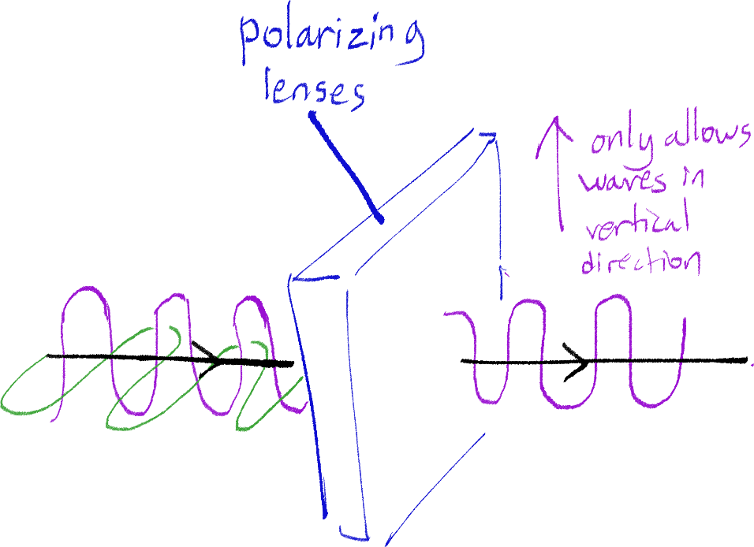 Since waves in real 3D space have many directions they can oscillate in, it is also possible to block out any electromagnetic waves that oscillate in one direction, while allowing another direction to pass through. This illustrates it:

A good example of this is in 3D movies and glasses – light in vertical and horizontal wave oscillation is projected, but one of the glasses’ lens filters to get only the vertical light, while the other lens filters to get the horizontal oscillating light.

The photoelectric effect

Since I told you that electromagnetic waves directly affect electrons, it will be easier to wrap this around your head. When enough electromagnetic energy from photons (‘electromagnetic particles’) hits a metal (since it has delocalized electrons), it can give enough energy for some of the electrons to escape the metal. This is what’s called the photoelectric effect.

Without going into details, the shorter the wavelength of an electromagnetic wave, the more effective that wave is at knocking off electrons. It takes a really long time for it to happen with red light, but it doesn’t take long for it to happen with violet light.

Photons (honestly there is literally no way to explain this shortly, so if it’s easier, only look at the highlights)

Although photons are often visualized as particles of electromagnetic waves bunched up together, that is not what photons are. To keep it short, photons are a discrete value of electromagnetic energy that make up a wave – so one can say that electromagnetic waves are made up of individual photons. Some people call them ‘particles of electromagnetic energy’, which works in a certain context, but they aren’t one little dot like we usually imagine particles. The energy of a single photon of a wave, in simpler terms, depends on the frequency of the wave, not the total energy/amplitude of the wave itself[29].

Because of this, the energy of radio wave photons are the lowest, and the energy of gamma ray photons are highest in the spectrum, just like comparing red and violet light.

Uses and hazards of different electromagnetic waves

Optic cables

Optic cables are cables that use light to transfer information, reflecting off the inside of the cable to travel. An example of its use is in cable television, and high speed broadband (AKA that ethernet cable). Also used for communication and medical imaging.

Radio waves

Radio waves are used for radio communication, and can travel very long distances due to their long wavelength. Radio communication includes TV and radio signals, remote-controlled toys, and Bluetooth.

These waves are also used in astronomy to study distant stars by the radio waves they produce, another use of its long travel distance.

Microwaves

Used in microwave ovens and wireless internet. The ones from your phone are so small that they don’t harm you, and microwave oven waves are stronger, but the oven doesn’t let any rays get out.

Satellites use microwaves to communicate. There are two types of satellites: geostationary and polar. I have no idea why we need to know this, but it’s simple.

Geostationary satellites orbit the earth following the path of the equator, 36000km above the surface. This way, it covers a lot of area. They take a 24-hour period to orbit.

Polar satellites, you guessed it, orbit around the poles. They are only 200km above the surface, and thus have faster and clearer signal transmissions. However, they cover less area. Often used for monitoring weather, military applications and taking pictures of the Earth from above.

However, microwaves are dangerous because they can cause internal heating of body cells.

Infrared

Infrared radiation makes a lot of heat, so it is used in grills and toasters. Infrared cameras can be used to detect infrared radiation coming from humans or animals. TV remote controls also use infrared, along with internet and phone signals in optical fibers. However, the heat of infrared can cause skin burns.

Ultraviolet

Ultraviolet is used in security markers, detecting false bank notes, and sterilizing water. Over-exposure to it can be damaging and may cause skin cancer, so using UV-blocking sunscreen can tackle that. It can cause eye conditions, too.

X-Rays

Used to scan bones in the medical field and also in security scanners to scan for contraband. X-rays are on the stronger side of the spectrum, and can cause mutation and damage to body cells.

Gamma rays

Gamma rays are the strongest and have the most energy. They are used in radiation therapy to detect and treat cancer and to sterilize food and medical equipment. Like X-rays, they can cause mutation and damage to body cells.

Extra things

Brownian motion

Forgot what chapter this was in, but I’m doing it now. I didn’t really understand Brownian motion before watching [this guy’s video](https://youtu.be/ZNzoTGv_XiQ), I do recommend it.

Brownian motion is the random movement of microscopic particles observed under a microscope.

You’ll know there are two ways to show Brownian motion – both under a microscope, the first being watching pollen particles moving in water, and second being smoke particles being hit by air molecules with a light. In both cases, the atoms and molecules (water or air) that cannot be seen by the microscope constantly hit the larger, visible microscopic particles (pollen or smoke). This results in the erratic, random movement of the microscopic particles.

Brownian motion is important as it explains a lot of the randomness that is observed in real life, and supports the kinetic particle model of matter.

Converting units

Rearranging formulae

Precautions for experiments

Working with lenses

* Carry the experiment out in a dark room.
* Use a set square to ensure a screen is vertical.
* Draw a line in the middle of the lens’ holder to set the vertical axis of the lens for measurements.
* Move the lens back and forth until the image is focused.
* All objects involved (lens, object, screen) should be on the same height on the table, AKA don’t start adding a Z axis into this.

Raytracing & possible causes of inaccuracy measuring angles in raytracing experiments

* Place pins as far away from each other as possible.
* Use one eye when doing the experiment
* Don’t change eyes
* View pins from the top to see if any are slanted
* Lines should be thin – too thick can cause angle measurement inaccuracies
* The protractor should have enough divisions, at least to one degree.
* Angle inaccuracies from the pins not lining up with ray exactly

Thermometer readings

* Insulate the beaker to reduce heat loss
* Stir water/liquid to ensure uniform temperature throughout the liquid
* Use a lid

Those moment experiments with the meter rule and pivot and weights and stuff

* Rule can be difficult to balance
* Rule can slide on pivot
* Weights can slide on the rule
* If the rule isn’t uniform, it won’t balance when the pivot is on the 50cm mark.

Magnetism

Intro

Okay, I changed the formatting. I think it will be more readable this way.

Magnetism is not only used in things like phone holders and fridge magnets. In fact, these days, they are a fundamental part of our electronics and tools. Understanding magnetism beyond the surface level of ‘opposites attract’ can further our view on how they are used.

Poles

Every magnet has two poles – the north pole, and the south pole, usually on opposite ends. No magnet has only one pole, or at least that hasn’t been proven yet. If you get two magnets side by side to each other, they can either repel or attract.

[picture here]

Like poles repel, and opposite poles attract.

Actually, the poles on magnets and that of the Earth’s poles are opposite, so the north pole of a magnet is attracted to the Earth’s north, which is how a compass works.

So, we can define the north pole of a magnet as the end of the magnet that points toward the Earth’s north, vice versa for south pole. Why am I telling you this dumb definition? Because this question from 2006 was put on my physics test and I got it wrong. I don’t even know if it’s in the current syllabus, but I am frustrated and not taking any chances here, ok?

If you have a magnet, and split it in two, it will just result in two, smaller magnets, with their pole directions being the same. You can keep on splitting them until it’s as small as an atom, and that atom would still be like a small bar magnet with its poles in the same places.

Magnetic fields and magnetic forces

The magnetic field[30] of a magnet is the area of which the magnet can exert a magnetic force on another object within that area.

The repelling and attracting caused by magnets are magnetic forces. The magnetic force between magnets gets stronger as they get closer to each other, whether they’re repelling or attracting.

Magnetic field lines

Magnetic field lines are imaginary lines we make to represent the direction and strength of a magnetic field.

[picture of magnetic field lines around a bar magnet here]

As you can see, the north and south poles don’t represent points but rather two ends forming a loop that shapes the magnetic field. This continuous loop explains why the north and south ends always come together, even when a magnet is split.

Important things to notice are:

* The direction of the magnetic force always goes from north to south.
* The magnetic field lines never cross or touch each other, even when touching the bar magnet. Field lines inside the bar magnet are parallel to each other.

[picture of magnetic field lines around a bar magnet here]

You’ll often see this diagram, but magnetic fields are actually 3D in real life. Drawing it like this just makes it simpler.

Another thing is that the explanation for the magnitude of a magnetic force is proportional to the number of magnetic lines in that area in space – you can see that there are more lines in a smaller area near the ends of the bar magnet, so the strength of the field will be stronger there.

Magnetic field diagrams of repelling and attracting magnets

[just put the drawings here]

Always remember to mark the directions of the field lines, and make sure that the lines never cross.

How it works

A material is a magnet if the directions of its electrons are generally aligned. More specifically, the current of the electrons in a magnet defines its field’s strength and direction. However, just remember the first definition for now.

Uniformity

You can see that in the diagram between two attracting poles right next to each other, the field lines are straight.

[picture here]

Where the field lines are straight and parallel to each other, the magnetic force experienced by objects within that area will be uniform – that is, anywhere in the area, the force will have the same magnitude.

Types of magnets and inducing magnets

Inducing magnetic material

If you use a strong bar magnet to attract an iron bar, it will easily be induced into becoming a magnet itself. This is observable as the iron bar, still attracted to the bar magnet, can attract paper clips to itself.

[picture here]

The reason behind this is that the iron bar’s electrons, originally in different directions, were induced into aligning with the bar magnet’s magnetic field. You can see in the previous diagram of two attracting magnets, the loop connects as if the two magnets were one big magnet. Inducing materials to become magnetic can be thought of in a similar way.

Non-magnetic material and magnetic material

Of course, you know that you can’t attract a wood block using a magnet. Such objects that don’t particularly get affected by magnetic forces are called non-magnetic. Objects that do get affected, like iron, are called magnetic material.

Soft magnets vs hard magnets

Now, if we do that same thing with steel – it will also be attracted by the bar magnet, but it will attract less paper clips. However, it can still retain some magnetization and pick up a few paper clips even after removed from the bar magnet.

You can also notice that the iron bar from earlier won’t retain any magnetization after being removed from the bar magnet.

This is because of their difference in coercivity – it is easy to induce and align iron’s electron directions, but is also easy for them to scramble again once no longer affected by the field. For steel, it is harder to align its electron directions (thus the less paper clips picked up), but it can retain its magnetization after being induced even without the field.

Iron can be said to have low coercivity, while steel has a high coercivity. Materials with low coercivity are called soft magnets, and ones with high coercivity are called hard magnets.

Temporary magnets vs permanent magnets

These terms are pretty self-explanatory. Temporary magnets are magnets that are currently induced into being a magnet, but won’t retain magnetization afterwards. Permanent magnets are magnets with or without the presence of external magnetic fields. From the last section, we can deduce that permanent magnets are made out of hard magnet material.

Methods to induce and demagnetize permanent magnets

We already know a way to induce hard magnetic material into permanent magnets, but this method will not produce a strong magnet. There are more effective ways to make a permanent magnet/strengthen a permanent magnet:

* Heating the magnet while its aligned with another magnet
* Hammering/tapping the magnet while its aligned with another magnet
* Coiling a wire around the material and running an DC (direct current) through the coil

However, similar methods can be used to demagnetize magnets as well.

* Heating the magnet without the presence of a magnetic field/placing it perpendicular to another magnet’s field
* Hammering/tapping the magnet without the presence of a magnetic field/placing it perpendicular to another magnet’s field
* Coiling a wire around the material and running an AC (alternating current) through the coil

You can think of these methods as aligning and jumbling the directions of the electrons in the magnet.

Electromagnets

As we discussed in the last section, you can induce a magnet by coiling a wire and running a DC current around the magnet. In fact, any coil with a DC current can be a magnet by itself. What is useful about using electricity to create a magnetic field is that it can easily be turned on and off.

Magnets induced by electricity are called electromagnets. Soft magnets are often used in electromagnets since they don’t retain magnetization after the current is turned off, but will make a strong magnetic field once induced.

Factors that affect the strength of an electromagnet are:

* The number of coils – the more there are, the stronger field is.
* The distance between coils – the closer they are, the stronger the field is.
* The size of the current being run through the wire – the greater it is, the stronger the field is.

Electromagnets are extremely useful in not only all sorts of electronics, but in tools such as wrecking yard cranes that use very strong magnetic forces to lift cars.

Finding the north and south of an electromagnet

Before we continue to the hand method, I think it’s best to explain and clarify what this method does. The direction of a magnetic force always going to be perpendicular to the line of the current in the wire. However, it is difficult to know which direction the force is going to go. This is what the right hand method is for.

1. Using your right hand, your thumb will be representing the direction of the magnet’s magnetic force, and the rest of your fingers will represent the current in the coil.
2. The direction the rest of the fingers curl into your palm should follow the direction of the coil’s current. You should already know the direction the current is turning in.
3. Make sure your thumb is perpendicular to the other fingers. Your hand should look like its gripping the object with a thumbs up sign.
4. The direction the thumb points to is the direction of the magnetic force.

Don’t worry about the starting orientation of your hand, it will always work as long as you’re using your right hand.

It is possible to also use this method to find the direction of the current using the direction of the magnetic field, since their directions are perpendicular to each other.

[image here]

This video is useful for understanding this method - <https://youtu.be/LAnRTNwrFMo>

Static electricity

Intro

When you rub a plastic straw and its paper packaging together, pull the straw out, rip the paper into small pieces, then hold the straw over the pieces, the pieces get attracted to the straw. This is what I hope is a relatable occurrence that shows the effect of charges and static electricity on objects.

[picture here]

The reason this happens is related to the transfer of electrons between those materials and the electric charges they gain, which will be discussed in this chapter.

Basics and definition

As you rub the straw and paper, the friction causes the electrons from one object to move to the other. This causes electrons to move from the straw to the paper[31]. This means the straw has lost electrons and now has a net positive charge, and the paper has gained electrons and now has a net negative charge.

[picture here]

This is a display of static electricity – static electricity is the buildup of electric charges on an object.

Charge and stuff

Charge introduction

To elaborate further on what charge is, we can go back to what we know about it down to a subatomic level – in an atom, we have protons, neutrons, and electrons. We know that protons have a positive charge, neutrons a neutral charge, and electrons a negative charge. Because atoms have the same number of protons and electrons, the net charge of an atom is neutral.

If you’ve taken chemistry, the concept of electron transfer is very important when talking about ions; when an atom loses an electron, it becomes a positively charged ion, and when an atom gains an electron, it becomes a negatively charged ion. Ions of opposite charges tend to become attracted by electrostatic forces, which is what an ionic bond is.

Yes, electrostatic forces are forces caused by static electricity. Similarly to ions, a negatively charged rod with more electrons is attracted to a positively charged rod with fewer electrons.

IGCSE loves asking you from time to time about ‘what is transferred when a rod and cloth is rubbed together?’ – when it comes to anything electricity, the only things really moving are electrons. Protons are stuck in the nucleus, remember? Whenever we say ‘positive charge moves’, it’s really just the *lack of electrons* (sometimes called holes) moving, not protons.

Distributing charge

If you get a positively charged rod and a neutral rod and touch them together, some of the positive charge from the charged rod will go to the neutral rod so that all the charge is equally distributed among both rods. Thus, both rods will have a smaller, positive charge.

[image here]

Electrons can be distributed unequally in the same object

If you get a positively charged rod and a neutral rod and hold them close together without touching, the electrons on the neutral rod will attract and move to the part of the rod closer to the positive rod, while the positive charge on the neutral rod will be repelled and move further away.

Now, one part of the neutral rod is negatively charged while the other part is positively charged. This is called polarization, where there one object has different charges in different areas, despite having an overall net charge.

[image here]

If you split the polarized rod between those differently charged areas, you would get a negatively charged part and a positively charged part.

Polarization also allows neutral objects to be attracted by charged objects, for example, holding a charged rod near the flow of a running water tap, the flowing water can be seen to slightly bend towards the rod.

Movement of charges within materials

You can notice that we’ve been using insulators in these examples. Although static charge can build up in conductors as well, insulators are specifically used when charges are transferred by friction, because the electrons will be moved by the friction, but will not be able to return back since the materials are insulators.

Conductors are still used in many situations involving static electricity – for example, in factories where workers are handling sensitive chips and circuitry, their hands have metal bracelets that are connected to the ground wire to ensure that their hands are always neutral in charge. Conductors must be used in this case to allow fast and smooth travel of the charges to ground.

The unit for charge

The unit for charge is Coulombs (C), and we’ll be using it a lot in electricity. For example, it’s a part of the formula for current.

Earthing

Now, if you take a polarized rod with its electrons being attracted to one end using a separate positively charged rod without touching, we know that the other end of the polarized rod will be positively charged.

If we stick the other end into the ground, the positive charge of the polarized rod will move into the earth, and only the negative charge will be left in the rod, making the rod’s net charge negative.

[picture here]

This is a property of Earth that is important to anything related to electricity – any charge connected to the earth will move into it. This is useful to neutralize charged objects or to create a charged object like in the aforementioned example.

Electric fields and electrostatic forces

An electric field is defined as a region of space where a charge will experience a force.

Similarly to magnetic fields, like charges will repel and opposite charges will attract. The repelling and attraction of objects due to difference in charges is called electrostatic force.

Other properties are:

* The direction of the force will be from the positive charge to the negative charge (like north to south)
* The closer the charged objects are, the stronger the electrostatic force will be.

Notice that these properties are also similar to magnetic fields. However, a electrostatic field can exist with only one type of charge, unlike magnetic fields.

[picture here]

Drawing the electric field of charges

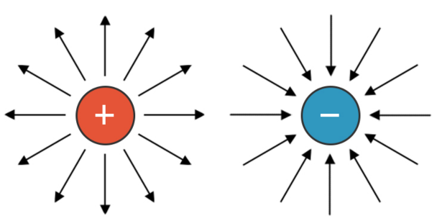 This is only for representing the electric field of *charges*, not charged objects.

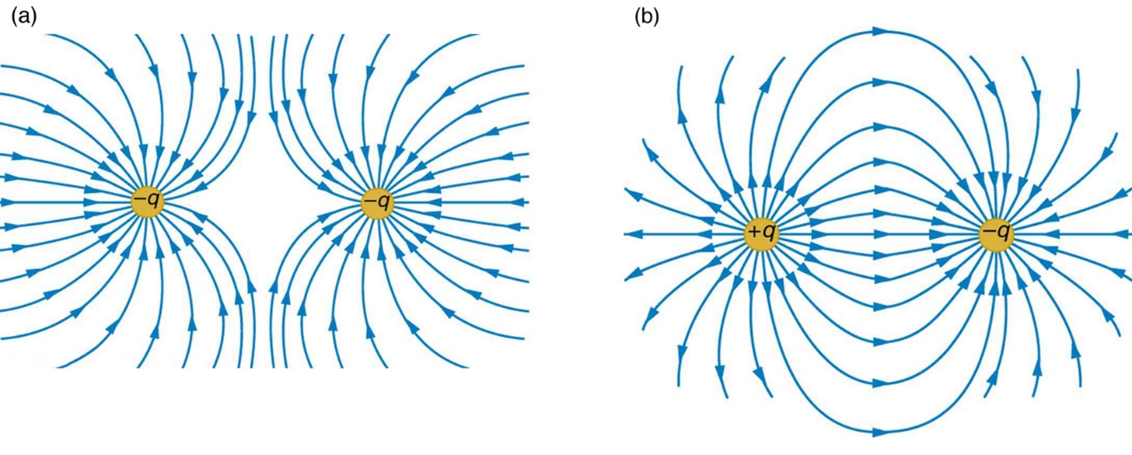This is for individual charges. Like in magnetic fields, they also have field lines that show the direction of electrostatic force. Remember that since the direction is always positive to negative, the force from positive charges will be outwards, and the force from negative charges will be inwards.

This shows what it looks like between two like charges and two opposite charges.

Idk why you have to memorize this

When a Perspex rod is rubbed with wool cloth, it will lose electrons and gain a positive charge. However, a polythene rod will gain electrons and gain a negative charge.

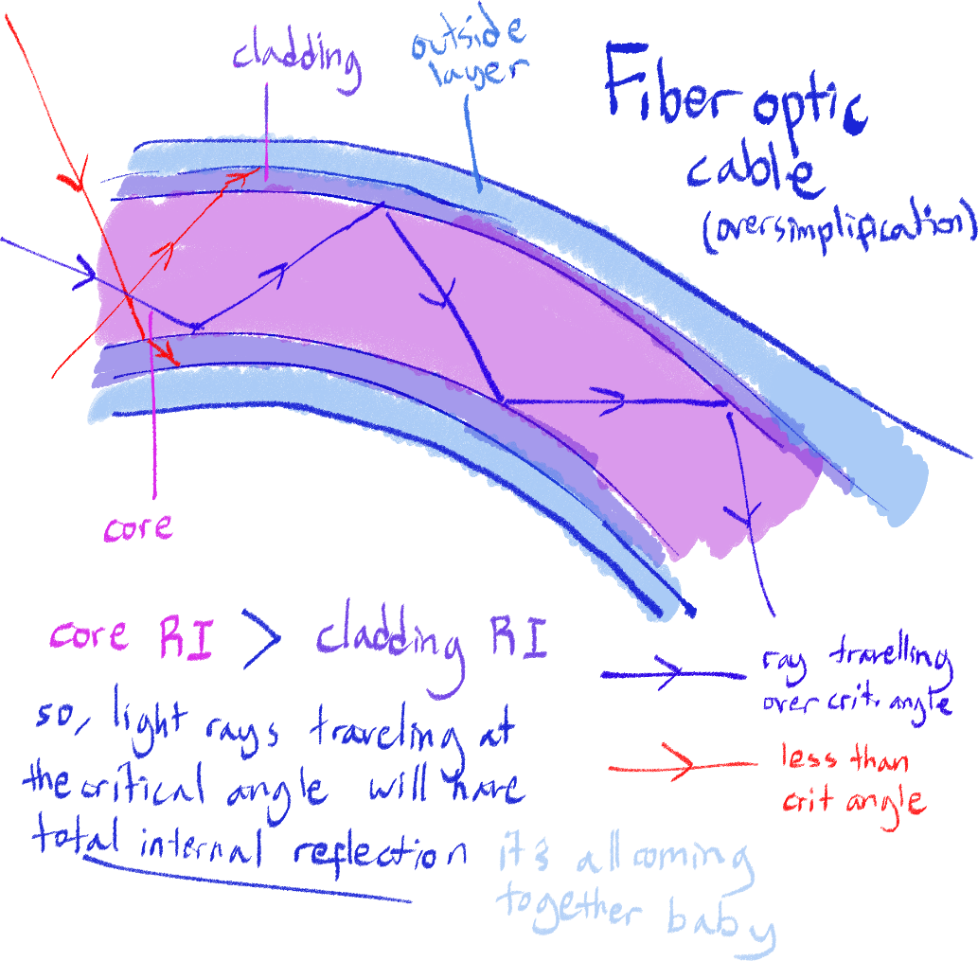More on fiber optic cables

Emmm yeah sorry idk where to properly put this, I finished this diagram a while ago and just never inserted it and the way I’ve previously formatted this document makes it so that if I do add it in where it’s supposed to, it will shatter and combust and explode and go crazy.

The definition and explanation with all the marks for this thing is:

It transmits data by using light rays/infrared pulses, using TIR (total internal reflection) to prevent rays from escaping.

Uses for fiber optic cables include:

* Medicine

A cable can be inserted into the body as an endoscope where internal organs need to be examined, by having light travel through optic cables

* Telecommunications

Used in landlines and network connections to transfer data over long distances in a short amount of time

Basic Electricity – Quantities & More

This chapter will lay down basic things that we will need before going more into electricity. It is different enough that I think I can make it separate.

Conductors and insulators – in full

This is part of the syllabus, so I have to know it. This will be explained in terms of the simple electron model.

Conductors

Examples of conductors are:

* Copper
* Iron
* Any other metal
* Graphite

Most conductors we will be working with are metals. Metals are conductive of electricity because they have many delocalized electrons that surround their positive ions that are assembled in a lattice structure, creating a sea of electrons. The electrons here are free to move, which is how they can carry a current. For anything to be a conductor, it must have charged particles that are free to move.

Not sure if you need to know this for physics, but graphite is also a conductor because it has delocalized electrons between its layers.

Insulators

Examples of insulators are:

* Plastic
* Wood
* Glass
* Cloth

Insulators do not have any free charges (ions or electrons) so they cannot conduct a current.

Describing an experiment to distinguish between electrical conductors and insulators

Word for word from the syllabus.

From what I have found, the way to do this is by wiring a battery and lightbulb to the material to create a circuit. If the lightbulb lights, it’s a conductor. If not, it’s an insulator.

Quantities and units

Here, we will be going into the definitions for the values we will use later on for electricity-related work. Not all formulas will be included, just what is necessary for now.

Charge

We have already talked about charge before, like in static electricity. A charge will produce an electric field. When using charge in conjunction with other quantities and in circuits, we keep it as a value, in the unit Coulombs (C). Its symbol is Q.

Current

Current is generally defined as the movement of electrons. You can think of it as the charge moving like a stream of water. As a quantity, current is defined as the rate at which charge/electrons pass one point in a circuit. It is measured in amperes (A), with the symbol I.

The formula for it is:

I = Q/t

Where:

I: current (A)

Q: charge (C)

t: time (s)

Something flowing will always have a direction of movement. *Conventional current*, what we usually refer to when we say current, moves in direction of movement of positive charge. Of course, we know that protons cannot move – the only thing moving in electric conductors are electrons. However, this is the standard when it comes to current in physics.

When referring to the ‘real’ current of moving electrons, we say *electron current.*

Voltage/potential difference

The two words are used interchangeably, no difference.

Voltage is defined as the work done per unit of charge between two points/a component. What does that mean? A way to put it is like the potential gravitational energy (similar name, see?), where the height of the object defines the total amount of energy the object has, but not necessarily all of it is used on purely kinetic energy, which is why we say *potential.*

The unit for voltage is volts (V) and the symbol is also V, makes the most sense out of all other units. Ohm’s law (commonly used for most problems related to circuits and electricity) is:

V = IR

Where:

V: voltage (V)

I: current (A)

R: resistance (Ω)

Resistance

*Now what is that R I see?*  You may be wondering. Resistance is defined as the opposition of the flow of current. Going back to the potential gravitational energy explanation, resistance can be seen as air resistance (also similar name) that uses up some of the potential gravitational energy, so there is less kinetic energy in the object (this can be thought of as current).

Looking at *V = IR,* the definition of resistance is clear, as rearranging it produces I = V/R; showing an inversely proportional relationship between I and R.

The unit for resistance is Ohms (written Ω) with the symbol of R.

Electromotive force (e.m.f.)

Definition (which they may ask, remember word for word) is the electrical work done by a source in moving a unit charge around a complete circuit. This is the formula:

e.m.f. = W/Q

Where:

e.m.f.: electromotive force

W: work done

Q: charge

To measure e.m.f. of a battery, you connect the voltmeter directly to it, without a circuit. It has the same unit, Volts, as voltage, and is very similar to it. However, think of it more as the absolute total energy being used on a circuit – the total voltage on the circuit measured will likely be lower than the e.m.f., because there are factors that use up the e.m.f. in the process.

Factors affecting resistance

Resistance is a value that depends on the component it is going through. Filament lamps have a very high resistance, which is how it produces light from electricity. Any component, including the wires, will have a resistance. 0 resistance is impossible, although we get close.

Here are the factors that affect the resistance of a wire:

Material

This one isn’t mentioned very often, but I think it’s worth pointing out anyway. Although all metals are electrical conductors, they have different resistances. For example, gold has a lower resistance than copper. We use copper because gold is really expensive, though.

Length

The length of the wire the current travels through increases resistance. For example, the same current and voltage running through a 1m wire will experience less resistance than in a 2m wire.

If you like math, think of it like this:

R ∝ l

Cross section

The bigger the cross-section of the wire, the less resistance experienced by the current running through it. It can be expressed like this:

R ∝ 1/σ

Radius and diameter

Because the formula for the cross-section of a wire would be r2, that would mean:

R ∝ 1/r2

Thus, the reducing factor would be squared. This is the same for diameter because diameter is just 2r.

Temperature, Ohm’s law and Ohmic resistors

As a part of Ohm’s law (the formula V=IR), it states that this formula is only followed when temperature is constant. This is because in different temperatures, resistance can vary.

In most cases, increasing temperature of a component will increase its resistance.

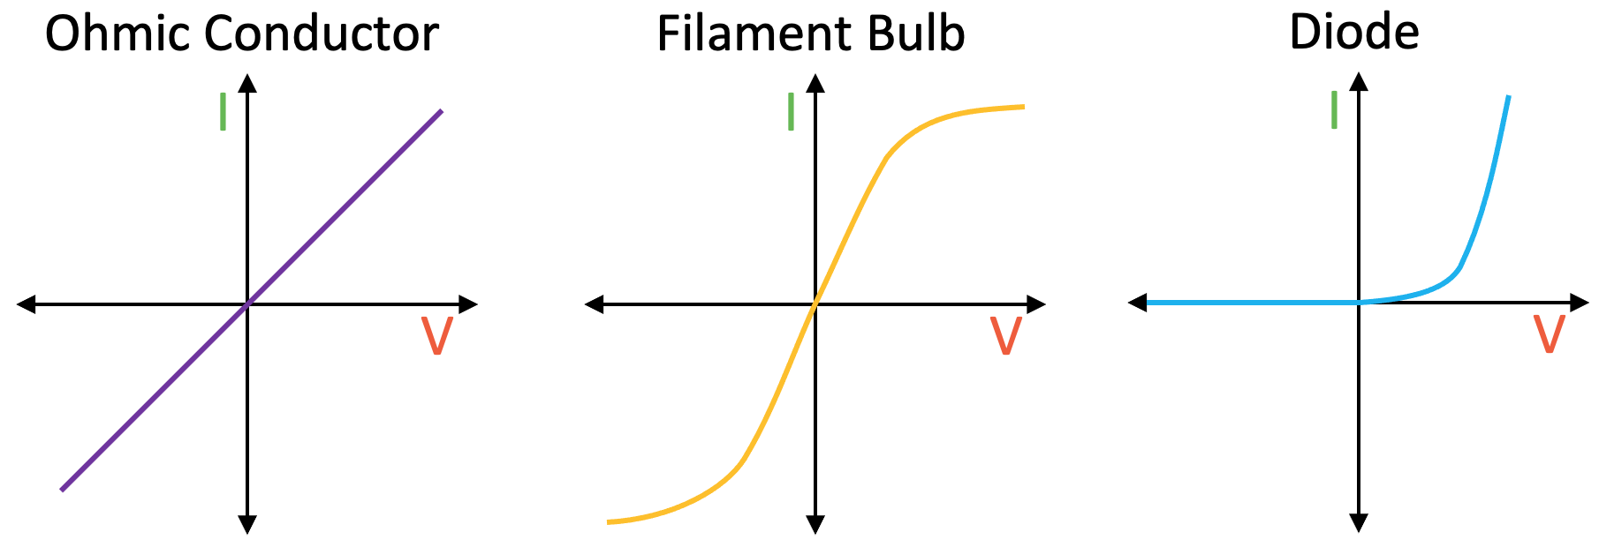 There are two types of resistors; Ohmic resistors and non-Ohmic resistors. Ohmic resistors follow Ohm's law of maintaining a constant resistance. However, non-Ohmic resistors have varying resistance depending on the value of voltage. Remember the graph examples below.

Diodes and rectification

When you want to convert an AC current (where the direction of current is constantly changing) to a DC current (only one direction), diodes can be used to rectify the AC current. This works as the diode only allows current through it in one direction, blocking out the other direction.

To make the produced DC current constant, that is make its voltage remain constant over time, capacitors and resistors are used to do this.

Furthermore, there are rectifier circuits that ensure that all the AC current over time is converted into DC. This can be used with the capacitors to produce a very consistent DC current.

Draw something here 😊

Electric Circuits (ahh I explode)

Circuit diagram symbols

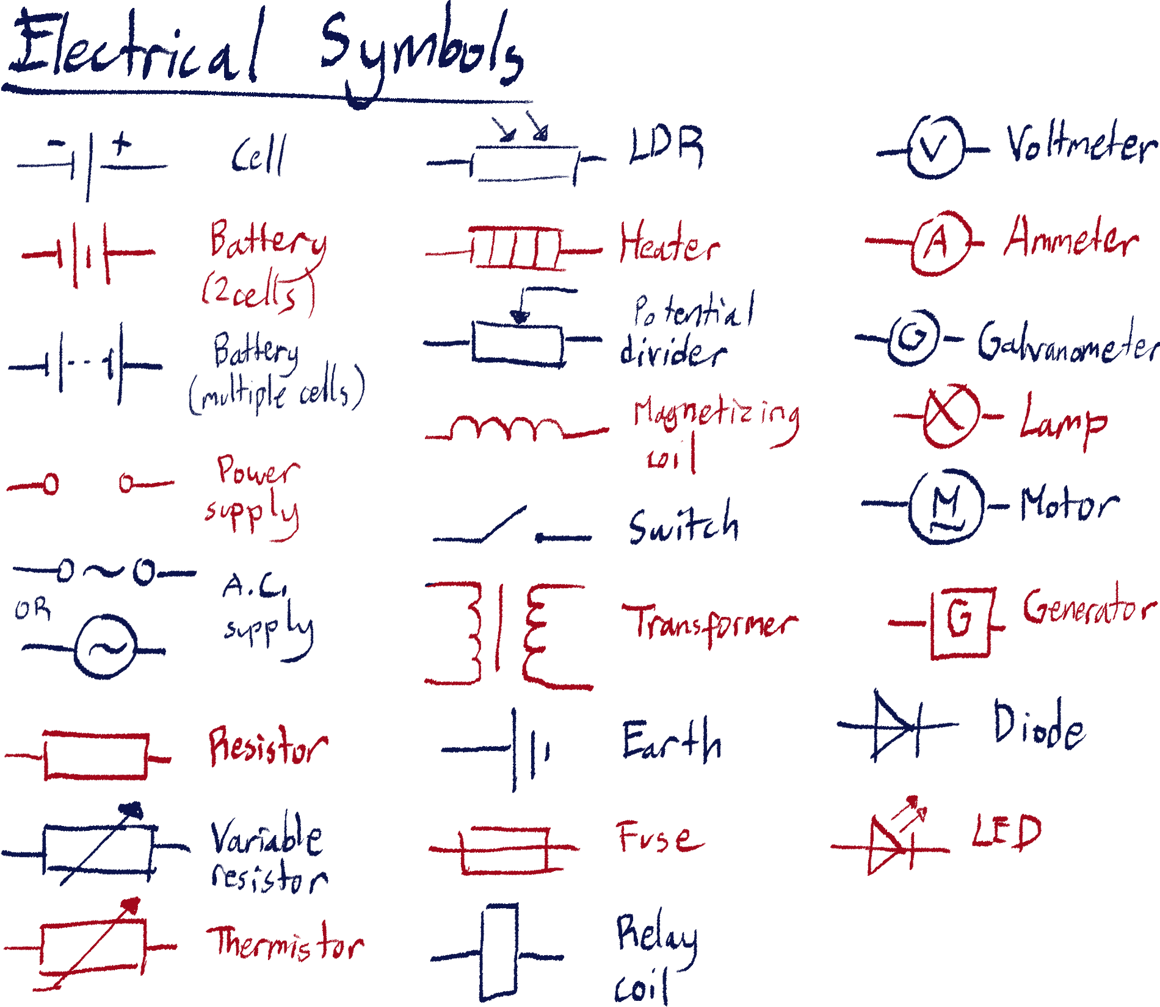

In series

In parallel

Circuit voltage, current and resistance

Some questions will be a bit tricky because they deal will *circuit* voltage, current or resistance. You already know how to figure out the overall voltage, current or resistance for an entire circuit, by using the series and parallel rules and calculations.

What I want to mention here is that, for example:

There is a circuit with a lamp in it. The circuit is on, and the map glows at a certain brightness. Then, the wires of the circuit are made longer so that resistance in the wires increases. Although nothing else has changed, the overall circuit resistance has increased. Because of that, following Ohm’s Law (V= IR) and knowing that the battery’s voltage will be the same, we can deduce that the current in the lamp will decrease and the lamp will dim.

Potential divider circuits

Potential divider circuits are used to, well, divide the total potential difference of a circuit in a controllable way. This is usually done to adjust something like the brightness of a lamp or strength of an electromagnet. It could also just be used to make sure a component doesn’t receive too much voltage.

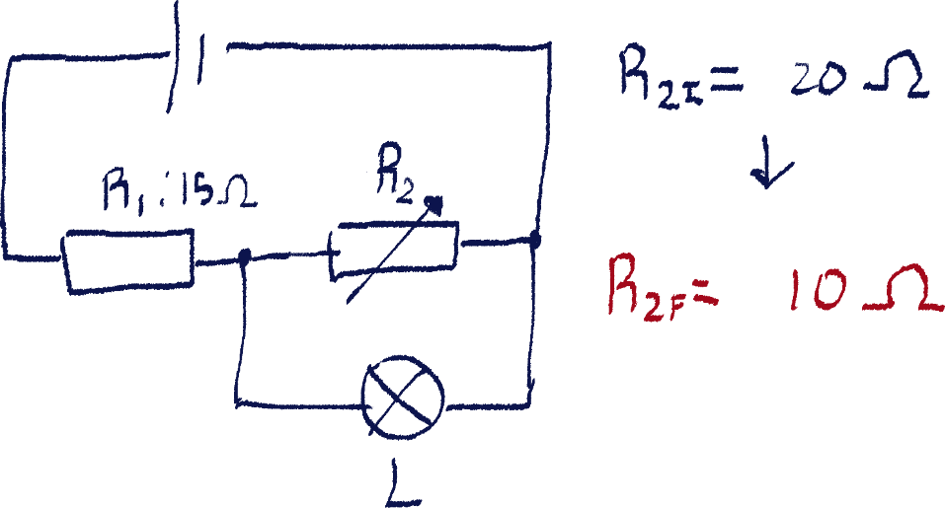 An example of a potential divider circuit is shown below.

In this case, this circuit’s purpose is to power the lamp where it’s brightness can be adjusted. The more voltage through the lamp L, the brighter it will be.

R2 is a variable resistor. It will change from 2OΩ to 10Ω. What happens to the brightness of the lamp? Explain why.

The total voltage across the circuit will always be constant. This voltage will be split across the two resistors, since they are in series. Because V = IR, the voltage across a component is directly proportional to the component’s resistance, the resistor with higher resistance will get more of the voltage – which at the start, is R2. However, as R2 changes resistance to 10Ω – less than that of R1 – it will receive less voltage.

Because R2 and L are connected in parallel, both of them must get the same amount of voltage. Thus, if the voltage across R2 has decreased, the voltage across L will as well. This means the lamp will dim.

Rectifier circuits

Rectifier circuits are circuits that turn AC current into DC current. I believe they are implemented in electric appliances as main power sources tend to supply AC current.

Electromagnetic effects

[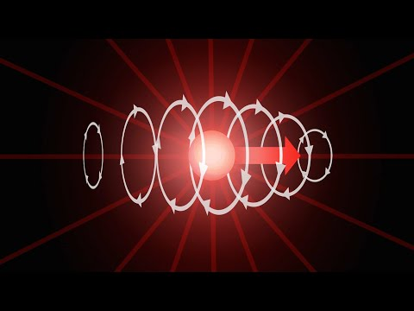](https://www.youtube.com/embed/XoVW7CRR5JY?feature=oembed)Mega good video

Magnetic field of current

Intro

The concept that is the start of the entire study of electromagnetism is the ability for electric current to produce magnetic fields, and the ability for magnetic fields to produce electric current.

You already know the former through the introduction of electromagnets, and we will start with that.

Right-hand rule

Yes, it is the same rule we used in the magnetism chapter. Remember it again so that we are sure how to apply it in different ways.

Around a straight wire

When current is running through a straight wire, the magnetic field lines produced from that current will be circular, around the center of the cross-section of the wire.

We can use the right-hand rule to determine which direction the magnetic field lines will go, according to the direction of current in the wire. Remember, in the right-hand rule, you can interchange the thumb and the rest of the fingers with current and magnetic field according to the situation.

In this case, the thumb will represent the direction of current, and the curling fingers represent the magnetic field, since we know the magnetic field will be circular.

Around a coil

The field lines will look just like that of a bar magnet, with a north and a south pole, lines being straight when inside the coil. To determine which direction will be north, use the curled fingers of your right hand to represent the coil of current, and the thumb will point to the north. The thumb does NOT point in the direction of the field lines, it points to the NORTH POLE.

Experiment to determine field lines

For the coil, you can push it through a piece of paper in a way that it is perpendicular to the plane of paper. A compass can be placed on that paper, and the point the compass points towards can be marked on the paper by drawing an arrow. The compass can then be moved onto that mark, and the process repeats.

Once the compass markings make a full loop, you can connect them to form one field line. The compass can be placed further or closer to the wire, and the same drawing process can be completed, to form more magnetic field lines.

As for the magnetic field around a coil, the process is exactly the same, except that the coil can simply be placed on top of the paper lying horizontally.

Variation of strength in magnetic fields around wires

The strength of magnetic force at a point in a magnetic field is determined by its distance from the wire, in the case of a straight wire, or its distance from the poles, when it comes to electromagnets (just like bar magnets). So, the closer to the wire/the poles the point is, the stronger the magnetic force experienced there.

Sometimes, a question might ask to draw field lines so that it represents this variation in strength, or it has enough marks on it to warrant being more detailed. In such a case, remember that in the chapters on electrostatic forces and magnetism, that the more field lines in an area, the stronger the force experienced there.[32] So, you must draw the field lines closer to each other/denser where magnetic force is stronger, and reduce the density as strength decreases.

Force created by the interaction between current and magnetic field

Intro

Honestly, I’m not sure how I would explain why electric fields and magnetic fields can cause and affect each other, because it would mean a very lengthy chunk of text that might sound incoherent coming from my mouth. Just watch the video at the start of the chapter.

All you need to know is that current and magnetic field can produce a moving force on involved charges (electrons) when interacting with each other. Think of it as a net force produced from the magnetic force inflicted on the charge and the moving charge itself.

Don’t worry, you’ll never be asked to explain the theory behind this. You just need to predict what will be observed.

Experiment

Imagine a wire carrying a current is running straight through a uniform magnetic field, that is between two opposing magnetic poles. [Fay make sure to draw this it is quite hard to imagine]

The wire will be observed to visibly experience a force. The direction of this force, in this case, is upwards. If the wire is flexible, you will see that it bends upwards.

Left-hand rule

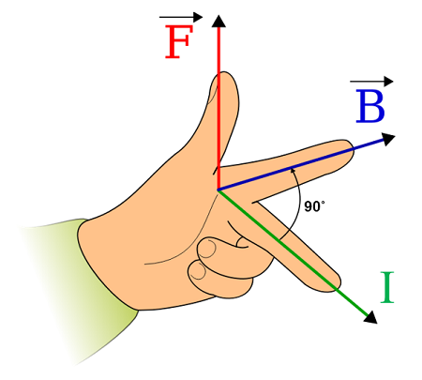 New rule guys! Using your left hand, position your thumb, pointing finger and middle finger so that they are all perpendicular to each other.

You may also interpret the pointing and middle finger to form a plane that the thumb is perpendicular to.

The pointing finger represents the direction of magnetic field line, the middle finger represents the direction of current, and the thumb represents the resultant force produced.

F-B-I; remember that.

Using this rule, we can look at the (hopefully drawn in diagram by now) experiment we looked at earlier. According to this rule, the resultant force is in the upwards direction.

DC motors

This concept is the driving force of electric motors, allowing us to convert electrical energy into mechanical energy. The setup will look similar to the first experiment, but they will be different in certain, vital ways.

[draw it here]

First, the wire will be in a loop, usually a rectangular one. This part is called the armature of the motor, since it will be the one moving. *Why a coil?* You may ask. This is because doing this will cause 2 main forces to be produced; one on each side of the coil. These two forces will be equal in magnitude and opposite to each other, so they do not produce any net force – hence nothing like the bending in the straight wire happens.

However, these forces do create a turning force on the loop. The turning of the loop is the mechanical output of the motor.

A question could ask you what direction the motor spins in – use the left hand rule to discern that.

There are other parts to a DC motor you should know. If the loop kept on turning, it would reach a point where the direction of the current on each side essentially switches relative to its original position; this means that the coil would start turning back the other way. To prevent this, a split ring commutator – the split metal ring you see in the diagram – is used to connect the armature to the power source. The commutator’s halves are separate, and each halve is attached to one end of the armature.

When the armature spins, it and the commutator will spin, but the wires supplying the power will stay still. So, when the armature spins half a turn, the brushes change contact with the other half of the commutator, and the direction of current within it will switch. This ensures that the turning force will always be in one direction.

Carbon brushes are what keep the commutator in contact with the power source.

Factors influencing strength of produced force

Of course, the strength of the current and magnetic field will be proportional to that of the produced force. Furthermore, having a longer length of wire (usually done by more looping) in the magnetic field will also increase the resultant force.

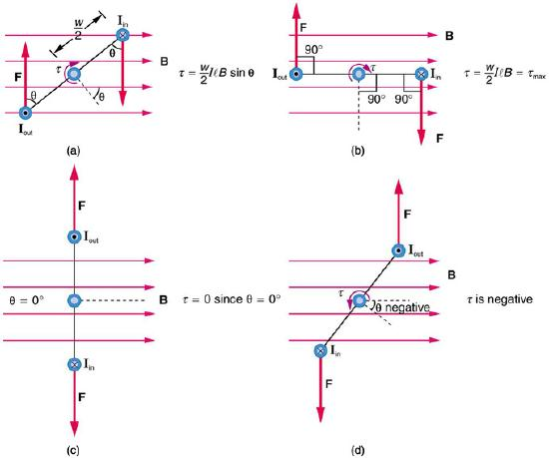

Devices that make use of these effects

Relays

Relays are used to close and open a circuit using a separate circuit. However, the more accurate definition in relation to how it’s used in real life is that it can close and open a circuit of higher current using a circuit of lower current.

Imagine two circuits. The first circuit has an electromagnet, in this case formally known as a relay coil. As current passes through the first circuit, the coil produces a magnetic field.

On the second circuit, a switch made out of magnetic material is positioned so that it is close to the relay coil on the first circuit. It is set up in a way that it is open in its default state, using a spring or something similar.

When the coil on the first circuit is magnetized, it attracts the switch on the second circuit, closing it. This completes the second circuit, allowing current to flow through it. By using a relay, we can use one circuit as an indirect switch for another circuit.

*Why use relays instead of just using normal switches?* You may ask. Sometimes, it may be too dangerous for someone to directly open a switch of a circuit with a very large current. Other times, it may be to easily control multiple circuits at once, electronically.

One example of a relay is in car engine ignition. The current needed to actually start a car is very, very big, bigger than any other electric device in the car. It would be dangerous to start the car by completing the circuit directly, and this current is only needed for a moment to ignite the car.

Because of this, the manual ignition switch (car keys) is connected to a relay circuit, which draws far less current to then turn on the circuit which start’s the car’s engine.

Speakers

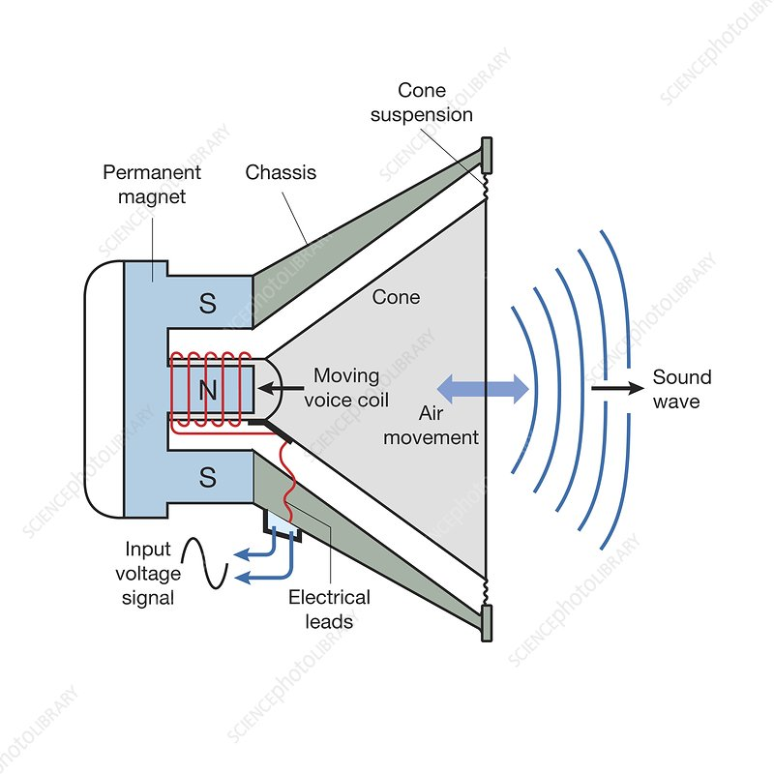 Speakers are made up of a 3 main parts:

* Hollow cylindrical permanent magnet – the base of the speaker
* Electromagnet inside the permanent magnet
* A paper/fabric cone

As current passes through the electromagnet, it will produce a magnetic field. This field will interact with that of the permanent magnet, causing the electromagnet to move.

Being attached to the cone, this will vibrate the center of the cone. Thus, the vibrations produce compressions and rarefactions of the air particles in contact with it, producing sound waves.

The volume and frequency of the sounds produced is controlled by changing the strength of the current accordingly.

Circuit breakers/trip switches

Circuit breakers are used to temporarily open a circuit when it reaches a certain value of current. Its function is similar to that of a fuse, except that it does not have to be replaced once opened, only switched back. Because of this, circuit breakers are often used to maintain safety in the electric circuits of buildings.

In terms of mechanics, circuit breakers are like the opposite of relays, using an electromagnet to open a circuit instead.

Circuit breakers only require one circuit, and is installed as a singular component. In a circuit breaker, there is an electromagnet and a closed switch made out of magnetic material close to it. The electromagnet is set up so that its produced magnetic field will be strong enough to attract and open the switch once it reaches a certain magnitude of current, turning off the circuit.

Electromagnetic induction

Intro

A changing magnetic field can produce a current/e.m.f. in a conductor affected by that field. That is the definition of electromagnetic induction. You can relate it to how electromagnets work – current creates a magnetic field. This is the reverse.

The most important part of this to remember is that the magnetic field must be *changing*. This means that the magnetic force experienced by the conductor must either be changing in direction or magnitude or both. Otherwise, no electric current will be produced.[33] Also, it seems like you can also call this ‘magnetic field lines cutting through the conductor’.

It is best to use the word ‘e.m.f.’[34] rather than voltage, just to be on the safe side, when talking about electromagnetic induction.

Galvanometer

A galvanometer is an instrument used to determine the presence and fluctuation of current in a circuit. It is not meant to be used to measure values accurately like an ammeter, but is rather used to see the mere presence of current and the direction of that current[35]. An ammeter only measures the magnitude, without direction.

A galvanometer, unlike an ammeter, has a scale that reaches negative and positive, 0 in the middle. Positive and negative just denotes the direction of the current. For example, 1 is in the opposite direction of -1.

That one experiment where you drop a magnet through a solenoid

I think this should be the easiest experiment to understand first. Imagine a solenoid, not connected to any power source, just connected to an ammeter. We also have a bar magnet. The solenoid is positioned upright and suspended.

When we drop the bar magnet through the solenoid, the galvanometer will fluctuate for a moment, before moving back to 0. This proves that a current has passed through the solenoid due to the magnet dropping through, and thus the magnetic field experienced by the solenoid has changed for a moment.

I believe sometimes questions will use an ammeter instead of a galvanometer, and that’s all fine and dandy. Don’t get confused over that.

Moving a wire up and down wee

Really, it’s basically the same thing. Instead of having the magnetic field move while the conductor is still, it’s the conductor moving through the still magnetic field.[36]

Imagine a conducting wire is running straight through a uniform magnetic field, that is between two opposing magnetic poles. What a familiar setup! [Fay make sure to draw this at some point]

The only difference is that there is no current flowing through the wire. The wire is will be connected to a galvanometer and form a full loop.

So, moving the wire up and down, the galvanometer will fluctuate from one direction to the other. This shows that a current of constantly changing direction is present, and thus electromagnetically induced e.m.f. is being produced by the changing magnetic field on the wire.[37]

Another right-hand rule but its different this time guys

To discern the direction of electromagnetically induced current, we use a hand trick that is the same as the left-hand rule, except we use our right hand instead. All the fingers correspond to the same thing, don’t worry. For sake of differentiation, we’ll call this rule Fleming’s right-hand rule.

[draw something here]

The difference between Fleming’s right-hand rule and Fleming’s left-hand rule is that the former is to deduce direction of induced current and the latter is to deduce the direction of resultant motion/force.

Direction of an induced e.m.f. is produced to oppose the change causing it

This is simply a fact that you should remember. This statement is Lenz’s law, although I don’t believe you need to remember that name.

When a magnet is dropped vertically through a solenoid, it will be observed that the galvanometer deflects one way as it falls through the upper half of the solenoid, and deflects the other way when it falls through the lower half.

This is because when falling *into* the solenoid in the upper half, the current induced wants to produce a force that opposes the

To expand on this idea, this follows the idea of conservation of energy that we repeat over and over again in physics. If a force is exerted, a force opposing it will be produced in response. This is a reiteration of that.

AC generators

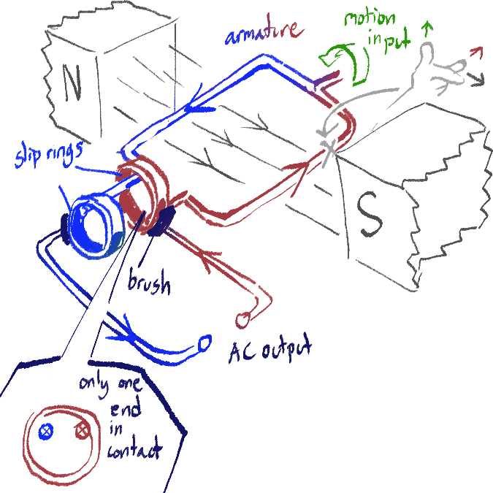 AC generators produce electrical power out of mechanical force. This is how we convert nuclear power, hydraulic power, fossil fuel burning and wind power into electricity that we can use. We have actually already made a pseudo AC generator – the wire moving up and down. The galvanometer showing that current was moving between both directions shows that it is an alternating current.

The setup is quite similar to that of a DC motor. Try thinking of how you could turn a DC motor into an AC generator.

This time, the input is the turning motion instead of current. As you should know by now, this produces an e.m.f., creating a current through the wire. Note that slip rings are used instead of a commutator here. You can make this into a DC generator by using a split ring commutator instead of slip rings.

Effect of direction & on a graph

[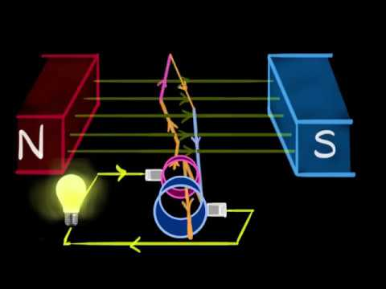](https://www.youtube.com/embed/Ylgb8FFMgd4?feature=oembed) If you have been paying close attention, you may be thinking about how this produces an *AC* current. You may remember that we used a commutator in the DC motor to switch the direction of current periodically. Here, we are applying that in reverse. Without a commutator, the current produced by the force turning in one direction will produce a current that periodically switches direction. Look at this video to visualize this better.

Now, on top of that, you must also be aware that the current direction of the force in relation to the magnetic field lines determines the magnitude of the current produced.

We will keep in mind two forces – one acting on each side of the wire. These forces will always be opposite in direction to each other.

When the moving forces are directed perpendicular to the magnetic field lines, the current produced is at its highest. On the other hand, when the direction of the forces are parallel to the field lines, induced current is 0.

[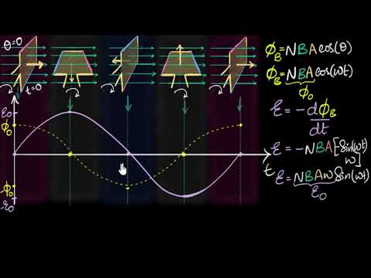](https://www.youtube.com/embed/Sp1m6GYo5iw?feature=oembed)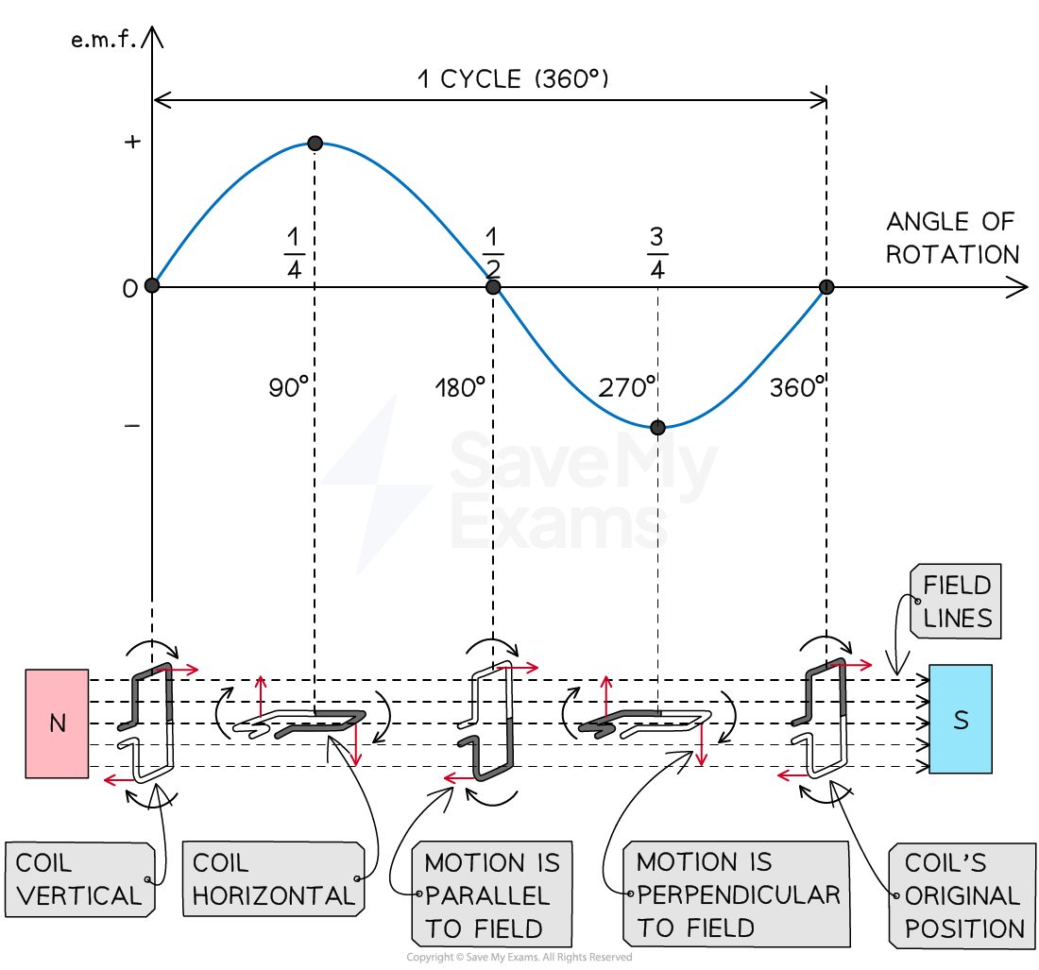

Factors influencing induced e.m.f.

Transformers

Intro and explanation

The iron core of the transformer is meant to channel the magnetic field of the primary coil to the secondary coil.

Formula

V1 / V2 = N1 / N2

Where:

V1 : voltage of primary coil

V2 : voltage of secondary coil

N1 : number of turns in primary coil

N2 : number of turns in secondary coil

Also, power is constant between both coils. Law of conservation and all that. It seems that the syllabus wants you to use it in a formula like this:

V1 I1 = V2 I2

Real life usage

Transformers are used to increase the voltage of electricity generated from power stations before they go a network of power lines, called the national grid. They are used again to reduce voltage from the power lines before entering local distribution centers. Transformers are located in buildings called substations.

Advantages of stepping up voltage

Transmitting electricity in very high voltages is dangerous, so why is it done?

Since power is constant between the two coils, following P = VI, when voltage increases, current must decrease. Having a low current means less energy is lost through heat dissipation produced due to resistance. This makes transmission as efficient as possible. It is also more costly to have higher current since it would need thicker cables.

Power loss can be calculated using this formula:

P = I2 R

Where P : Power loss

Remember this formula, because they will probably want to see it in your reasoning.

Also, this formula is actually derived from Ohm’s law and the formula for power, if you’re curious or ever forget.

Lenz’ Law

[](https://www.youtube.com/embed/yU_wwWC-K9c?feature=oembed) Direction of an induced e.m.f. is produced to oppose the change causing it. This is the version of Lenz’ law given in the syllabus. However, I just broke my head over a past paper question that really needs you to understand this.

Not part of our syllabus, but having a proper explanation for “induced current opposes the force that creates it” helps a lot in actually applying it.

Nuclear Physics

The structure of an atom

Relative charge

The Rutherford Experiment

Nuclide notation

Nuclear fission and fusion

Radiation intro

Radiation is simply the emission of energy, as waves or particles. This means sound waves, radio waves, and light are also considered radiation. However, in this chapter we mainly talk about ionizing radiation, that can alter the composition of an atom and other big things.

Contaminated vs irradiated

Properties of radiation

Penetrating power

Ionizing power (remember to explain with reference to kinetic energy and ionic charge)

Types of radiation

Alpha radiation

Beta radiation

Gamma radiation

Radioactive decay

Unstable nuclei emit alpha, beta or gamma radiation to become more stable. A nucleus may be unstable because:

* It is too heavy (most elements heavier than lead are radioactive)
* It has too many neutrons compared to protons (this tends to happen with isotopes of stable elements)
* It has too much energy. (exclusive to gamma decay)

Alpha decay

Beta decay

Gamma decay

Randomness of decay

Isotopes

Measuring radiation

Geiger counter

Bequerels

Background radiation

Background radiation is defined as radiation that is always present from the environment, in everyday life. Straight out of the mark scheme for that one.

Sources of background radiation

* Radon gas in the air
* Rocks and buildings
* Food and drinks
* Cosmic rays

Half-life

Uses of radiation

Cancer diagnosis

Cancer treatment

Sterilization of medical equipment

Irradiation of food

Controlling sheet thickness

Nuclear power generation

Finding faults and leaks

Dangers of radiation

Ionizing radiation can cause cell death, mutations and cancer (from those mutations).

Moving and storing radioactive materials

Precautions to take

Fay’s Double-Check-List

1. Reread questions carefully
2. Redo all calculations and readings ALL of them even the dumb ones

* For all calculations, check that values were not misread or miswritten

1. Reread theory answers for any dumb silly word mistakes

1. Throughout this document, density will be referred to assuming all solids are *solid*. I.e. no pores or empty space inside of it which would technically make all these measurement methods incorrect.
2. Because 1 kg/m3 = 103 g/m3 and 1m3 / 106  = 1cm3 so it becomes (103/106) g/cm3 = 10-3g/cm.
3. The second method is just *called* the *interrupt card* method, but both methods use light gates. I’m taking from [this manual](https://www.primaryict.co.uk/res/dataharvest/vu_light_gates.pdf) as a reference.
4. Essentially, the distance
5. To imagine, the longer it takes for the card to leave, the slower it is, and the quicker it takes for the card to leave, the faster it is.
6. If you’re thinking about the theoretics of this, the reason bouncy balls don’t bounce forever/bounce back weaker than when it hit the ground is because of slight inelasticity, affecting resulting acceleration. Keep in mind that Newton’s third law is still true.
7. This is a simpler definition. In actuality, free fall is when an object is free to move in a gravitational field. For example, the planets of the Solar System are all in free fall in the Sun’s gravitational field.
8. Remember that momentum’s symbol is p, not m as that is already used for mass.
9. Triangle is delta, otherwise known as change or difference. This formula is true as F = M * V/Δt and p = M * V
10. [A wonderful explanation](https://www.physlink.com/education/askexperts/ae462.cfm)
11. The longer the time force is applied, the stronger the impulse is, but since collisions often don’t last long, we don’t use the time factor often.
12. Weight is a vector because it’s essentially saying the object has a direction which is towards the center of the planet.
13. This is EXCLUSIVELY for 90 DEGREE difference vectors. There are completely different steps needed to be taken for other problems. If interested, watch [this](https://youtu.be/RxV06Oj5sMc).
14. Definitely doesn’t work for non-lamina objects
15. Converting kg to N for force
16. Multiplying force by distance from pivot to get moment
17. Force of bridge’s center of mass multiplied by distance from pivot to find moment
18. Right rope’s force multiplied by distance from pivot to get moment
19. Finding force by Timmy’s weight
20. Finding force by bridge’s weight
21. Force of right rope
22. Sometimes, the formula is defined as F = -kx. This is simply because the weight acting upon the spring will always be opposite to the spring constant, as per Newton’s second law. However, if you’re only looking for the magnitude, this isn’t needed.
23. Sorry for the fancy words, but imagine a spring has already gotten straight from stretching, it will have to break itself a bit to stretch further.
24. A.K.A. last line of division that you can see, not hidden
25. Letting out radiation
26. A calorimeter also does all of this.
27. <https://www.physicsclassroom.com/class/refrn/Lesson-3/The-Critical-Angle> really nice resource
28. This video explains it very well <https://youtu.be/V_jYXQFjCmA>
29. This has to do with Planck’s relation, which converts the frequency of a wave to the energy of one photon of the wave. It involves quantum mechanics, and how the energy given out by the wave and accepted by the electrons are in a discrete, quantitative amounts. This video explains it: https://youtu.be/Z8Fo2xZjpiE
30. The term ‘field’ in physics is often used to describe and explain forces caused by an object acting at a distance.
31. this is hypothetical, I don’t know if electrons would go from straw to paper or paper to straw and you don’t need to either
32. Flux that’s just flux
33. The more accurate and correct word to replace ‘magnetic field’ here would be *magnetic flux*, the total field lines affecting an area of object in a magnetic field, because it refers to what the object is experiencing rather than the magnetic field as a whole, I believe. However, this is not part of our syllabus, so saying ‘magnetic field’ should be just fine. I am saying this here so that you fully understand that although we are moving the conductor, not the magnetic field, the magnetic flux experienced by that conductor is changing as it moves from points where the magnetic field lines are different.
34. From my “research” (reading stack exchange forums) it seems that e.m.f. may be used here as a term to describe any general phenomena that creates a current. Voltage may be a more specific term that refers to the tangible value. I could still be wrong about this, and it’s the thing where e.m.f. can exist without current, when it there is no conducting path, so ‘induced e.m.f.’ is meant to cover both scenarios where current is and isn’t created. Man, I don’t think I’ll be able to understand this immediately when I come back to these notes after like, 2 months.
35. *Why not use a galvanometer as/instead of an ammeter then?* Ok, first of all, the only way you’re asking this many questions and looking at these footnotes is if you are Fay. Second, a galvanometer, practically, is only able to measure a small range of current, usually in microamperes. An ammeter on the other hand, measures milliamperes. The purpose of a galvanometer is to detect the presence of current, not measure it.
36. Heck, if you want to go into relativity, these two scenarios are *literally* the same thing.
37. I was almost going to say that the wire must enter and exit the field constantly as moving within a uniform field would not cause any change in flux, but I don’t think I have enough understanding of flux to say that for sure.